
CLOUDERA SOLUTION ENGINEERING

Open Data Lakehouse Hands-on Labs
CDP 7.3.2 SP2 Lakehouse

Revision: 2.0
Date: October 26, 2026

Overview
Hands-on Lab Setup
One cluster, many lab users
Cluster provisioning
Getting access
Lab administrator: load the airline data
Lab administrator: pause and resume the cluster
Every lab user: create your databases
Lab 1 - Iceberg with NiFi and SQL Stream Builder
NiFi: create a keytab for the flow
NiFi: import the flow
NiFi: set the parameters
NiFi: enable the services and start the flows
Inspect the NiFi Iceberg tables
SQL Stream Builder: import the project
SQL Stream Builder: unlock your keytab and set your environment
SQL Stream Builder: data sources and virtual tables
SQL Stream Builder: run the jobs
Inspect the SSB Iceberg tables
Lab 2 - Spark (Multi-function Analytics)
Migrate existing tables to Iceberg
Query the Iceberg tables
Create and load an Iceberg table
ACID: MERGE
Table maintenance
Hard deletes
Lab 3 - Data Warehouse with Impala
Migrate tables to Iceberg
Create and load a partitioned Iceberg table
Partition evolution
Time travel
Hive and Iceberg tables in one query
Lab 4 - SDX: Fine-grained Access Control and Lineage
Ranger: mask a column
Atlas: metadata and lineage
Lab 5 - Replication
Lab 6 - Cloudera Lakehouse Optimizer
Look at the problem
Open the Lakehouse Optimizer
Create the policy
Dry run and run the policy
Monitor the task
Cleanup
Appendix
Lab cluster settings
Performance tuning with Iceberg metadata tables
Lab setup SQL
Workshop repository

REVISION HISTORY
Version | Author | Description | Date
2.0 | Yazan Al-Yasin | Rebuilt for CDP 7.3.2 SP2 (CSA 1.18, CFM 4.13 / NiFi 2).  Supersedes v1.1 (CDP 7.1.9, Sep 2024). | Oct 26, 2026

Overview
This workshop shows the Open Data Lakehouse capabilities of Cloudera on premises 7.3.2 with Apache Iceberg as the common table format. You ingest data with NiFi and SQL Stream Builder (Flink), process it with Spark 3, query it with Impala in Hue, and govern it with Ranger and Atlas, all on the same Iceberg tables.
Version 2.0 is a refresh of v1.1 (CDP 7.1.9) for 7.3.2. Every step and screenshot in this document was run and captured on a 7.3.2 Lakehouse cluster deployed with the lakehouse-cluster.yml playbook. The steps use the user id admin: replace it with your own user id.
AT A GLANCE
Platform | Cloudera Manager 7.13.2  Cloudera Runtime 7.3.2 SP2 (7.3.2.20000)  RHEL 9.6
Services | HDFS, Ozone, Hive, Impala, Hue, Spark 3.5, Kafka (KRaft), Ranger, Atlas, Knox, Solr, HBase, YARN  CSA 1.18: Flink 1.20.5 and SQL Stream Builder  CFM 4.13: NiFi 2.11 and NiFi Registry
Labs | 1. NiFi and SQL Stream Builder to Iceberg  2. Spark (multi-function analytics, table maintenance)  3. Impala / Hue (data warehouse, time travel, evolution)  4. SDX (Ranger masking, Atlas lineage)  5. Replication (No Labs)  6. Lakehouse Optimizer
Time | About 2.5 hours for the labs; 30 minutes of lab setup by the lab administrator.  Longest jobs: the Lab 3 load up to 2006 (about 6 minutes) and the Lab 6 Optimizer task (about 2 minutes). Every other step returns in under a minute, most in a few seconds.
Access | All UIs through the Knox gateway with single sign-on: https://knox.<gateway-ip>.pvc.cloudera-labs.com/gateway/homepage/home (the gateway IP as is, e.g. knox.13.57.98.89)

WHAT CHANGED FROM V1.1 (CDP 7.1.9)
Area | v2.0 on CDP 7.3.2
NiFi | NiFi 2.11 (CFM 4.13). The flow is SSBDemo-v2.json: generic parameters, and the Kafka processors already use the Default Truststore-only SSL Context Service.  The parameter context is lakehouse_hol_params.
Keytab for NiFi | ktutil needs -f (salt from the KDC) with FreeIPA, or the keytab fails with "Preauthentication failed".
SQL Stream Builder | Unlock the keytab with your user id and password (no keytab upload needed). The Local Kafka data source is already configured for the cluster, so there is no Kafka data source form to fill in. Stop each job when you finish with it.
Lab setup | The planes table is created in the Hue Hive editor. The flights data is a split tar archive. hol-setup.sh loads everything.
Spark | Spark 3.5.8 on Python 3.11 (pyspark3). migrate keeps a <table>_backup_ copy.
Impala | In-place migration is now available: ALTER TABLE … CONVERT TO ICEBERG. Hive also supports Iceberg in 7.3.2.
Replication (Lab 5) | Not covered in v2.0: it needs a second cluster.
Lakehouse Optimizer (Lab 6) | New lab: a policy compacts the small files and expires the old snapshots that the Lab 1 streaming jobs leave behind.

Warning: The lab cluster is a single host. SQL Stream Builder runs every job in one shared Flink session with a limited number of slots: stop each SSB job before you start the next one, or new jobs wait for a slot and show no results.

Hands-on Lab Setup

One cluster, many lab users
One lab cluster serves all participants. Each participant works as their own user, for example user01, user02, user03, and gets their own databases (user01_airlines, user01_airlines_maint), NiFi process group, SSB environment and Ranger policy, so users do not affect each other's work.
- This guide uses the user id `admin` in every example and screenshot. Wherever you see admin or <user_id>, use your own user id; in Hue, enter it for the ${user_id} parameter.
- The lab administrator runs the setup once for everyone and passes the list of lab users to it (for example admin user01 user02 user03), so each of them gets an HDFS home directory.
- The lab users must exist in the cluster's FreeIPA directory (they log in to Knox and Hue with it). The lab administrator creates them in FreeIPA before the lab.
Note: The SSB project can be imported only once per cluster under the name SSB-Iceberg-Demo: the first user imports it and invites the others (Members), or each user forks the repository and imports it under their own project name.

Cluster provisioning
The cluster is provisioned using Cloudera Community Edition – One Node Cluster on AWS, with its lakehouse-cluster.yml playbook for the Cloudera services these labs need. Ask your lab administrator or the GOES team for access.

Getting access
Open the Knox homepage and log in with your user id and password (the lab password is the same for every service). All lab UIs open from here; you do not need SSH for Labs 1, 3 and 4.
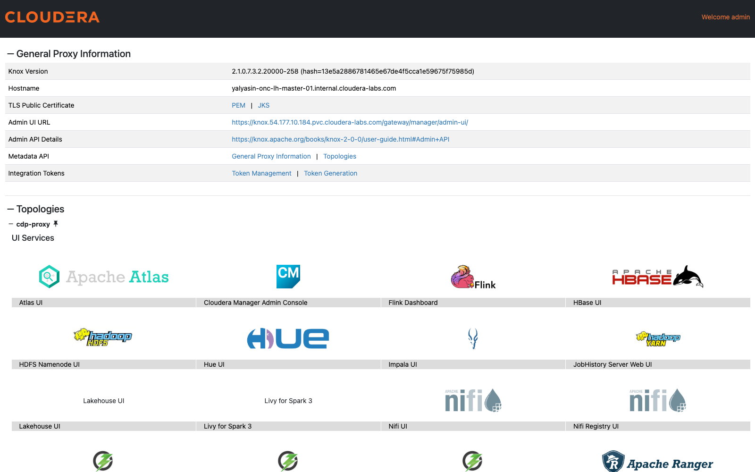
Note: Lab 2 (Spark) uses pyspark3 on the cluster host: ssh <user>@<gateway> as provided by the lab administrator, then kinit with your password.

Lab administrator: load the airline data
The lab administrator does this once per cluster, on the cluster base host. It takes about 5 minutes.
Step 1. SSH to the base host through the gateway, with the SSH key created by the deployment (<prefix>-ssh-key.pem):
ssh -i <prefix>-ssh-key.pem -J ec2-user@<gateway-ip> ec2-user@<prefix>-master-01.internal.cloudera-labs.com

# example
ssh -i jsmith-ce-ssh-key.pem -J ec2-user@13.57.98.89 ec2-user@jsmith-ce-master-01.internal.cloudera-labs.com
Note: The base host name only resolves inside the cluster network; -J connects through the gateway, which resolves it. The first time, answer yes to confirm the host keys of the gateway and the base host.
Step 2. On the base host (in the SSH session from Step 1), clone the workshop repository and run the setup script with the lab password and the lab user ids:
sudo dnf -y install git # already installed by lakehouse-cluster.yml
git clone https://github.com/ylysn/lakehouse-workshop.git
cd lakehouse-workshop/v2
./hol-setup.sh '<admin password>' admin user01 user02 user03
The script downloads the airline data from airlines-source-data (the flights file is a split tar archive), loads it into HDFS under /data/airlines-csv, creates an HDFS home directory for every lab user, and creates the airlines_csv tables in Hive (the SQL is in the appendix, Lab setup SQL). It ends with the size of each data set and beeline finishing without errors:
35.5 K 35.5 K /data/airlines-csv/airlines
200.0 K 200.0 K /data/airlines-csv/airports
7.4 G 7.4 G /data/airlines-csv/flights
422.5 K 422.5 K /data/airlines-csv/planes
7.5 M 7.5 M /data/airlines-csv/unique_tickets
Step 3. Check the data in Hue: open the Knox homepage and click Hue UI.
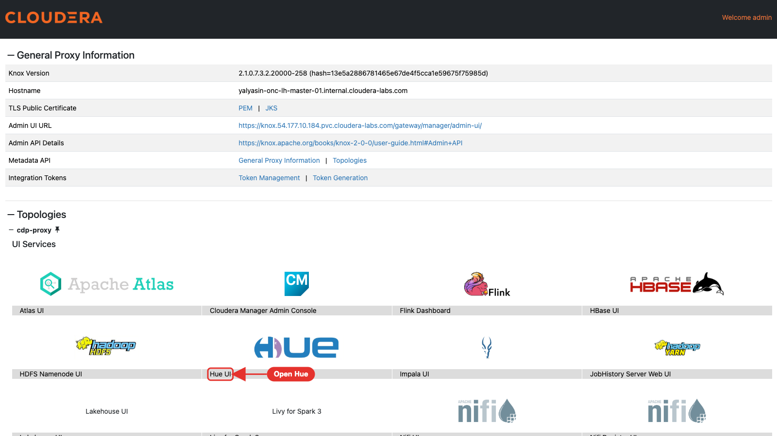
In the Impala editor, run the count below. It returns 86,289,323 rows.
SELECT COUNT(*) FROM airlines_csv.flights_csv;
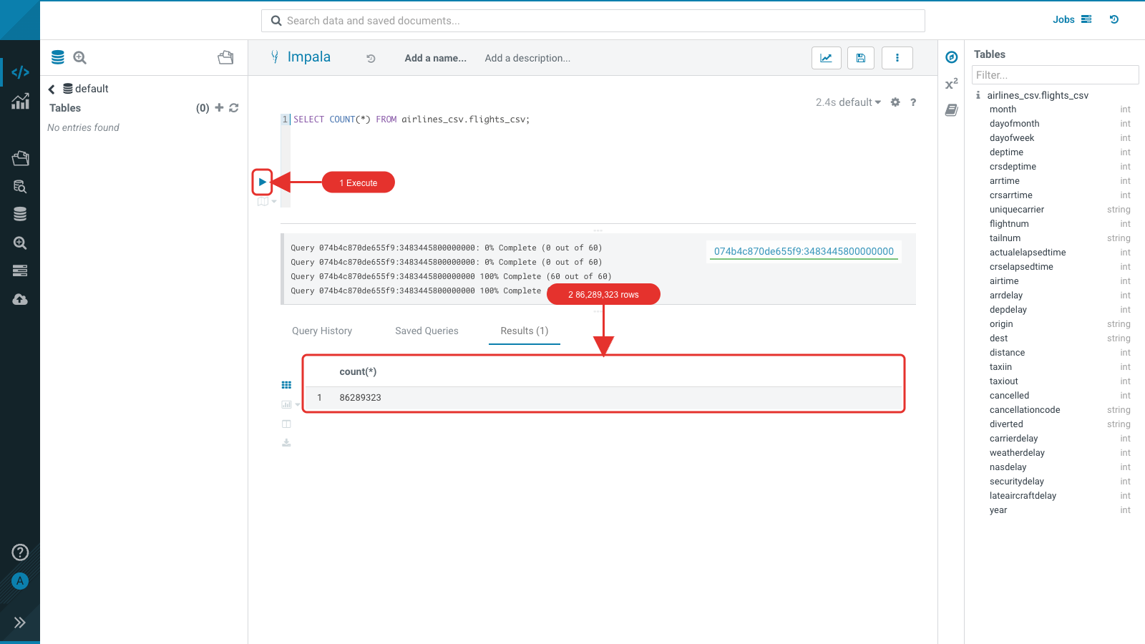

Lab administrator: pause and resume the cluster
For a workshop that spans several days, stop the cluster between sessions instead of rebuilding it. From the deployment project folder:
ansible-navigator run pause.yml -e @config.yml # stop the instances
ansible-navigator run resume.yml -e @config.yml # start the instances
The gateway IP, the Knox URL, the users and every lab table stay the same, so participants continue where they stopped. Resume well before the session starts.
Warning: Cloudera Manager does not bring the cluster back after a non-graceful shutdown. Before pause.yml, stop the cluster in Cloudera Manager (cluster Actions → Stop). After resume.yml, start it (cluster Actions → Start) and wait until every service is green.

Every lab user: create your databases
- Open Hue from the Knox homepage. The editor opens on Impala.
- Copy the SQL below into the editor. Hue detects the ${user_id} parameter: enter your user id in the box. Select all and run it. It runs 44 statements in a few minutes: the three loads into ${user_id}_airlines_maint.flights take about 10 seconds each, the other statements 2-3 seconds each.
-- Lakehouse HOL v2 (CDP 7.3.2): run in the Hue *Impala* editor (enter your user id for ${user_id})
-- CREATE DATABASES
-- EACH USER RUNS TO CREATE DATABASES
CREATE DATABASE ${user_id}_airlines;
CREATE DATABASE ${user_id}_airlines_maint;

-- HIVE TABLE FORMAT TO USE CTAS TO CONVERT TO ICEBERG
drop table if exists ${user_id}_airlines.airports_hive;

CREATE TABLE ${user_id}_airlines.airports_hive
AS SELECT * FROM airlines_csv.airports_csv;

-- HIVE TABLE FORMAT
drop table if exists ${user_id}_airlines.unique_tickets;

CREATE TABLE ${user_id}_airlines.unique_tickets (
ticketnumber BIGINT, leg1flightnum BIGINT, leg1uniquecarrier STRING,
leg1origin STRING, leg1dest STRING, leg1month BIGINT,
leg1dayofmonth BIGINT, leg1dayofweek BIGINT, leg1deptime BIGINT,
leg1arrtime BIGINT, leg2flightnum BIGINT, leg2uniquecarrier STRING,
leg2origin STRING, leg2dest STRING, leg2month BIGINT, leg2dayofmonth BIGINT,
leg2dayofweek BIGINT, leg2deptime BIGINT, leg2arrtime BIGINT
);

INSERT INTO ${user_id}_airlines.unique_tickets
SELECT * FROM airlines_csv.unique_tickets_csv;

-- CREATE ICEBERG TABLE FORMAT STORED AS PARQUET
drop table if exists ${user_id}_airlines.planes_iceberg;

CREATE TABLE ${user_id}_airlines.planes_iceberg
STORED AS ICEBERG AS
SELECT * FROM airlines_csv.planes_csv;

-- CREATE ICEBERG TABLE FORMAT STORED AS PARQUET
drop table if exists ${user_id}_airlines.flights_iceberg;

CREATE TABLE ${user_id}_airlines.flights_iceberg (
month int, dayofmonth int,
dayofweek int, deptime int, crsdeptime int, arrtime int,
crsarrtime int, uniquecarrier string, flightnum int, tailnum string,
actualelapsedtime int, crselapsedtime int, airtime int, arrdelay int,
depdelay int, origin string, dest string, distance int, taxiin int,
taxiout int, cancelled int, cancellationcode string, diverted string,
carrierdelay int, weatherdelay int, nasdelay int, securitydelay int,
lateaircraftdelay int
)
PARTITIONED BY (year int)
STORED AS ICEBERG
;

-- LOAD DATA INTO ICEBERG TABLE FORMAT STORED AS PARQUET
INSERT INTO ${user_id}_airlines.flights_iceberg
SELECT * FROM airlines_csv.flights_csv
WHERE year <= 2006;

--
-- TABLES NEEDED FOR THE NIFI LAB
DROP TABLE IF EXISTS ${user_id}_airlines.`routes_nifi_iceberg`;
CREATE TABLE ${user_id}_airlines.`routes_nifi_iceberg` (
`airline_iata` VARCHAR,
`airline_icao` VARCHAR,
`departure_airport_iata` VARCHAR,
`departure_airport_icao` VARCHAR,
`arrival_airport_iata` VARCHAR,
`arrival_airport_icao` VARCHAR,
`codeshare` BOOLEAN,
`transfers` BIGINT,
`planes` ARRAY<VARCHAR>
) STORED AS ICEBERG;

DROP TABLE IF EXISTS ${user_id}_airlines.`airports_nifi_iceberg`;
CREATE TABLE ${user_id}_airlines.`airports_nifi_iceberg` (
`city_code` VARCHAR,
`country_code` VARCHAR,
`name_translations` STRUCT<`en`:string>,
`time_zone` VARCHAR,
`flightable` BOOLEAN,
`coordinates` struct<`lat`:DOUBLE, `lon`:DOUBLE>,
`name` VARCHAR,
`code` VARCHAR,
`iata_type` VARCHAR
) STORED AS ICEBERG;

DROP TABLE IF EXISTS ${user_id}_airlines.`countries_nifi_iceberg`;
CREATE TABLE ${user_id}_airlines.`countries_nifi_iceberg` (
`name_translations` STRUCT<`en`:VARCHAR>,
`cases` STRUCT<`su`:VARCHAR>,
`code` VARCHAR,
`name` VARCHAR,
`currency` VARCHAR
) STORED AS ICEBERG;

-- [TABLE MAINTENANCE] CREATE FLIGHTS TABLE IN ICEBERG TABLE FORMAT
drop table if exists ${user_id}_airlines_maint.flights;

CREATE TABLE ${user_id}_airlines_maint.flights (
month int, dayofmonth int,
dayofweek int, deptime int, crsdeptime int, arrtime int,
crsarrtime int, uniquecarrier string, flightnum int, tailnum string,
actualelapsedtime int, crselapsedtime int, airtime int, arrdelay int,
depdelay int, origin string, dest string, distance int, taxiin int,
taxiout int, cancelled int, cancellationcode string, diverted string,
carrierdelay int, weatherdelay int, nasdelay int, securitydelay int,
lateaircraftdelay int
)
PARTITIONED BY (year int)
STORED AS ICEBERG
;

-- LOAD DATA TO SIMULATE SMALL FILES
INSERT INTO ${user_id}_airlines_maint.flights
SELECT * FROM airlines_csv.flights_csv WHERE year = 1995 AND month = 1;
INSERT INTO ${user_id}_airlines_maint.flights
SELECT * FROM airlines_csv.flights_csv WHERE year = 1995 AND month = 2;
INSERT INTO ${user_id}_airlines_maint.flights
SELECT * FROM airlines_csv.flights_csv WHERE year = 1995 AND month = 3;
INSERT INTO ${user_id}_airlines_maint.flights
SELECT * FROM airlines_csv.flights_csv WHERE year = 1995 AND month = 4;
INSERT INTO ${user_id}_airlines_maint.flights
SELECT * FROM airlines_csv.flights_csv WHERE year = 1995 AND month = 5;
INSERT INTO ${user_id}_airlines_maint.flights
SELECT * FROM airlines_csv.flights_csv WHERE year = 1995 AND month = 6;
INSERT INTO ${user_id}_airlines_maint.flights
SELECT * FROM airlines_csv.flights_csv WHERE year = 1995 AND month = 7;
INSERT INTO ${user_id}_airlines_maint.flights
SELECT * FROM airlines_csv.flights_csv WHERE year = 1995 AND month = 8;
INSERT INTO ${user_id}_airlines_maint.flights
SELECT * FROM airlines_csv.flights_csv WHERE year = 1995 AND month = 9;
INSERT INTO ${user_id}_airlines_maint.flights
SELECT * FROM airlines_csv.flights_csv WHERE year = 1995 AND month = 10;
INSERT INTO ${user_id}_airlines_maint.flights
SELECT * FROM airlines_csv.flights_csv WHERE year = 1995 AND month = 11;
INSERT INTO ${user_id}_airlines_maint.flights
SELECT * FROM airlines_csv.flights_csv WHERE year = 1995 AND month = 12;

INSERT INTO ${user_id}_airlines_maint.flights
SELECT * FROM airlines_csv.flights_csv WHERE year = 1996 AND month = 1;
INSERT INTO ${user_id}_airlines_maint.flights
SELECT * FROM airlines_csv.flights_csv WHERE year = 1996 AND month = 2;
INSERT INTO ${user_id}_airlines_maint.flights
SELECT * FROM airlines_csv.flights_csv WHERE year = 1996 AND month = 3;
INSERT INTO ${user_id}_airlines_maint.flights
SELECT * FROM airlines_csv.flights_csv WHERE year = 1996 AND month = 4;
INSERT INTO ${user_id}_airlines_maint.flights
SELECT * FROM airlines_csv.flights_csv WHERE year = 1996 AND month = 5;
INSERT INTO ${user_id}_airlines_maint.flights
SELECT * FROM airlines_csv.flights_csv WHERE year = 1996 AND month = 6;
INSERT INTO ${user_id}_airlines_maint.flights
SELECT * FROM airlines_csv.flights_csv WHERE year = 1996 AND month = 7;
INSERT INTO ${user_id}_airlines_maint.flights
SELECT * FROM airlines_csv.flights_csv WHERE year = 1996 AND month = 8;
INSERT INTO ${user_id}_airlines_maint.flights
SELECT * FROM airlines_csv.flights_csv WHERE year = 1996 AND month = 9;
INSERT INTO ${user_id}_airlines_maint.flights
SELECT * FROM airlines_csv.flights_csv WHERE year = 1996 AND month = 10;
INSERT INTO ${user_id}_airlines_maint.flights
SELECT * FROM airlines_csv.flights_csv WHERE year = 1996 AND month = 11;
INSERT INTO ${user_id}_airlines_maint.flights
SELECT * FROM airlines_csv.flights_csv WHERE year = 1996 AND month = 12;
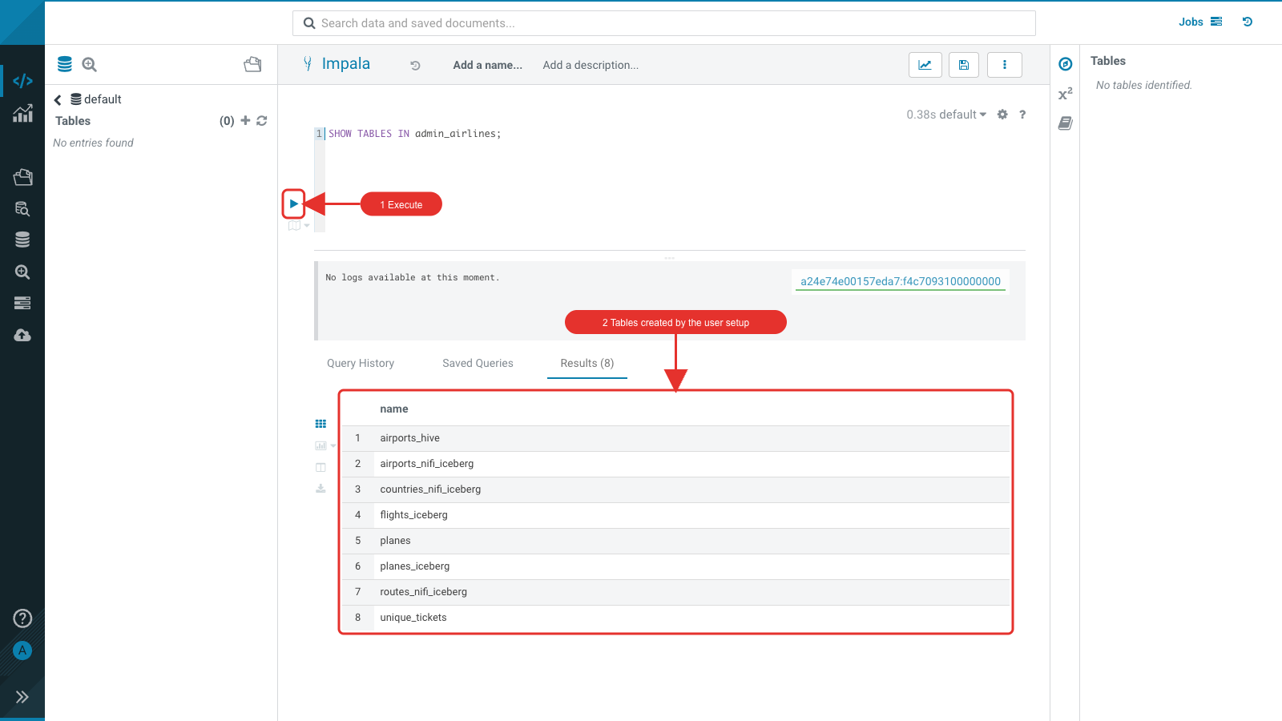
- Switch the editor to Hive (the editor drop-down next to the editor name) and run the planes table setup below, again with your user id. Lab 2 migrates this table in place with Spark, which needs a table that Hive wrote. The insert takes about 20 seconds.
-- Lakehouse HOL v2 (CDP 7.3.2): run in the Hue *Hive* editor, after the Impala user setup below
-- The planes table is created by Hive so that Spark can migrate it in place (Lab 2).
-- (A table whose files Impala wrote fails to read after Spark's migrate: "UUID require 16 bytes".)
drop table if exists ${user_id}_airlines.planes;

CREATE TABLE ${user_id}_airlines.planes (
tailnum STRING, owner_type STRING, manufacturer STRING, issue_date STRING,
model STRING, status STRING, aircraft_type STRING, engine_type STRING, year INT
)
STORED AS PARQUET
TBLPROPERTIES ( 'transactional'='false' );

INSERT INTO ${user_id}_airlines.planes
SELECT * FROM airlines_csv.planes_csv;
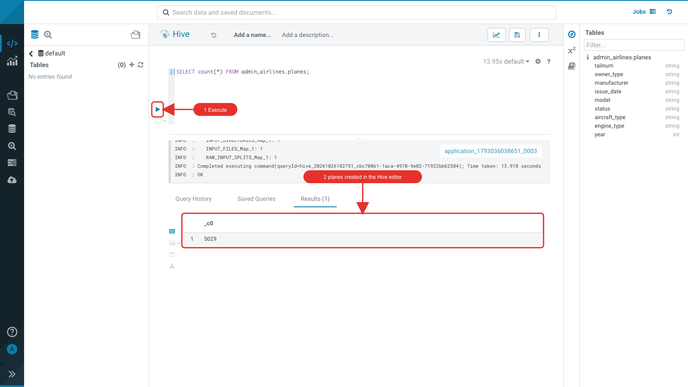
Back in the Impala editor, check the tables:
SELECT COUNT(*) FROM airlines_csv.planes_csv;

DESCRIBE FORMATTED ${user_id}_airlines.planes;

SELECT * FROM ${user_id}_airlines.planes LIMIT 10;
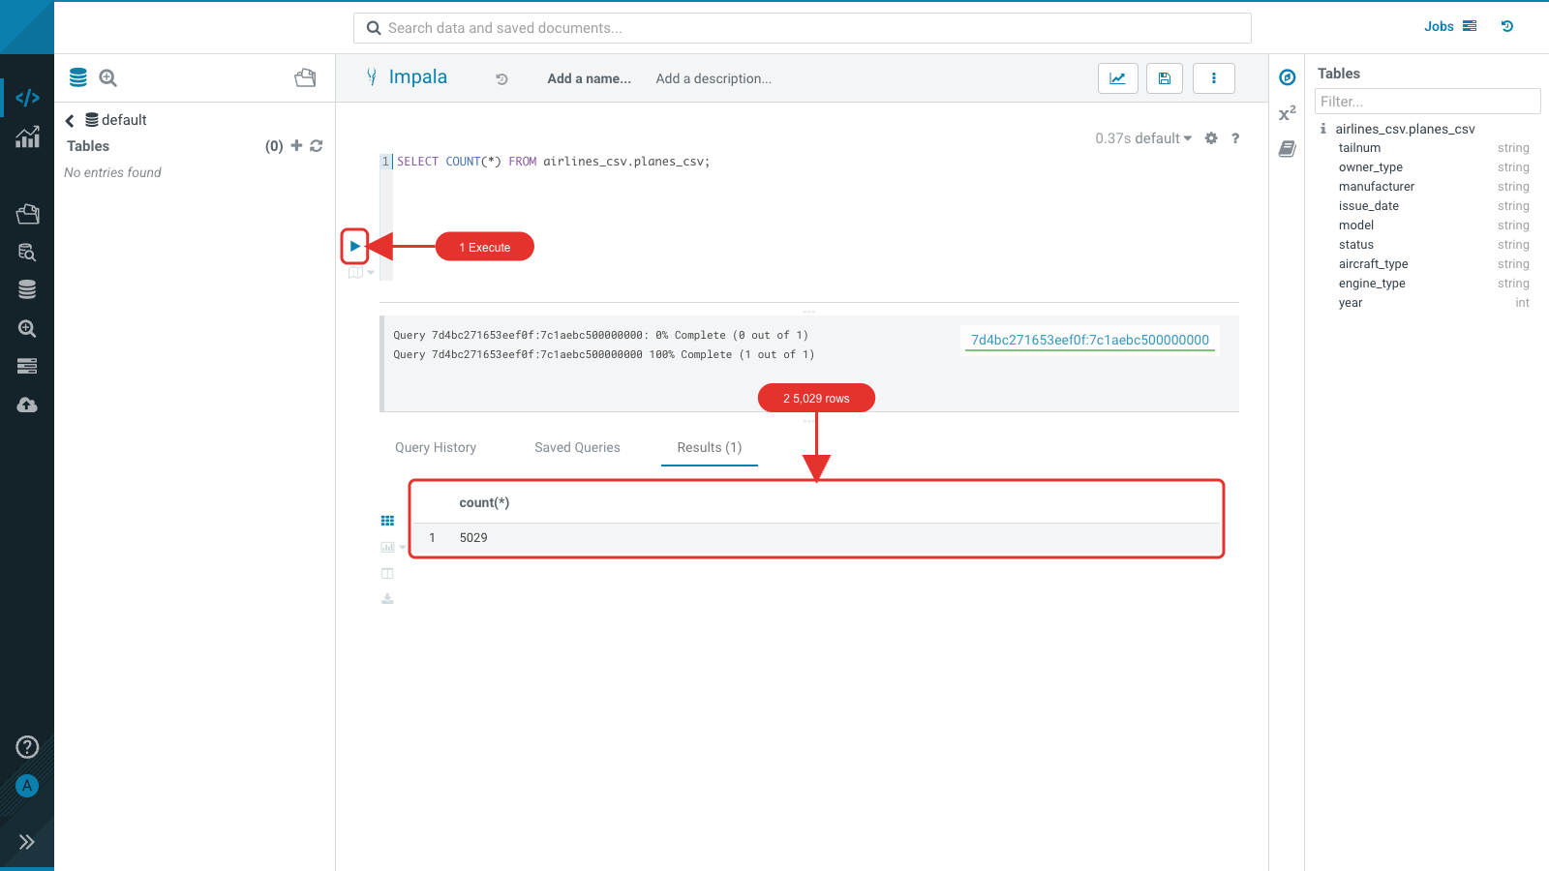
Look at Table Type, SerDe Library and Location: planes is a Hive-format table (Parquet).
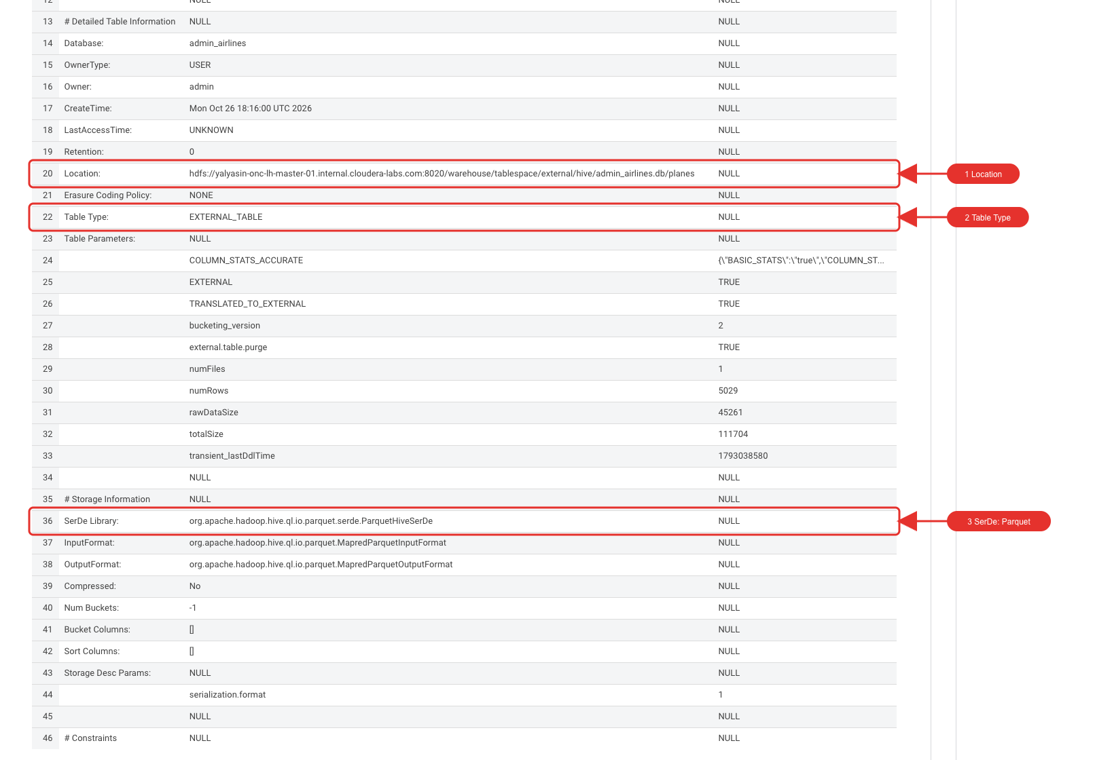
The tail number is filled in; most other columns are empty in the source data.
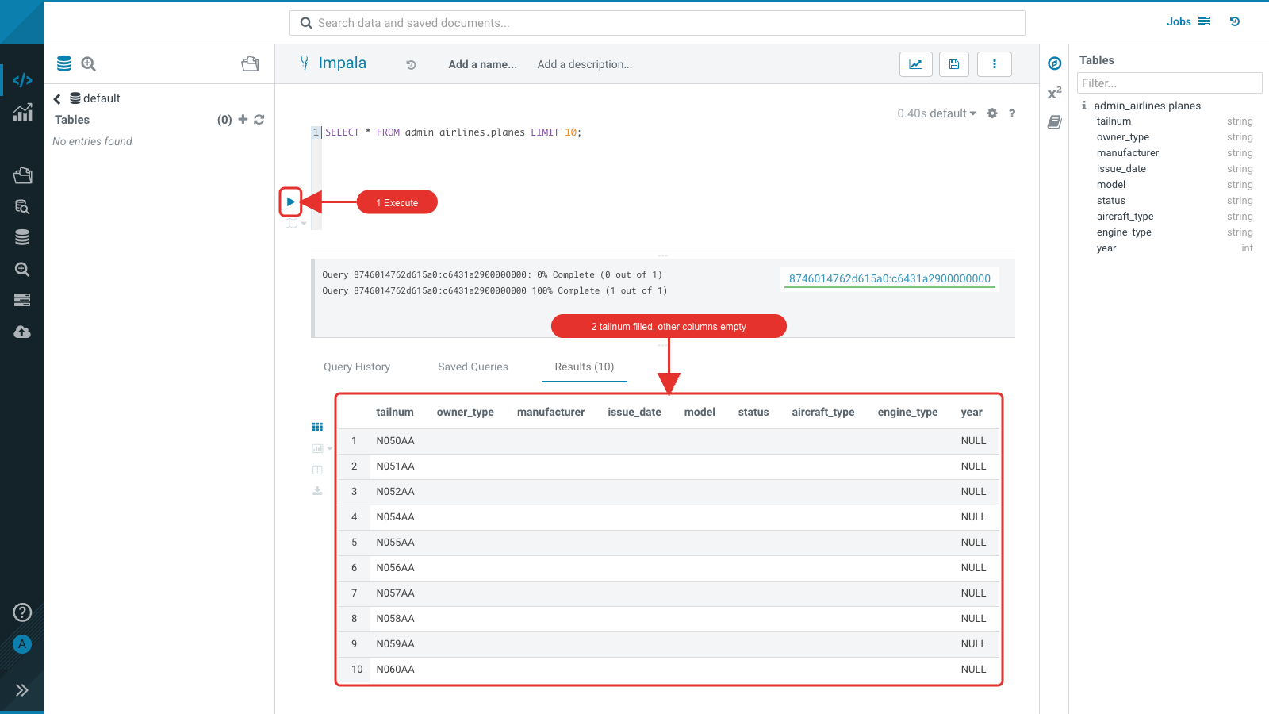

Lab 1 - Iceberg with NiFi and SQL Stream Builder
NiFi ingests three public JSON data sets (airline routes, countries, airports), publishes each record to Kafka, and writes it directly to an Iceberg table. SQL Stream Builder (SSB) then reads the Kafka topics with SQL and writes them to Iceberg tables as a streaming job. Finally you query all of these tables in Hue.
Note: The NiFi flow and the SSB project were created by Steven Matison (Cloudera) for the CDP 7.1.9 lab (NiFi-Templates, SSB-Iceberg-Demo). v2 adapts them for 7.3.2; the workshop repository keeps a copy.

NiFi: create a keytab for the flow
The NiFi flow writes to Iceberg as your user, with a keytab. SSH to the cluster host and create it:
ktutil
addent -password -p <user_id> -k 1 -e aes256-cts -f
(enter your password)
wkt /tmp/<user_id>.keytab
quit

kinit -kt /tmp/<user_id>.keytab <user_id> # must succeed
sudo chown nifi:nifi /tmp/<user_id>.keytab
Note: The -f option takes the salt from the KDC. FreeIPA does not use the default salt, so without -f the keytab is written but every login with it fails with "Preauthentication failed".

NiFi: import the flow
Download the flow definition SSBDemo-v2.json from the workshop repository (https://github.com/ylysn/lakehouse-workshop/blob/main/v2/SSBDemo-v2.json, Download raw file). Then open Nifi UI from the Knox homepage.
- Drag a Process Group from the toolbar onto the canvas.
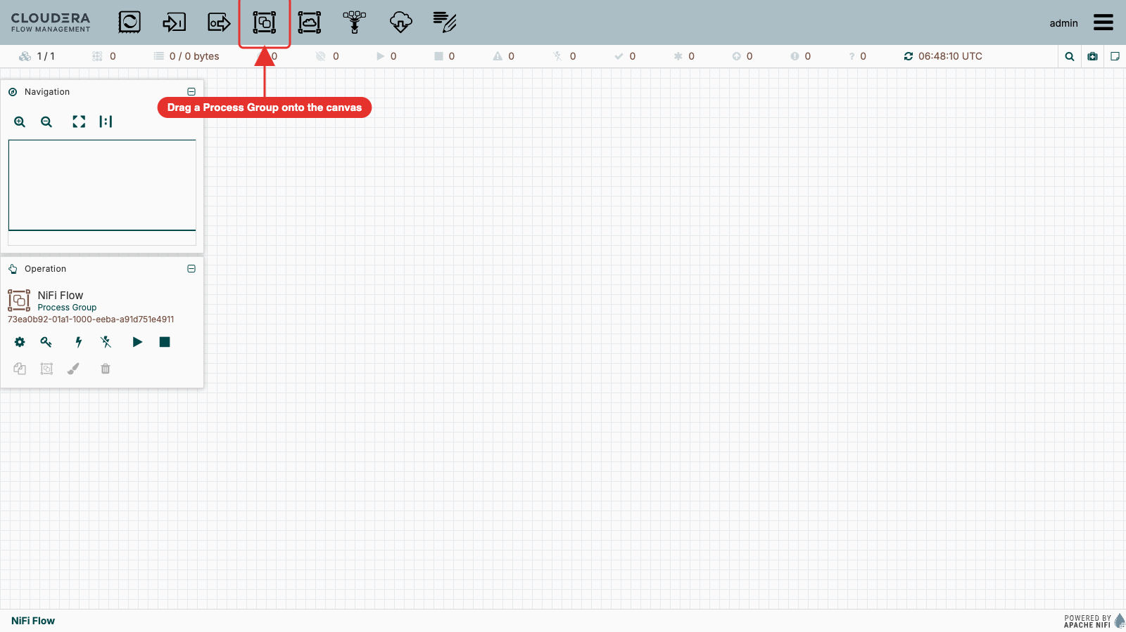
- In Create Process Group, click the upload icon at the right end of the Name field and select SSBDemo-v2.json.
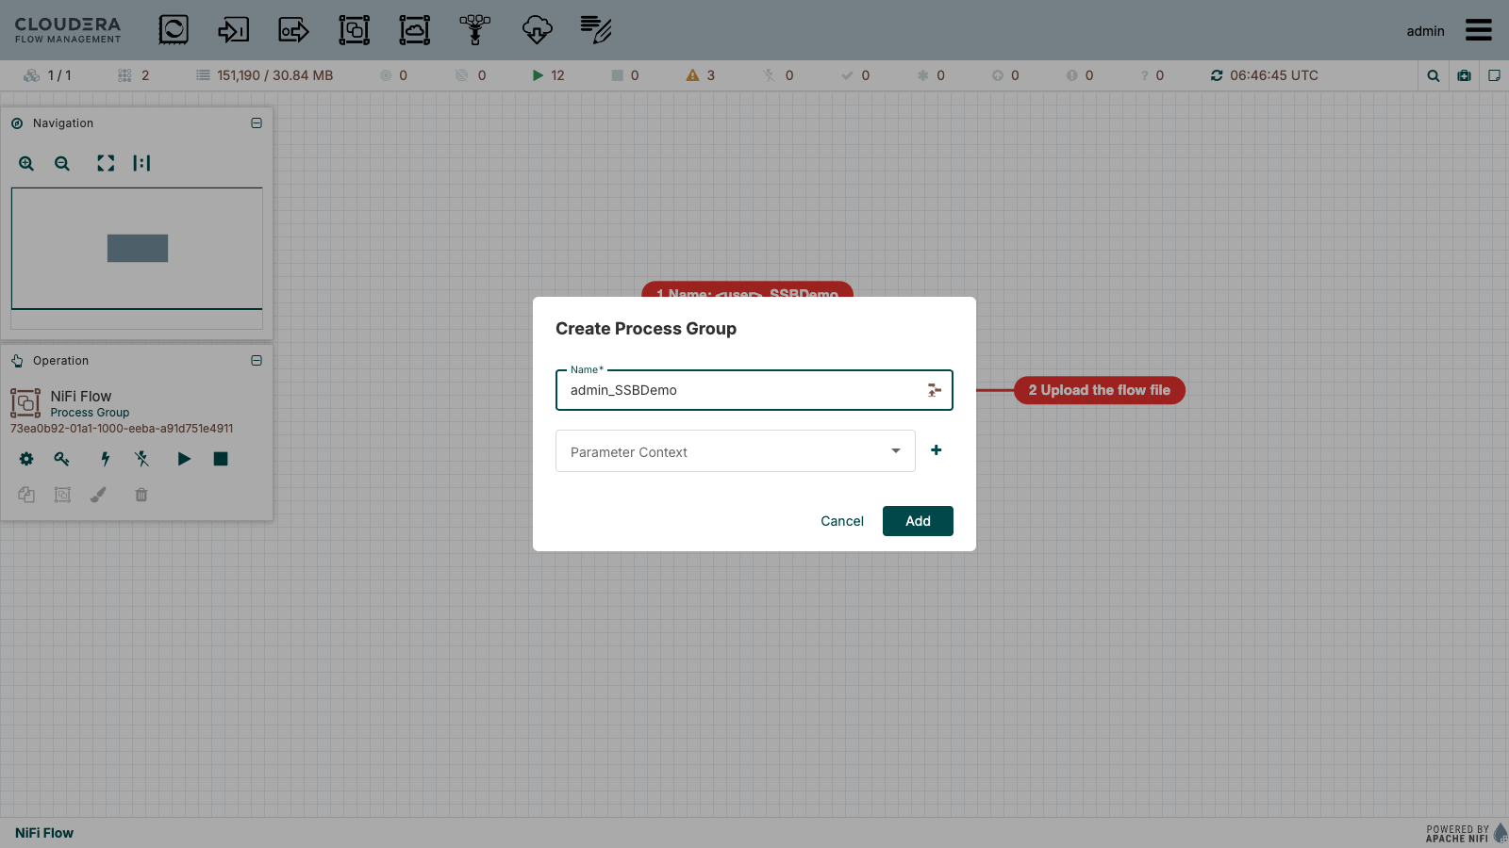
- After the file is attached, set the name to <user_id>_SSBDemo (attaching the file replaces the name with the file name) and click Add.
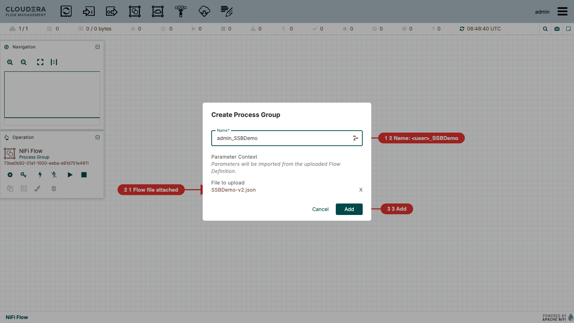
- The process group appears on the canvas. It stays invalid until the parameters are set.
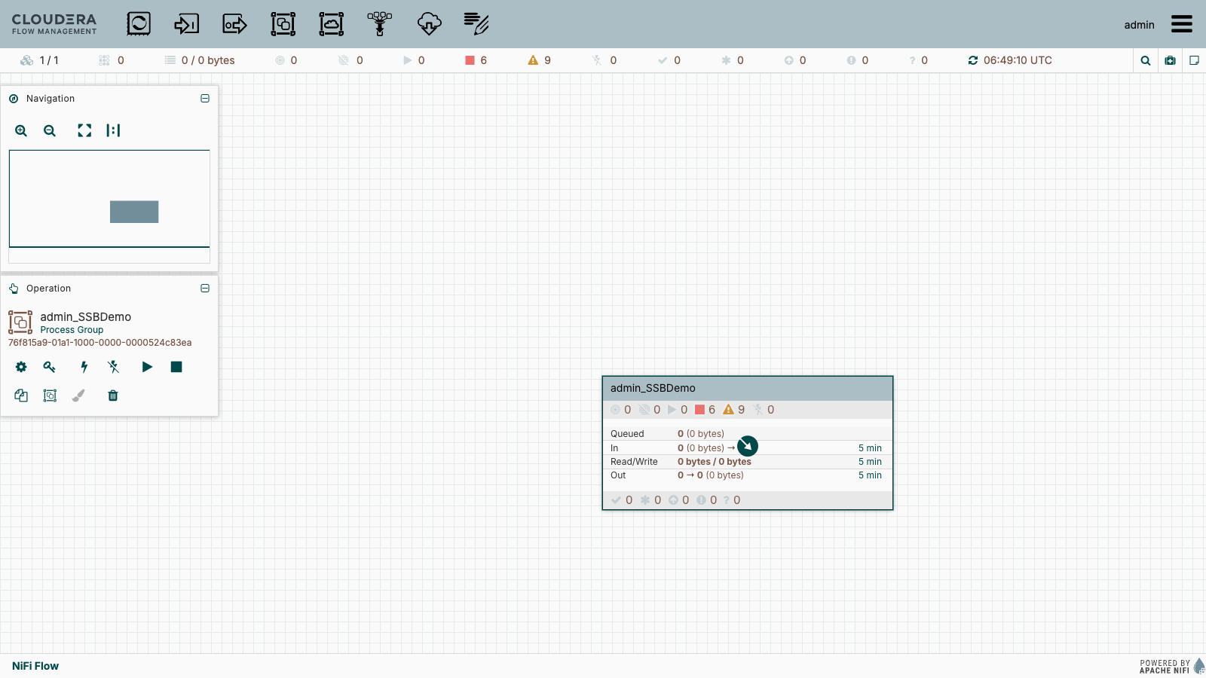

NiFi: set the parameters
- Open the menu (☰, top right) → Parameter Contexts.
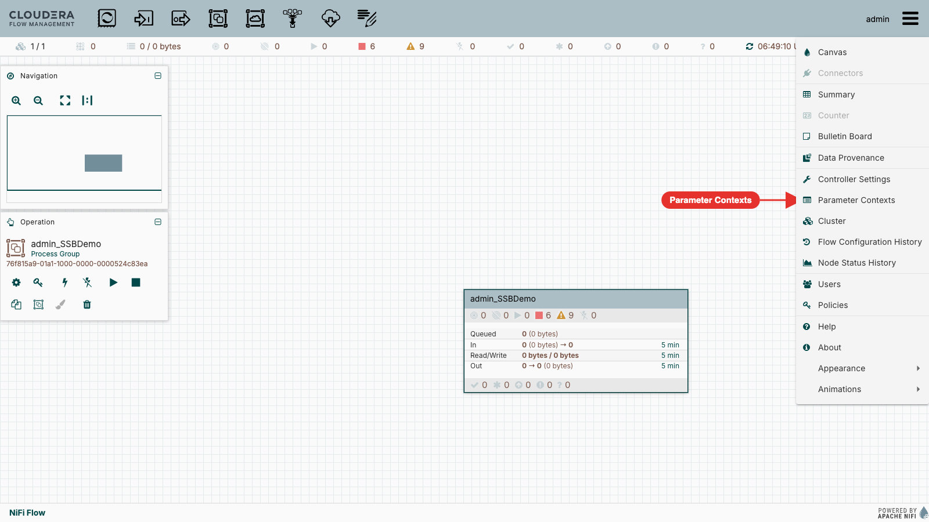
- On lakehouse_hol_params, click ⋮ → Edit, open the Parameters tab and set each value (⋮ → Edit on the parameter):
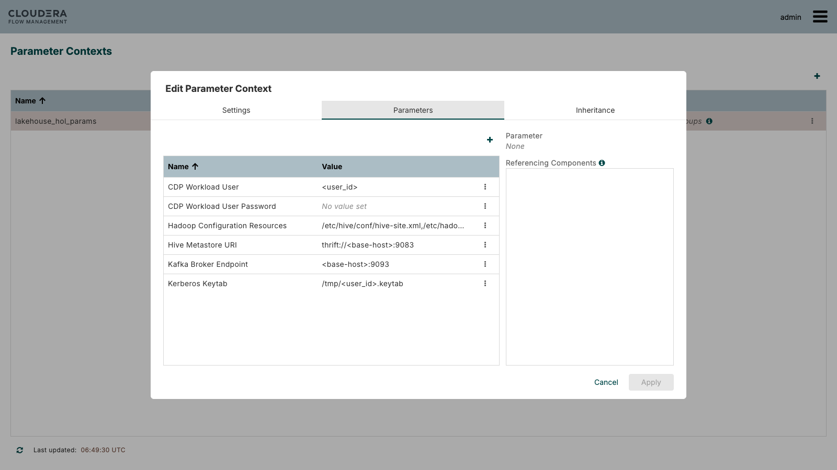
Parameter | Value
CDP Workload User | your user id, e.g. admin
CDP Workload User Password | your password (sensitive)
Hadoop Configuration Resources | /etc/hive/conf/hive-site.xml,/etc/hadoop/conf/core-site.xml,/etc/hive/conf/hdfs-site.xml (keep)
Hive Metastore URI | thrift://<base-host>:9083
Kafka Broker Endpoint | <base-host>:9093
Kerberos Keytab | /tmp/<user_id>.keytab

<base-host> is the cluster base host, for example <prefix>-master-01.internal.cloudera-labs.com (jsmith-ce-master-01.internal.cloudera-labs.com for the prefix jsmith-ce). Click Apply.
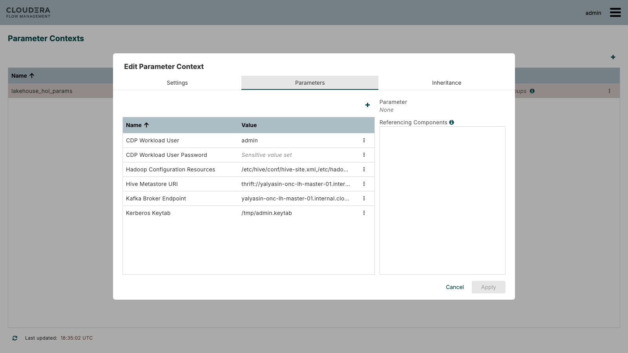
Note: If several users share the cluster, each user imports the flow into their own process group with their own parameter context (create a new one from the process group's Parameters menu) so the values do not collide.

NiFi: enable the services and start the flows
- Double-click the <user_id>_SSBDemo process group. Right-click an empty part of the canvas → Enable All Controller Services.
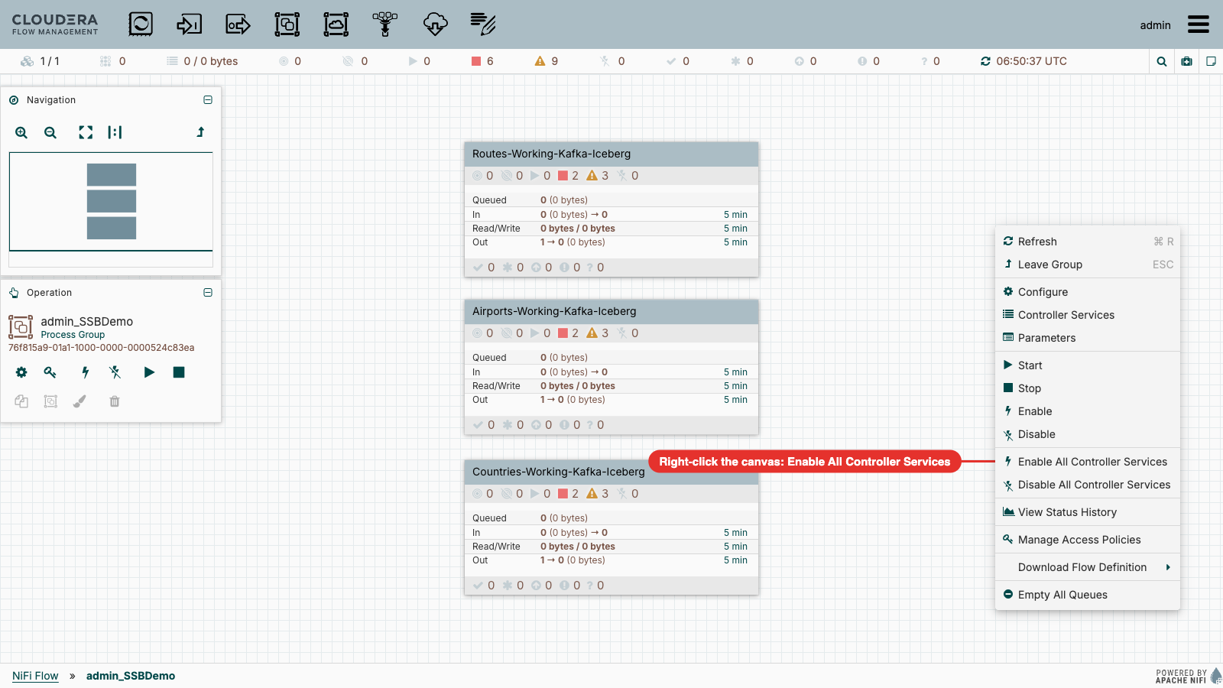
- Right-click the canvas again → Start. (v1.1 asked you to set the SSL Context Service on each PublishKafka processor: the v2 flow already has it.)
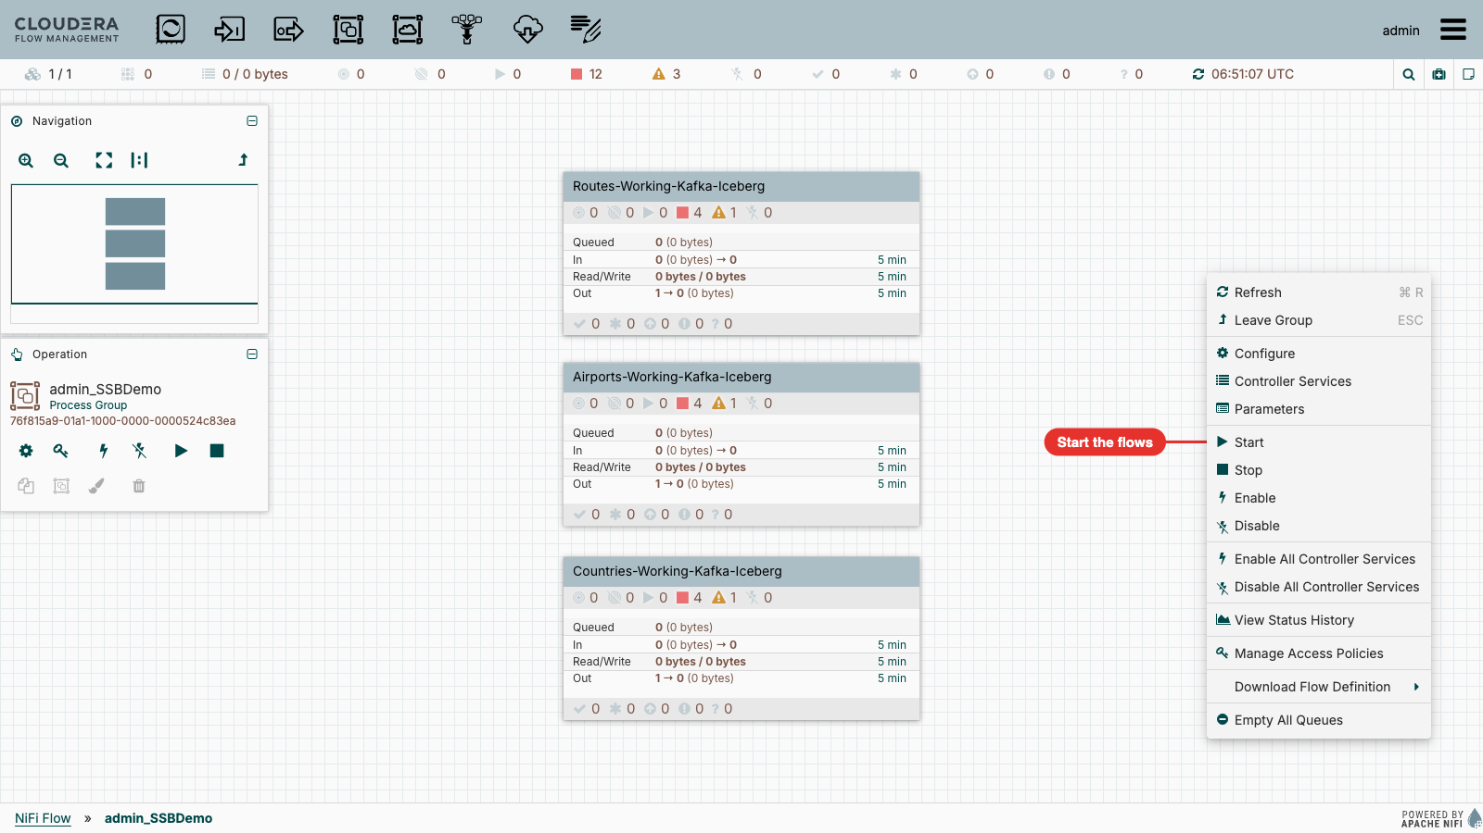
- Data flows within a minute. Open each process group to watch the queues; nothing should go to the failure relationships.
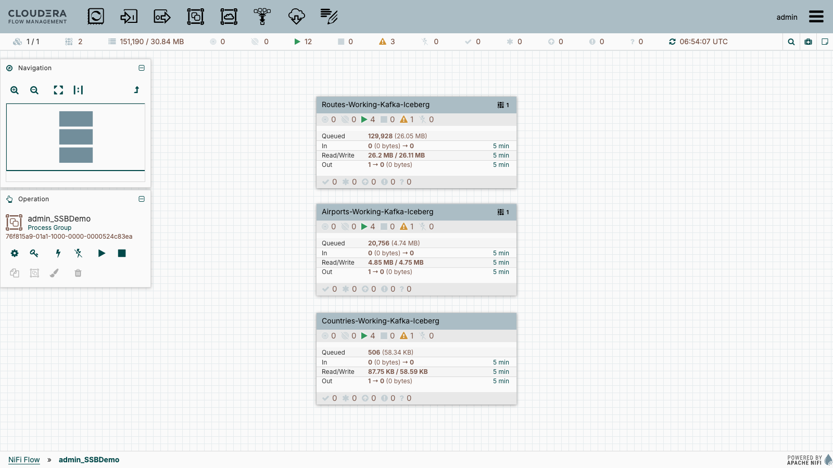
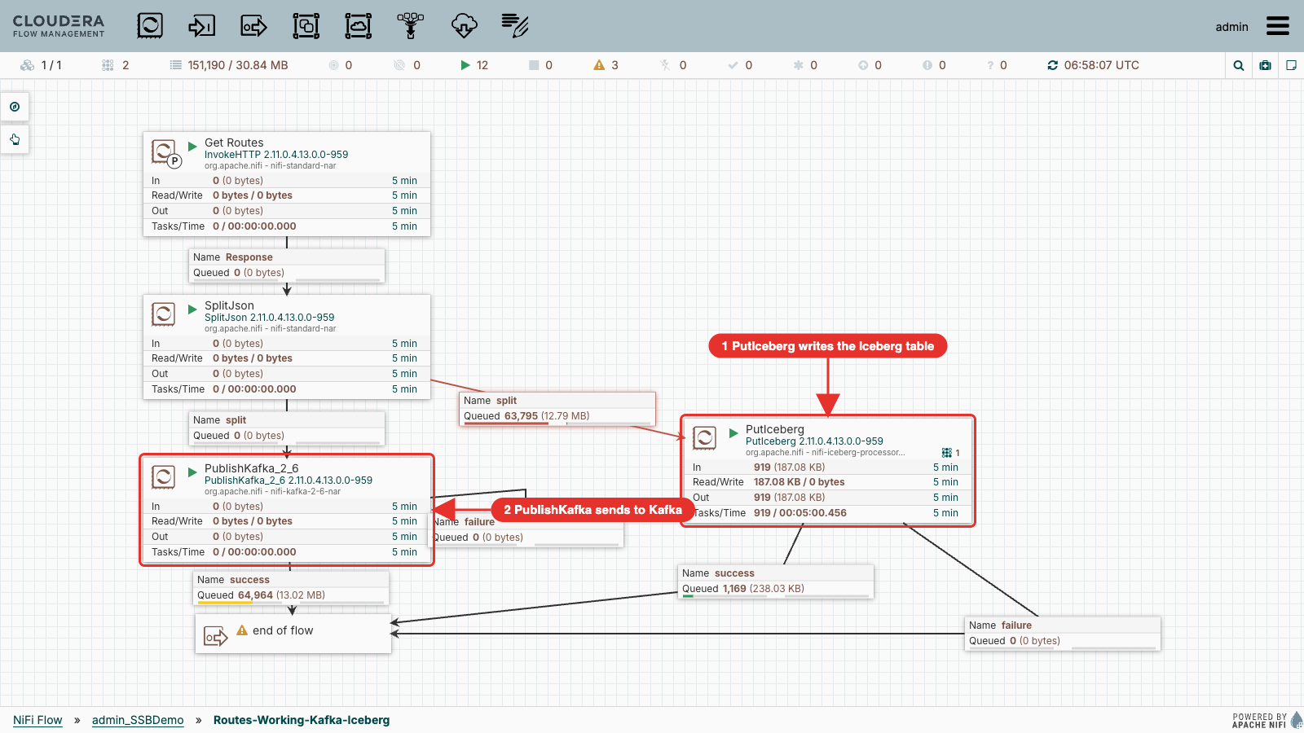
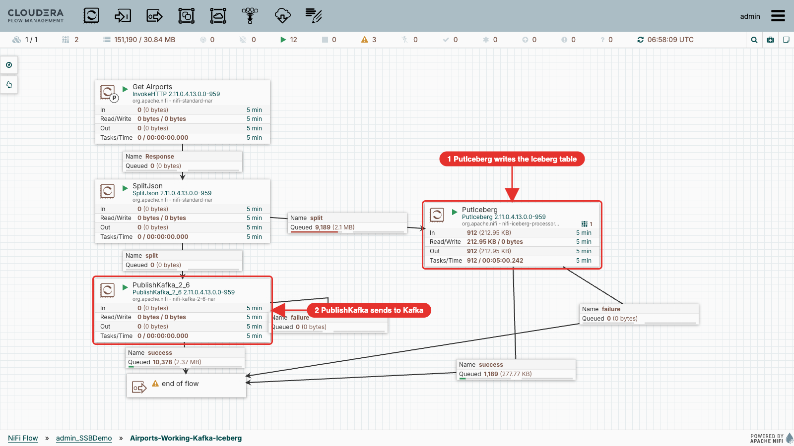
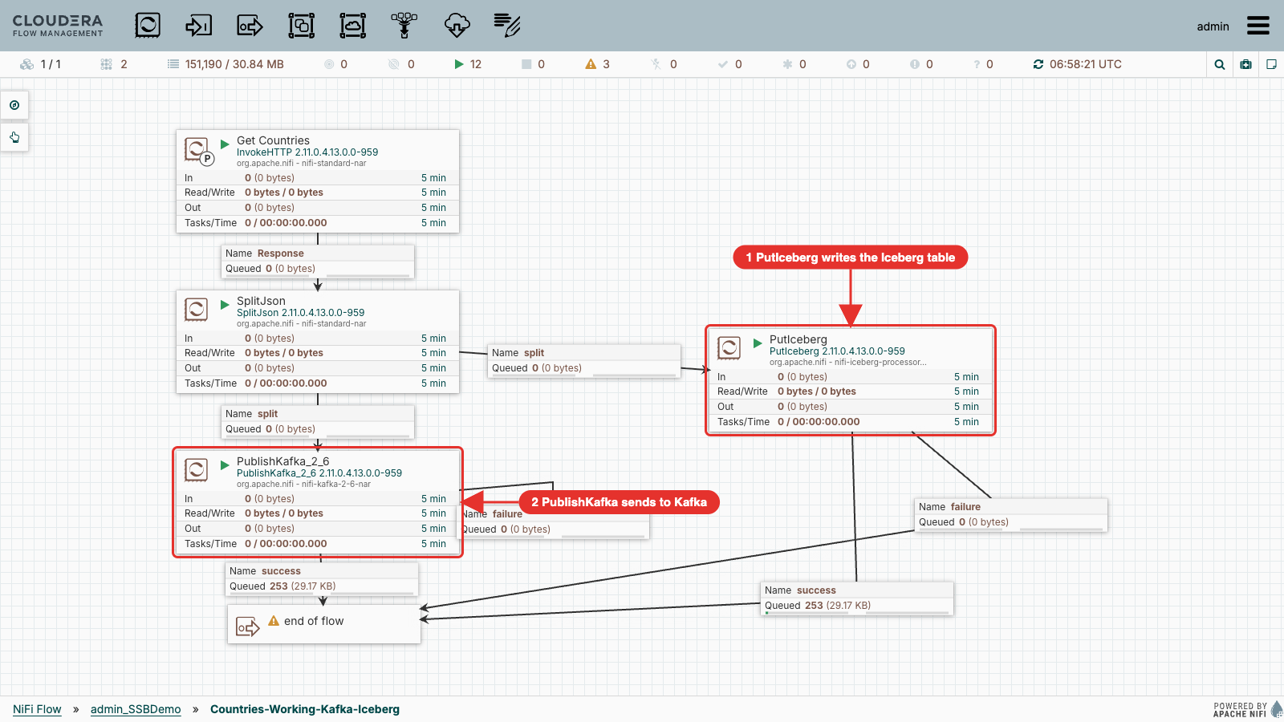
Note: PutIceberg commits in small batches: the Iceberg tables fill over a few minutes, while Kafka receives every record almost at once. The warning on "end of flow" is only the unconnected output port.

Inspect the NiFi Iceberg tables
In the Hue Impala editor:
SELECT * FROM ${user_id}_airlines.`routes_nifi_iceberg`;
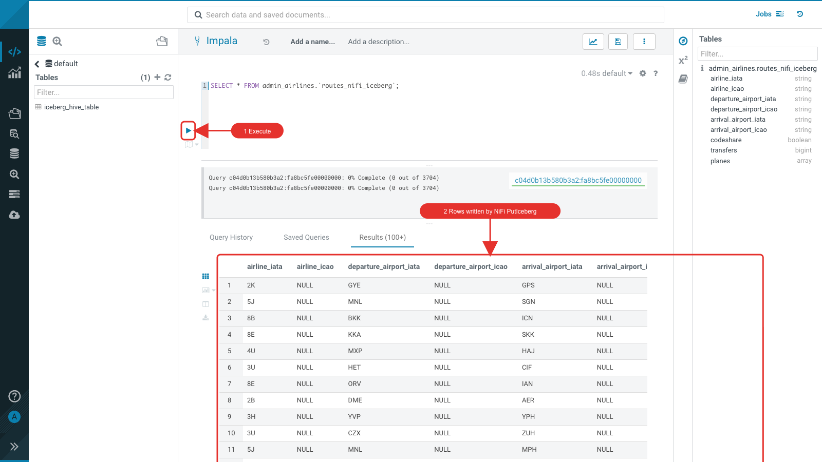
SELECT * FROM ${user_id}_airlines.`airports_nifi_iceberg`;
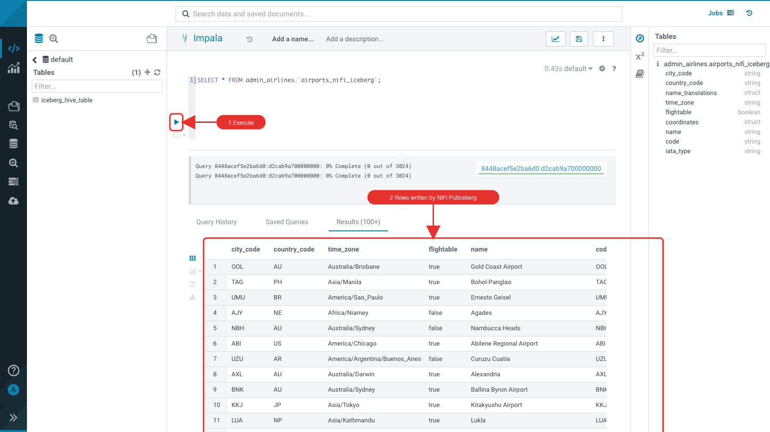
select * from ${user_id}_airlines.countries_nifi_iceberg;
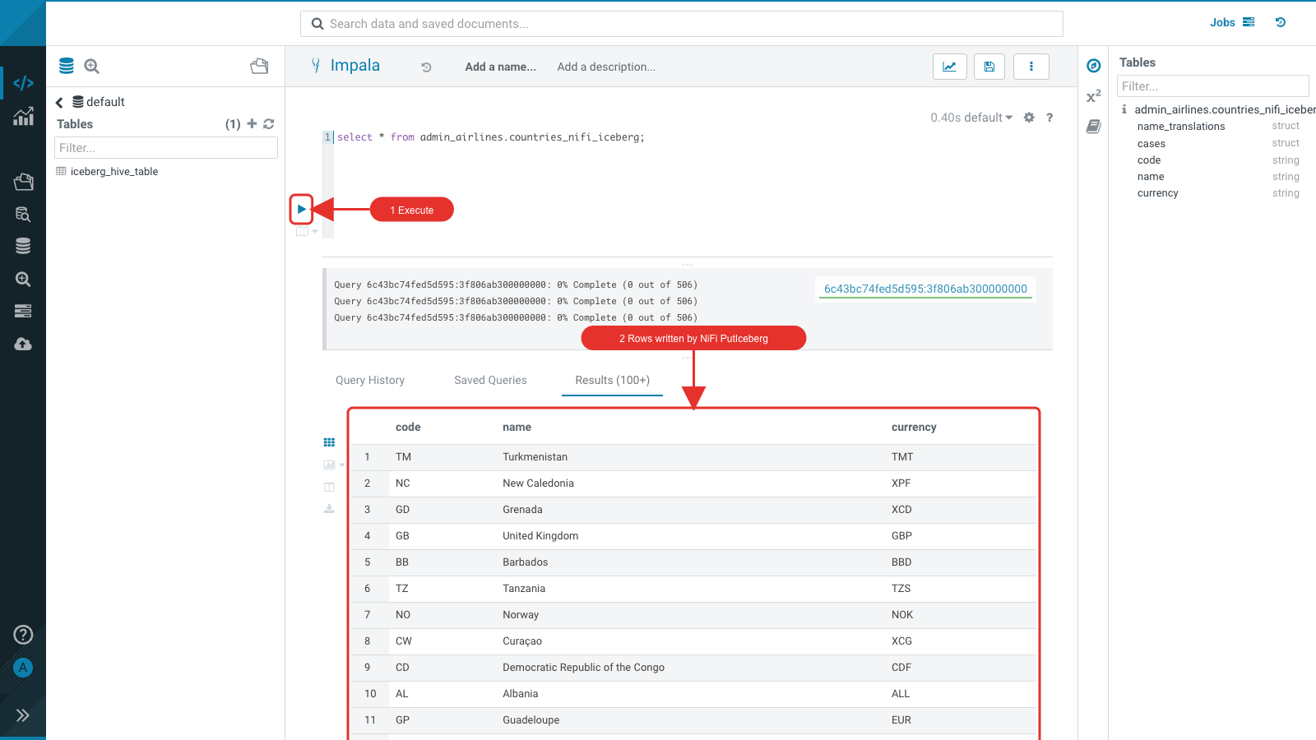

SQL Stream Builder: import the project
Open SSB (SQL Stream Builder) from the Knox homepage. Do not create a new project: import it from GitHub in one step.
- Click Import. Clone URL https://github.com/ylysn/lakehouse-workshop, branch main, project SSB-Iceberg-Demo, authentication off. Click Import.
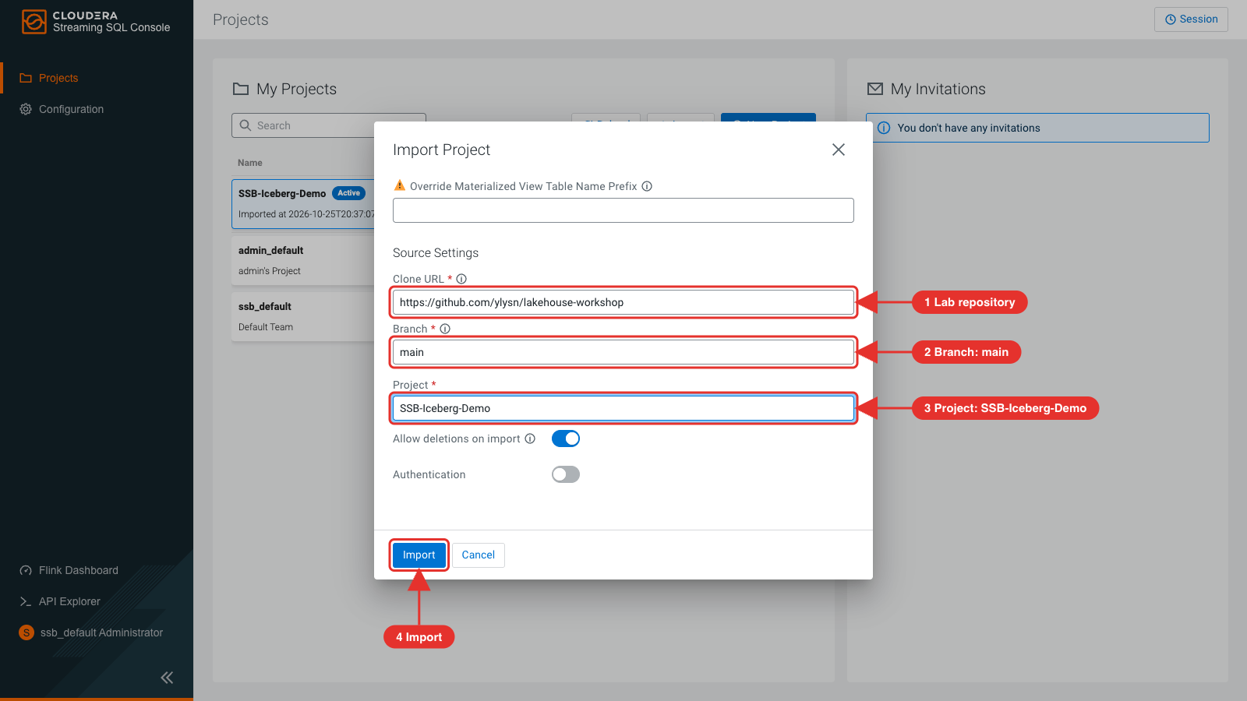
- The summary lists the data source (Hive catalog), 3 virtual tables, 6 jobs and an API key.
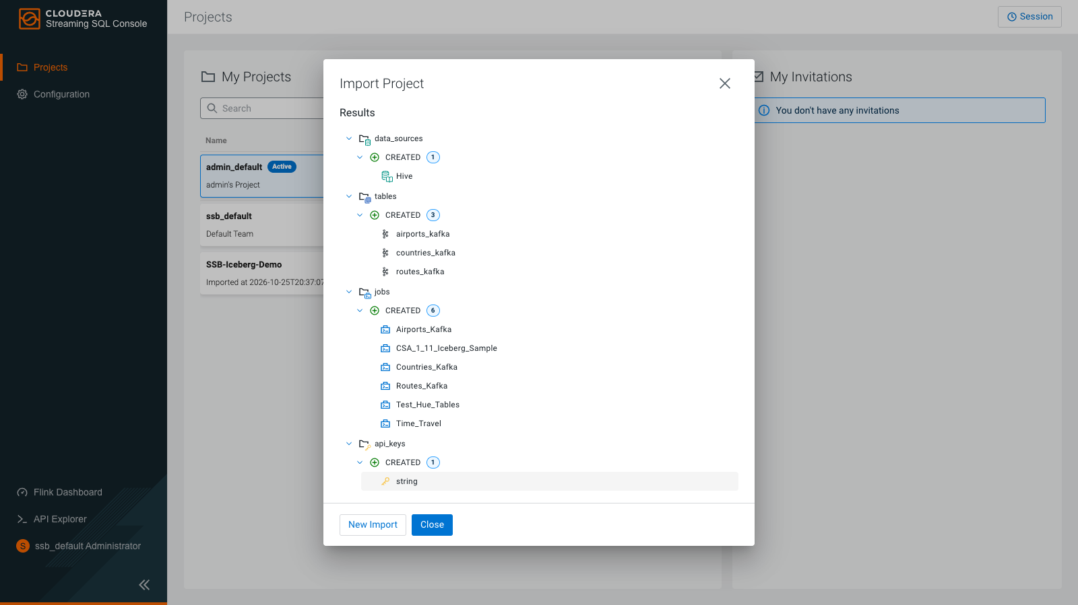
- Click Switch on SSB-Iceberg-Demo and confirm.
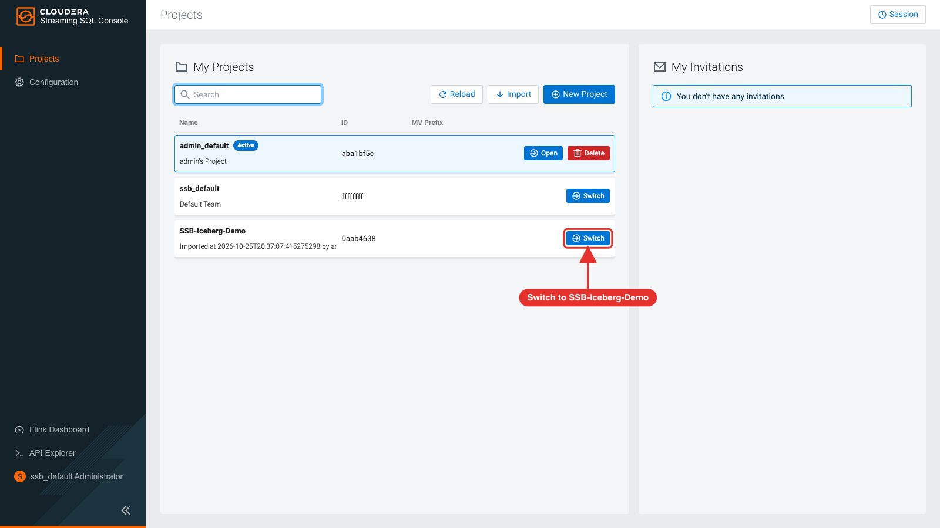
Note: Only one user can import a project with this name per cluster. Other users either get invited to the project (Members), or fork the repository and import it under their own project name.

SQL Stream Builder: unlock your keytab and set your environment
- The project page asks you to unlock your keytab. Click unlock your keytab.
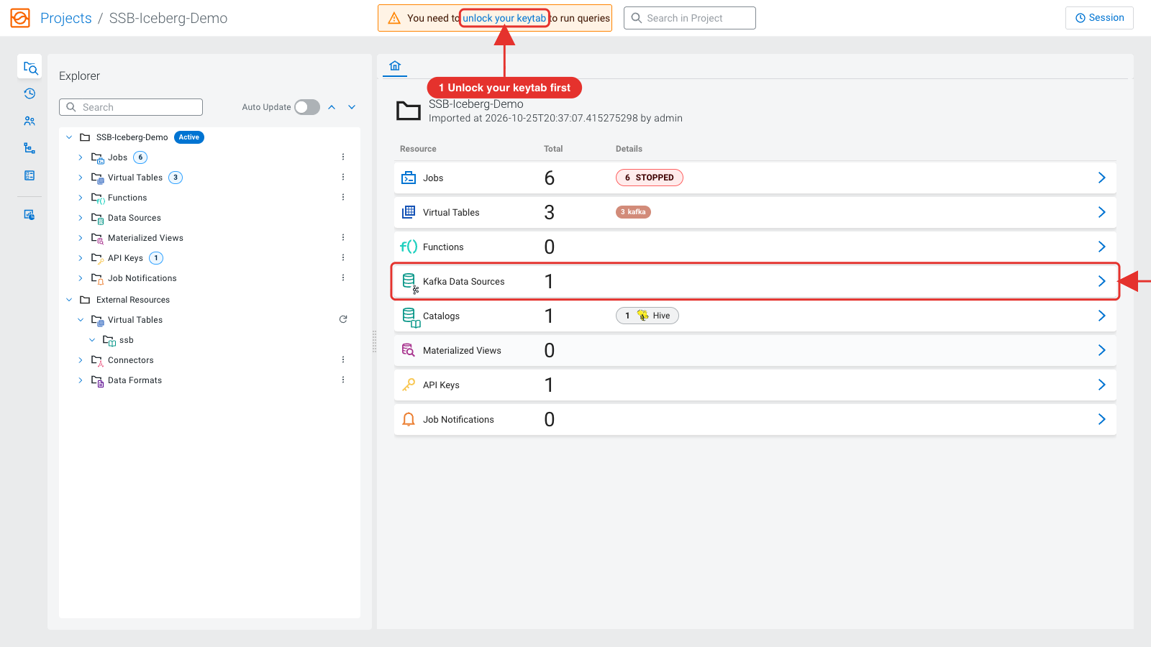
- Enter your user id as Principal Name and your password, then click Unlock Keytab. (Uploading a keytab also works, but is not needed.)
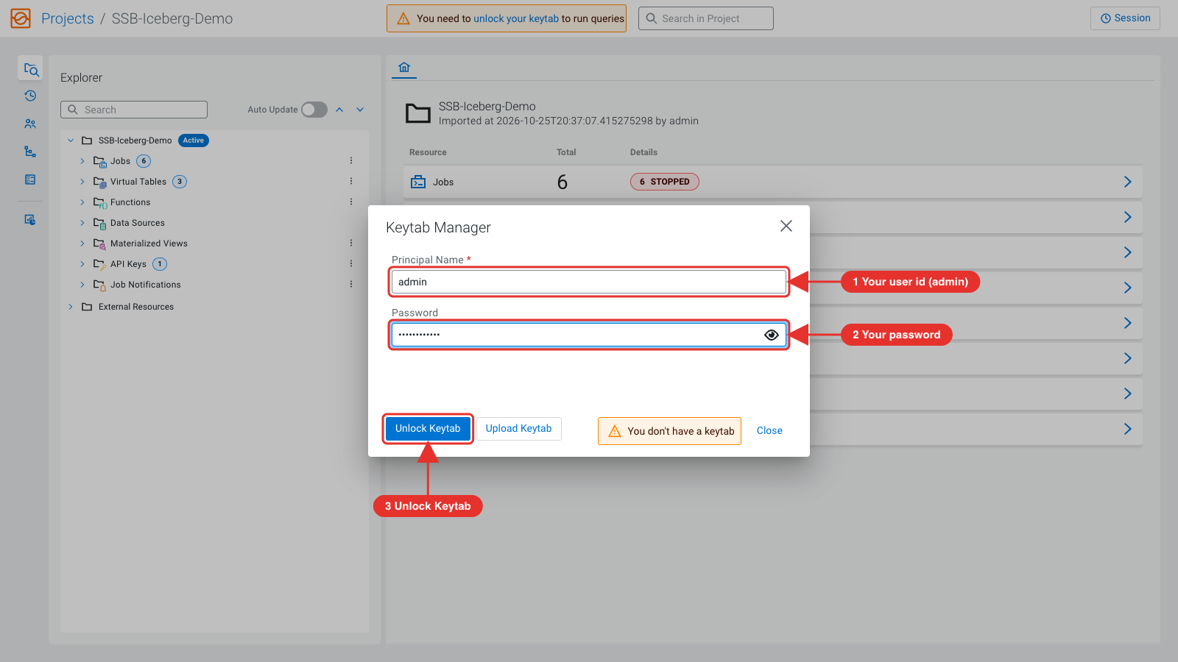
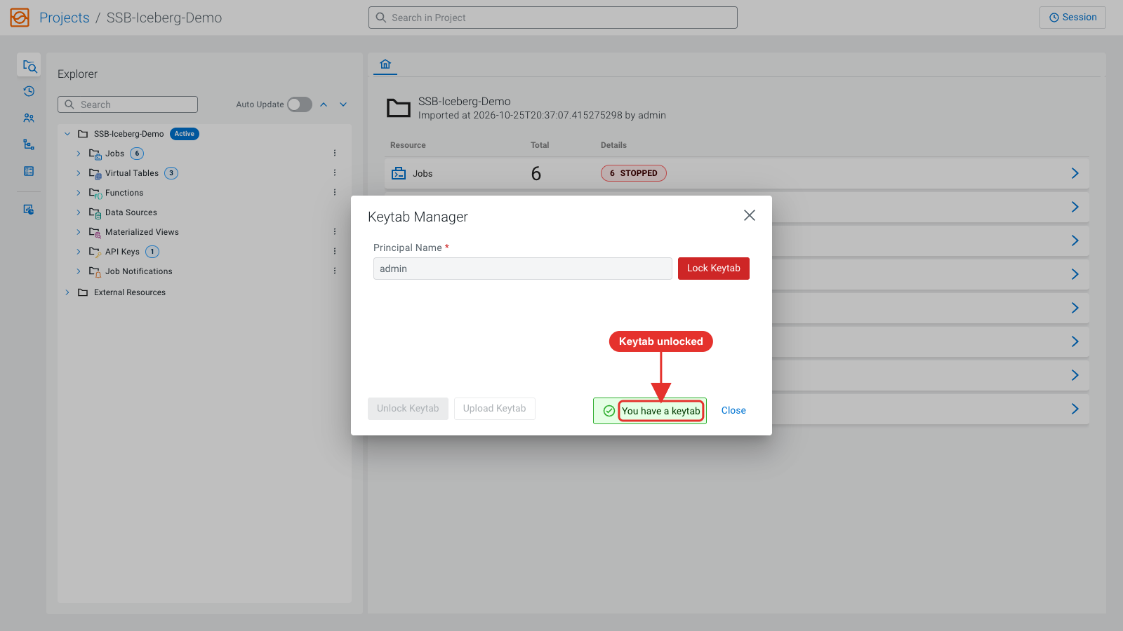
- Open Environments (left bar) → New Environment. Name it <user_id>_env, add the key userid with your user id as value, click Add, then Create.
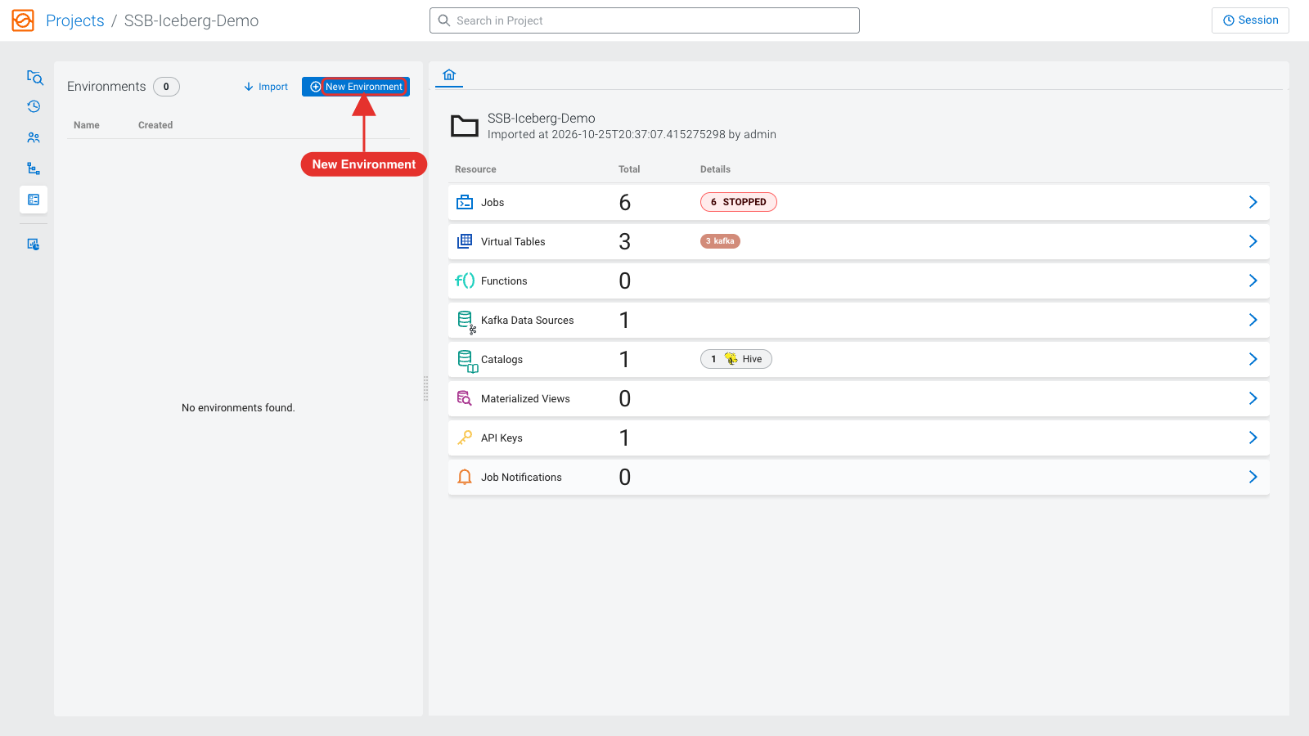
The jobs refer to your database as ${ssb.env.userid}_airlines: SSB replaces ${ssb.env.userid} with the value of the userid key in your active environment. For example, user user01 creates the environment user01_env with key userid and value user01, so the jobs write to user01_airlines. The screenshot uses admin, which writes to admin_airlines.
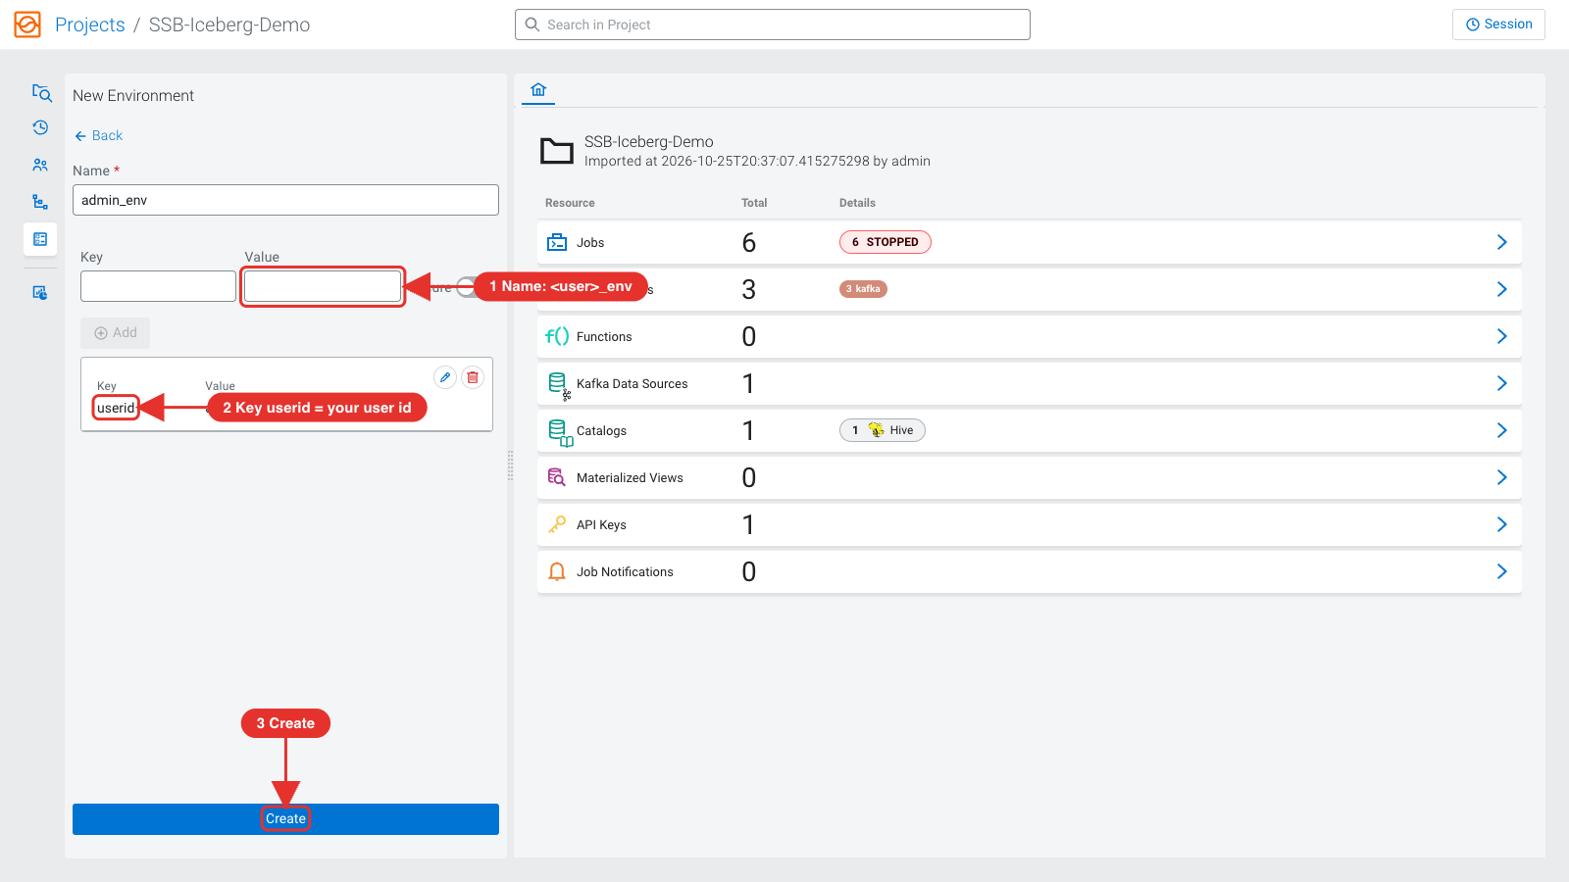
- Click Activate and confirm. The environment name shows next to the project name.
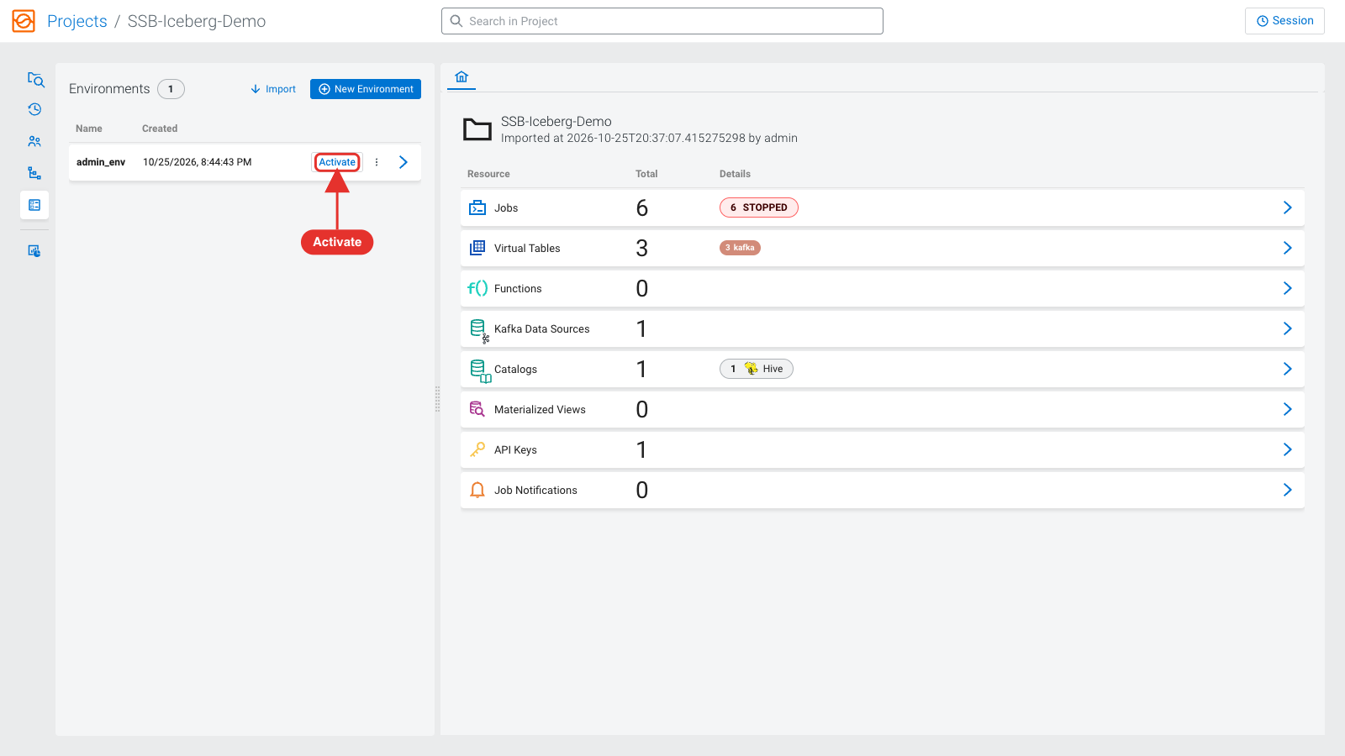
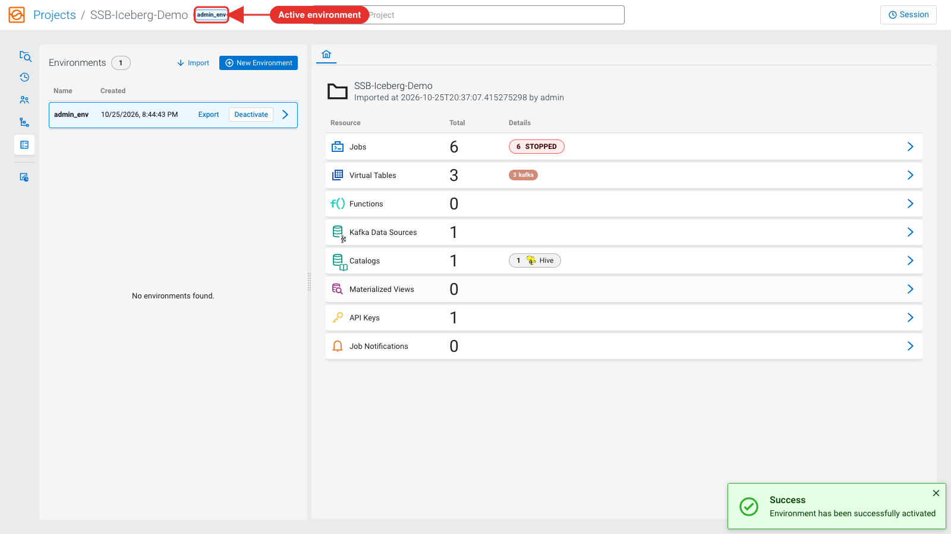

SQL Stream Builder: data sources and virtual tables
The Local Kafka data source points at the cluster's Kafka (SASL_SSL with Kerberos). It is already there: you do not need to create a Kafka data source.
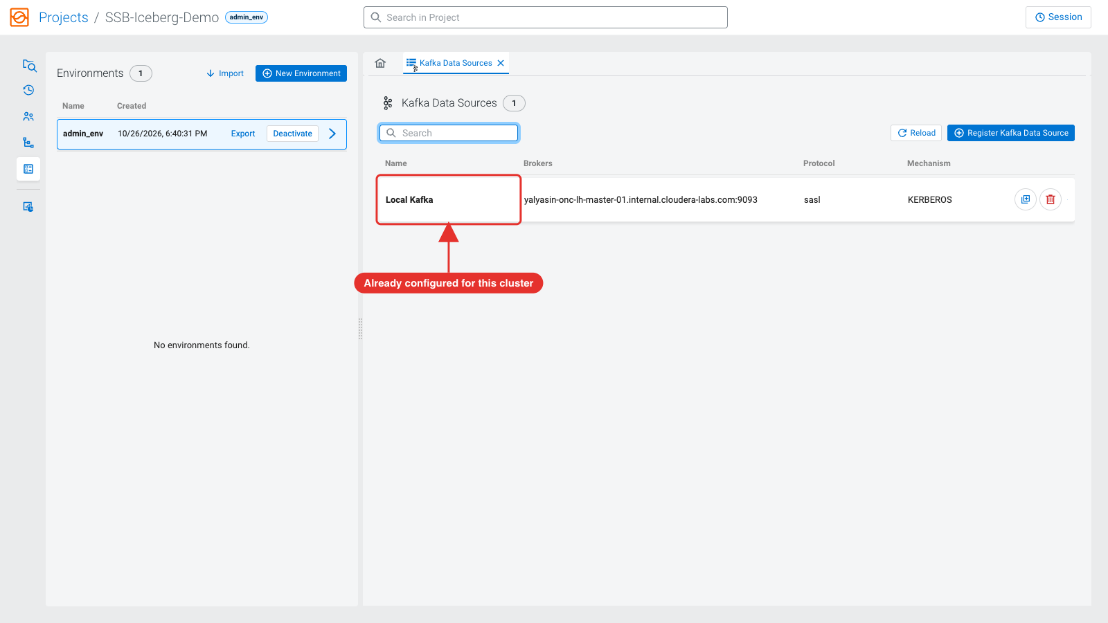
- In the Explorer, open Virtual Tables → airports_kafka. Select the topic <user_id>_airports (written by your NiFi flow) under Topic Name.
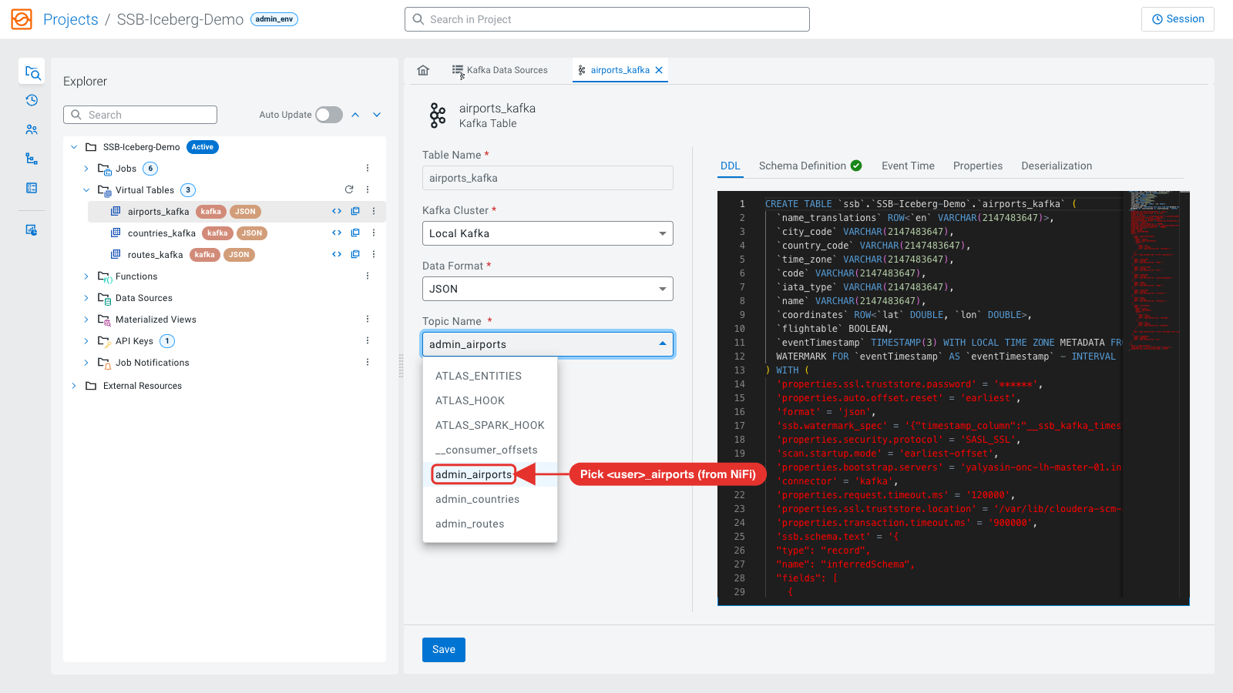
- SSB detects the schema from the topic. Click Save.
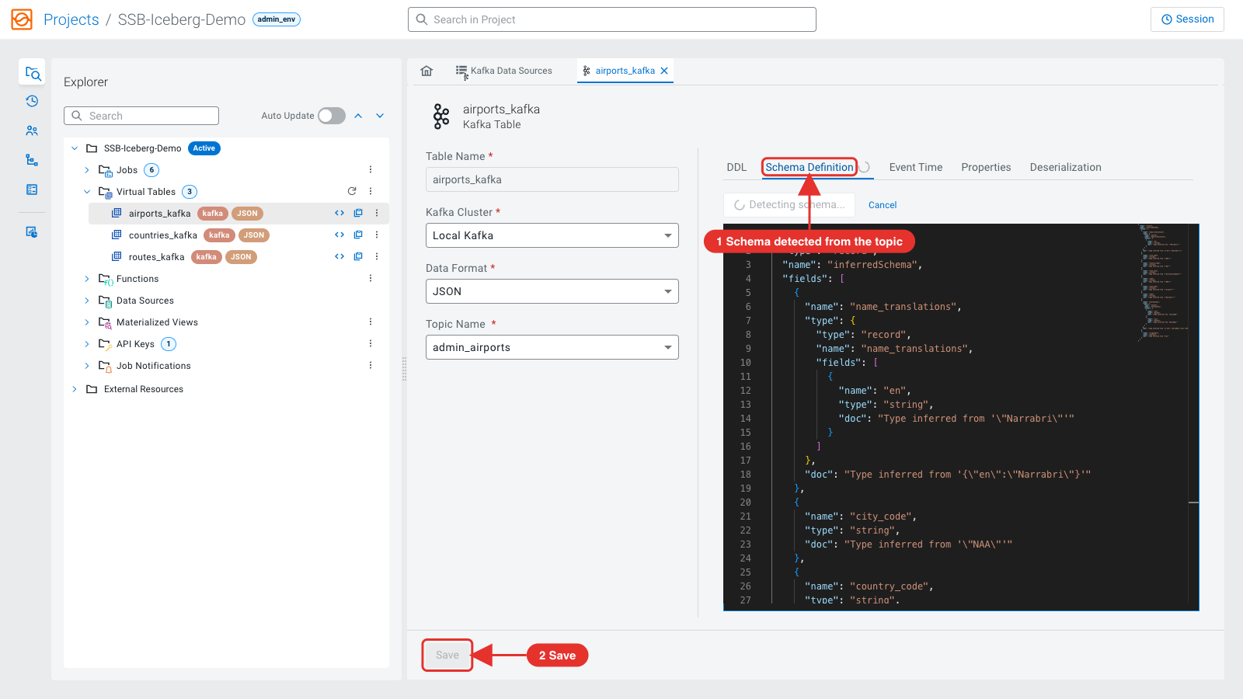
- Repeat for countries_kafka (<user_id>_countries) and routes_kafka (<user_id>_routes).
Note: If Detect Schema reports "Record value is empty", the topic holds an empty message: close the message and keep the imported schema, which already matches the data. Wait for the detection to finish before you click Save.

SQL Stream Builder: run the jobs
Run the statements of each job one at a time: select a statement and click Execute Selection. Do not run a whole job at once.
- Open the job Airports_Kafka. Select SELECT * FROM airports_kafka; and click Execute Selection. The first job of a session can take 1-2 minutes to show results.
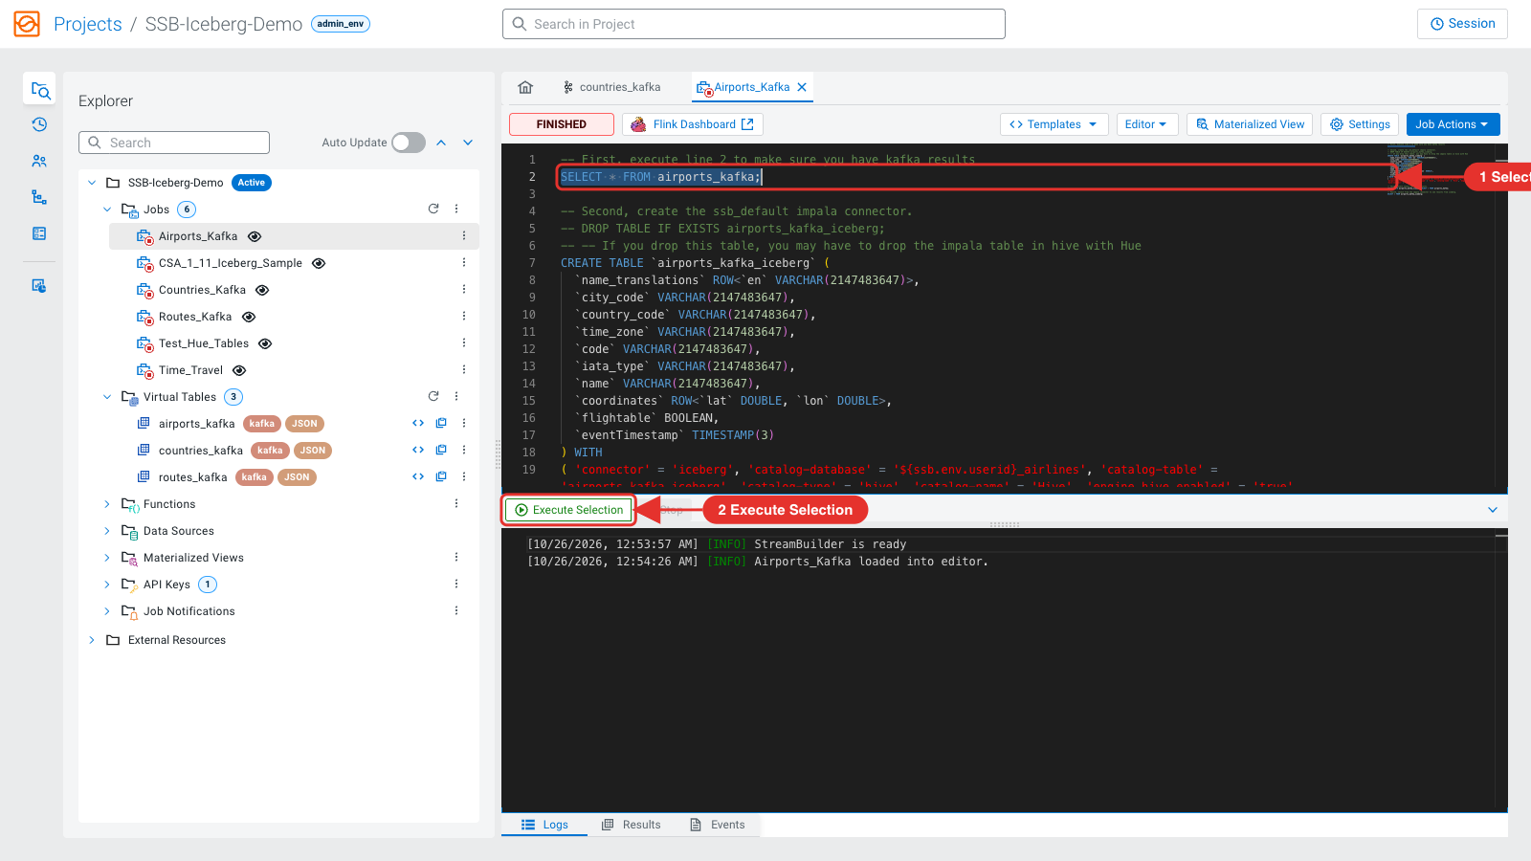
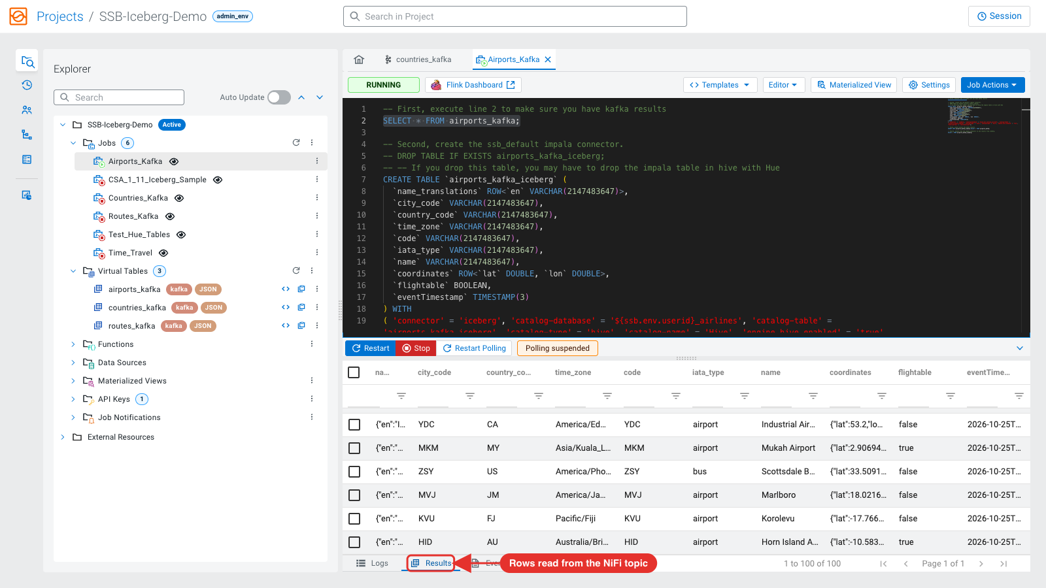
- Stop the job. Select the CREATE TABLE airports_kafka_iceberg statement and execute it: it creates the Iceberg connector (a virtual table in SSB; the Impala table is created by the next step).
- Select the INSERT INTO airports_kafka_iceberg SELECT * FROM airports_kafka; statement and execute it. This is a streaming job: it keeps writing Kafka records to the Iceberg table, committing every 30 seconds.
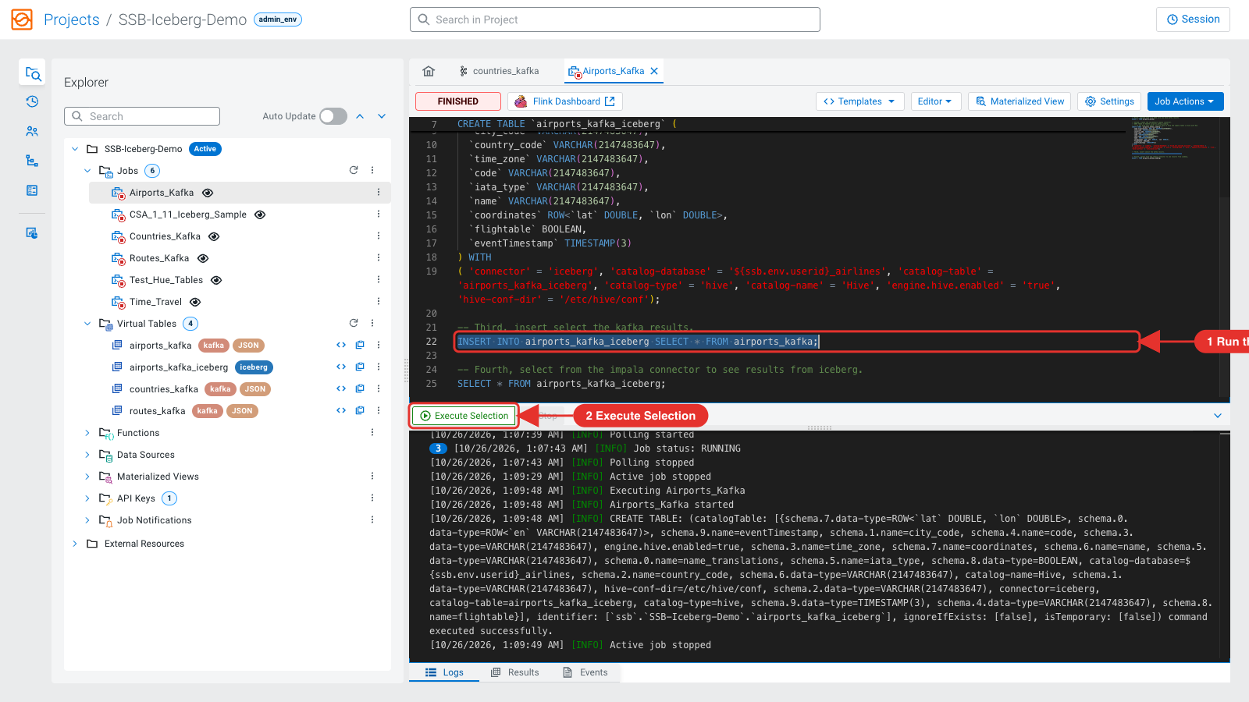
- After a minute, run the last select (from the Iceberg table) or query the table in Hue. Then Stop the job.
- Do the same with Countries_Kafka and Routes_Kafka, stopping each job when you are done.
- CSA_1_11_Iceberg_Sample creates a table in default, inserts one row and reads it back. Test_Hue_Tables reads the flights_iceberg table created by Impala in the setup.
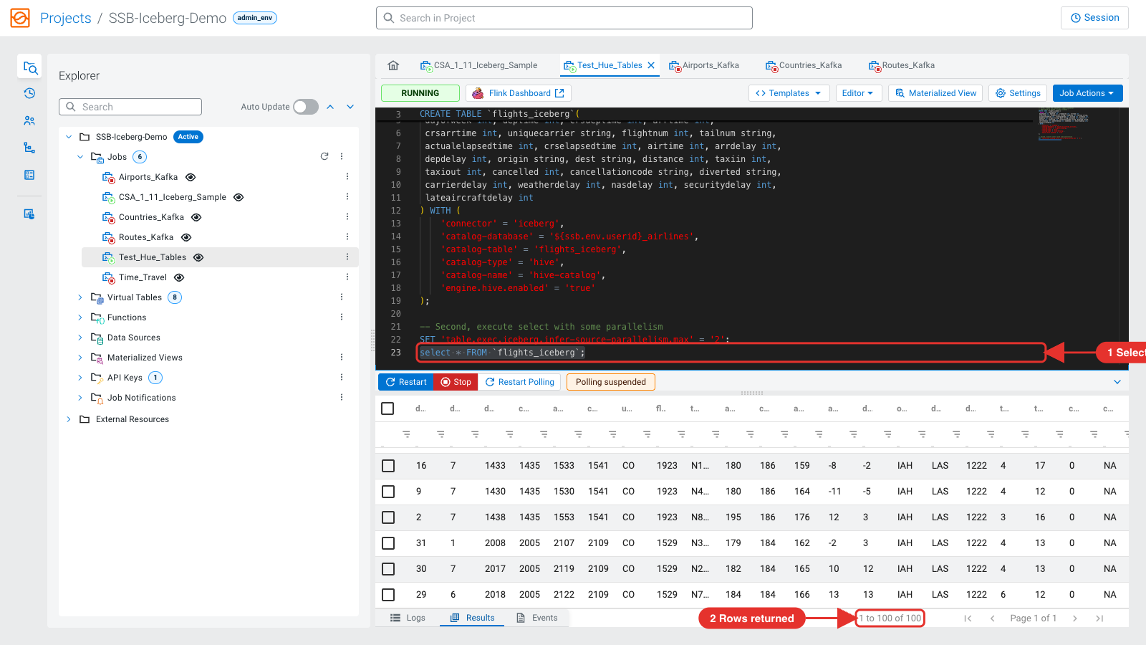
Warning: Stop every SSB job when you finish with it. Running jobs keep their Flink slots; on the single-host lab cluster new jobs then wait for a slot and show "No Results".

Inspect the SSB Iceberg tables
select * from ${user_id}_airlines.airports_kafka_iceberg;
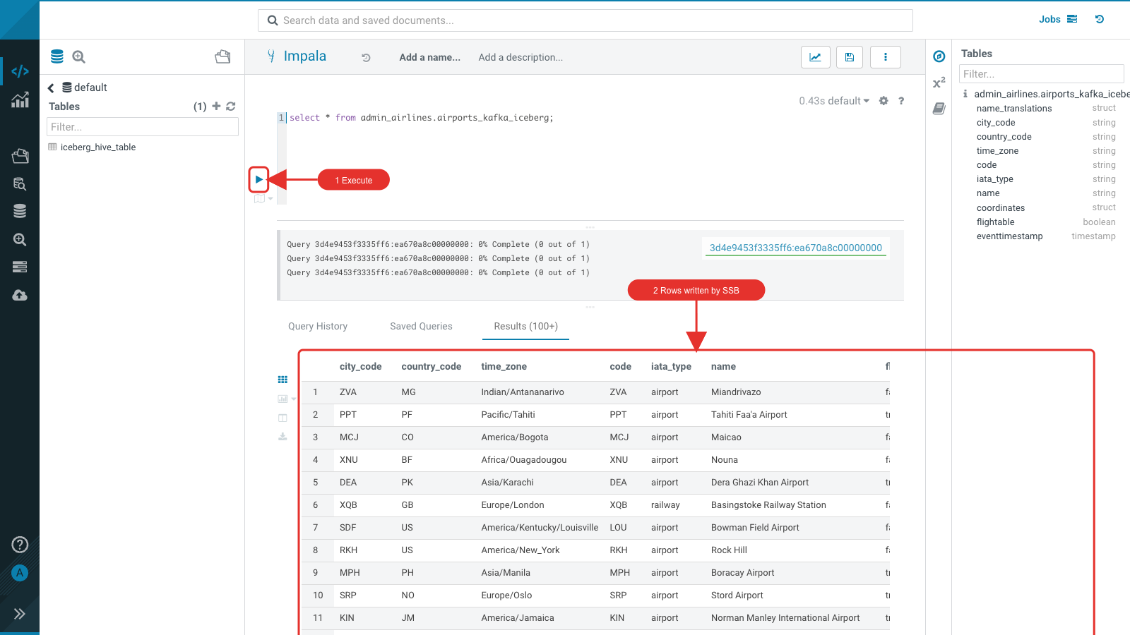
select * from ${user_id}_airlines.countries_kafka_iceberg;
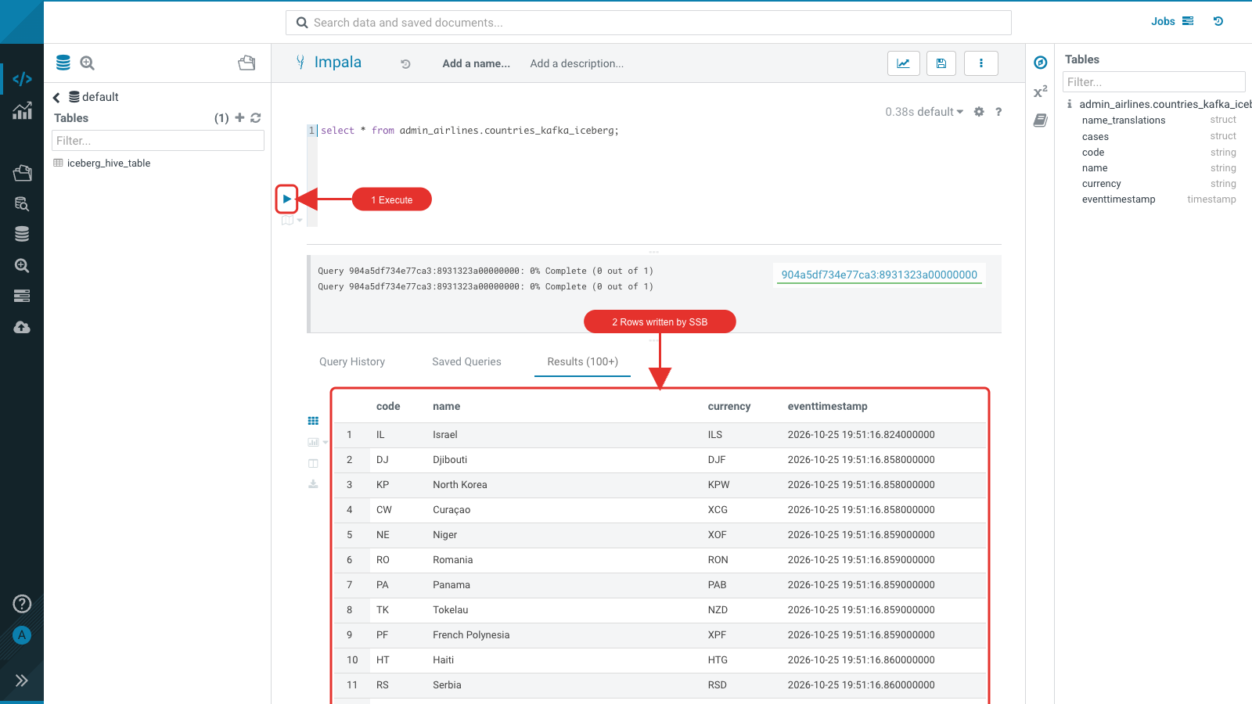

Lab 2 - Spark (Multi-function Analytics)
Iceberg is engine agnostic: the tables you created with Impala are now processed with Spark 3. Connect to the cluster host. Set your user id once in the shell (the commands below and every Spark statement use it), get a Kerberos ticket and start pyspark3 (Spark 3.5.8, Python 3.11):
export USERNAME=admin # your user id
kinit $USERNAME
pyspark3
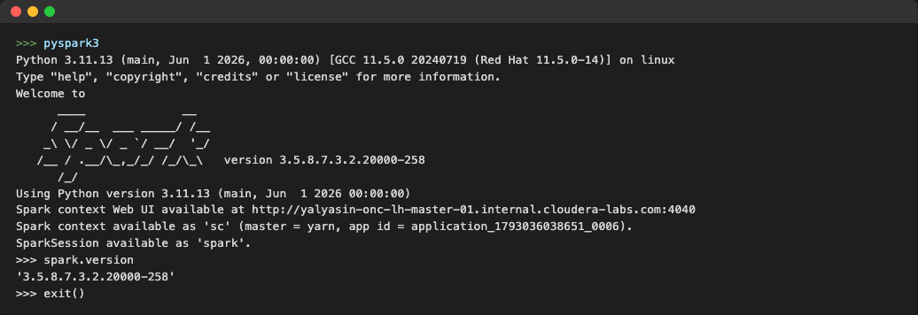
Every Spark step in this lab returns within seconds; all of them together take about 3 minutes.
Note: Spark needs an HDFS home directory for your user (/user/<user_id>). hol-setup.sh creates it for the users you pass. Without it Spark fails with "Permission denied: user=<user_id>, access=WRITE, inode=\"/user\"".
At the >>> prompt, read your user id from the shell, so every statement below can be pasted as is:
import os
USERNAME = os.environ["USERNAME"]

Migrate existing tables to Iceberg
Create a copy in Iceberg format (CTAS). This works for any Hive table, including ACID (transactional) tables:
spark.sql(f"CREATE EXTERNAL TABLE {USERNAME}_airlines.planes_de USING ICEBERG TBLPROPERTIES('format-version'='2') AS SELECT * FROM {USERNAME}_airlines.planes").show()
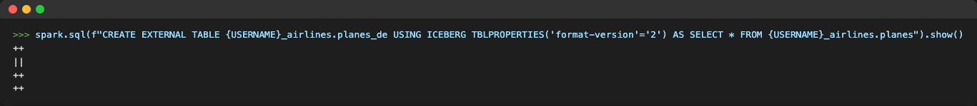
You would normally drop the original Hive table now (do not run it; next you migrate the same table in place):
spark.sql(f"DROP TABLE {USERNAME}_airlines.planes").show()
Migrate in place. The data files stay where they are; only Iceberg metadata is written. This works for non-transactional tables. First check the format of planes:
spark.sql(f"DESCRIBE FORMATTED {USERNAME}_airlines.planes").show(100)
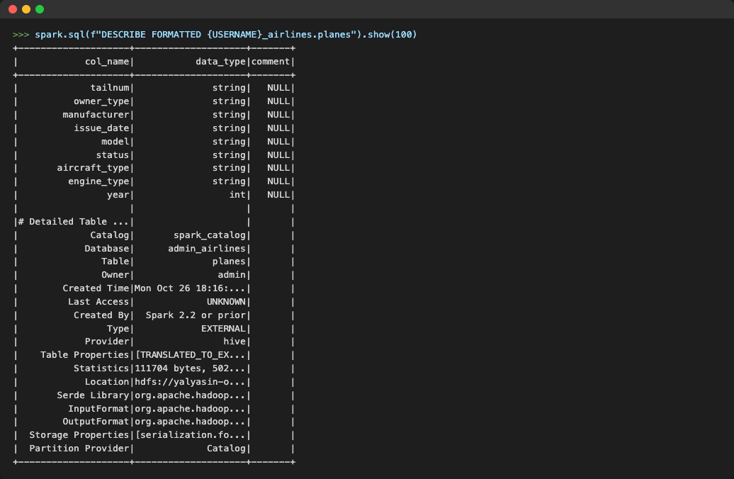
spark.sql(f"CALL spark_catalog.system.migrate('{USERNAME}_airlines.planes', map('format-version','2'))").show()
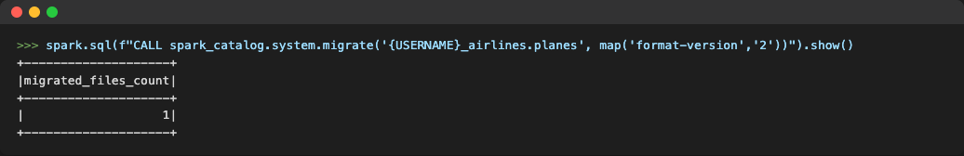
spark.sql(f"DESCRIBE FORMATTED {USERNAME}_airlines.planes").show(100, False)
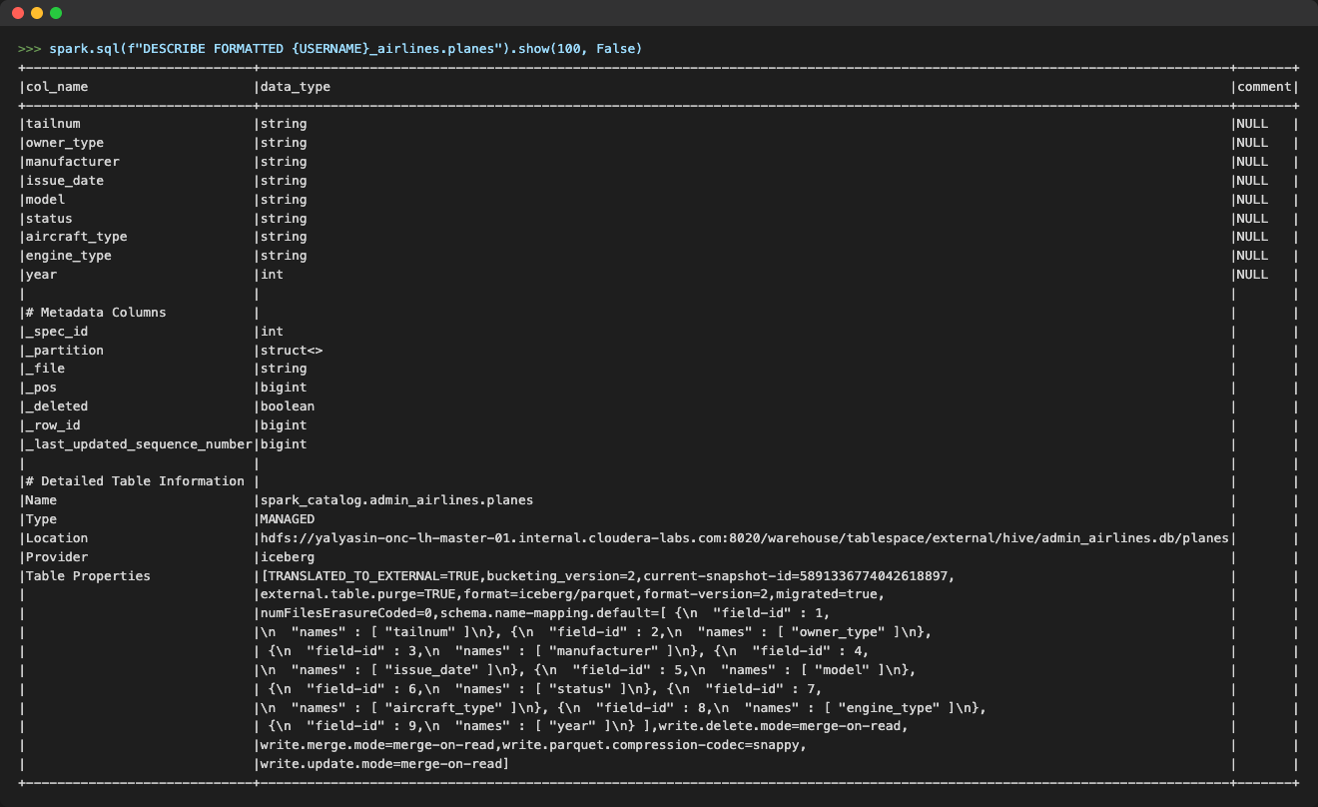
Note: migrate keeps the original table as <table>_backup_. Drop it before you migrate a table with the same name again.

Query the Iceberg tables
spark.sql(f"SELECT * FROM {USERNAME}_airlines.planes LIMIT 20").show()
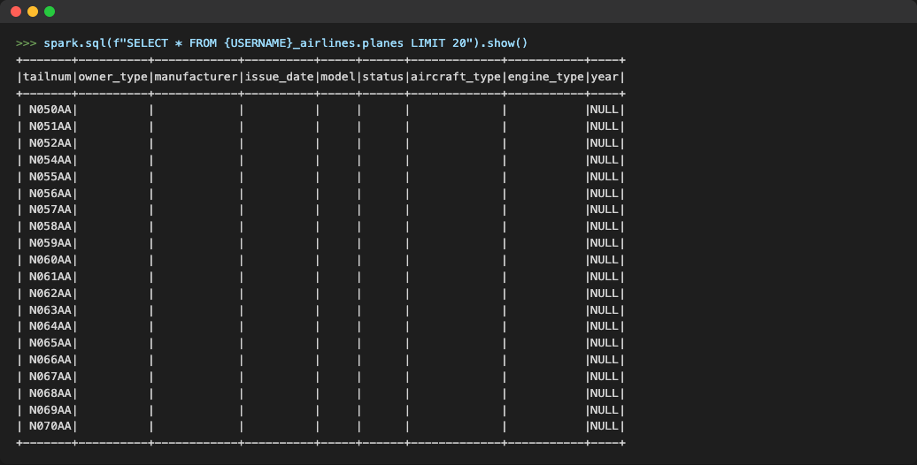
The first rows have mostly empty columns. Qualify the query:
spark.sql(f"SELECT * FROM {USERNAME}_airlines.planes_de WHERE year > 2000 LIMIT 20").show()
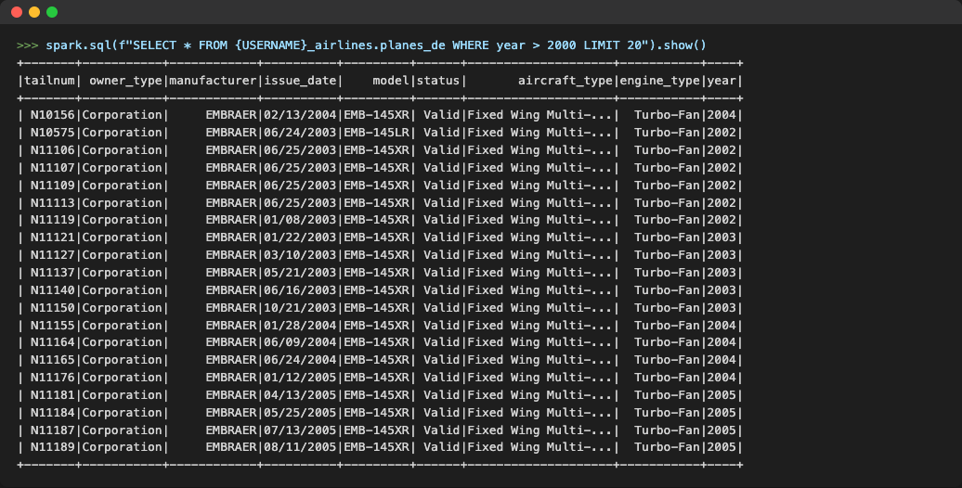

Create and load an Iceberg table
spark.sql(f"CREATE EXTERNAL TABLE {USERNAME}_airlines.airlines_de (code string, description string) USING ICEBERG TBLPROPERTIES ('format-version' = '2')").show()
spark.sql(f"SELECT * FROM {USERNAME}_airlines.airlines_de limit 20").show()
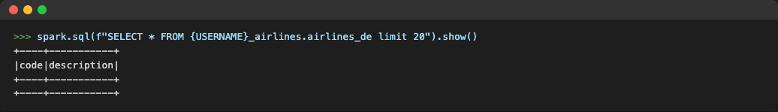
spark.sql(f"INSERT INTO {USERNAME}_airlines.airlines_de SELECT * FROM airlines_csv.airlines_csv").show()
spark.sql(f"SELECT * FROM {USERNAME}_airlines.airlines_de WHERE code ='UA'").show()
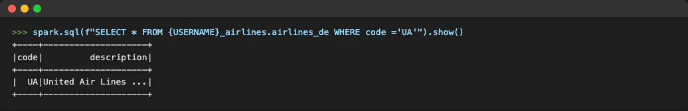

ACID: MERGE
Rename United Airlines to "Adrenaline Airways" with an ACID MERGE:
spark.sql(f'MERGE INTO {USERNAME}_airlines.airlines_de s USING (SELECT t.code, "Adrenaline Airways" AS description FROM {USERNAME}_airlines.airlines_de t WHERE t.code = "UA") source ON s.code = source.code WHEN MATCHED AND s.description <> source.description THEN UPDATE SET s.description = source.description')
spark.sql(f"select * from {USERNAME}_airlines.airlines_de where code ='UA'").show()
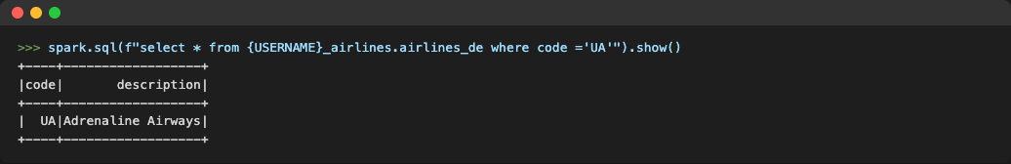

Table maintenance
Compaction: the setup loaded flights in the maintenance database month by month, which leaves many small files. Check them, compact them, and check again:
spark.sql(f"SELECT file_path, file_size_in_bytes/1024/1024 MB FROM {USERNAME}_airlines_maint.flights.files").show(100,False)
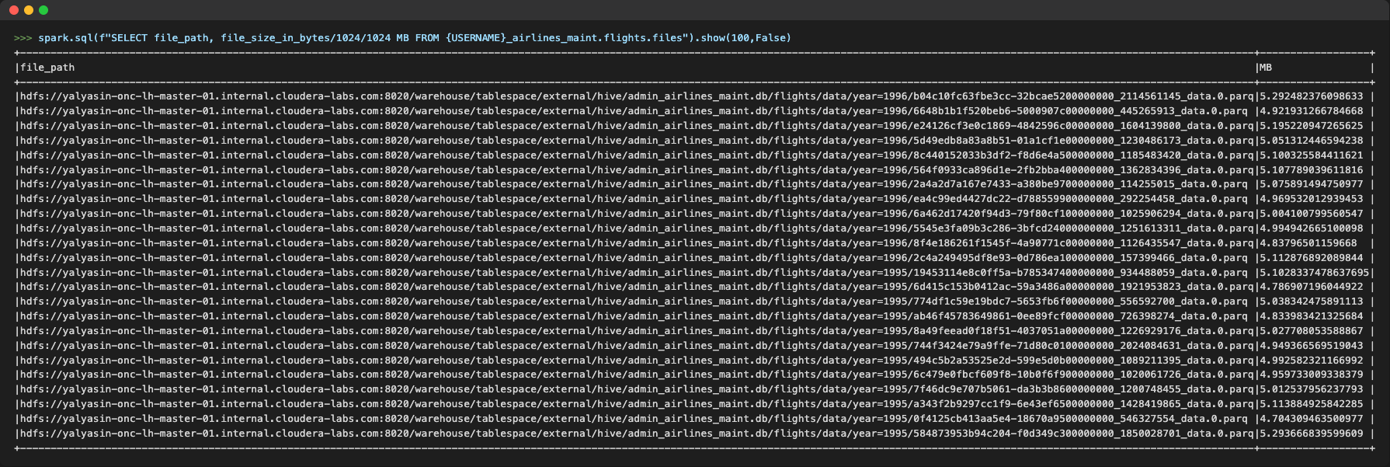
spark.sql(f"CALL spark_catalog.system.rewrite_data_files(table => '{USERNAME}_airlines_maint.flights', options => map('target-file-size-bytes','157286400'))").show()
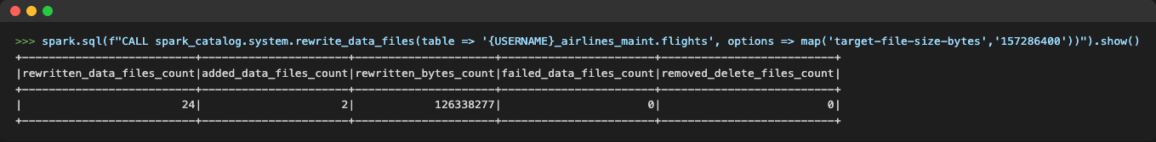
spark.sql(f"SELECT file_path, file_size_in_bytes/1024/1024 MB FROM {USERNAME}_airlines_maint.flights.files order by partition").show(100,False)
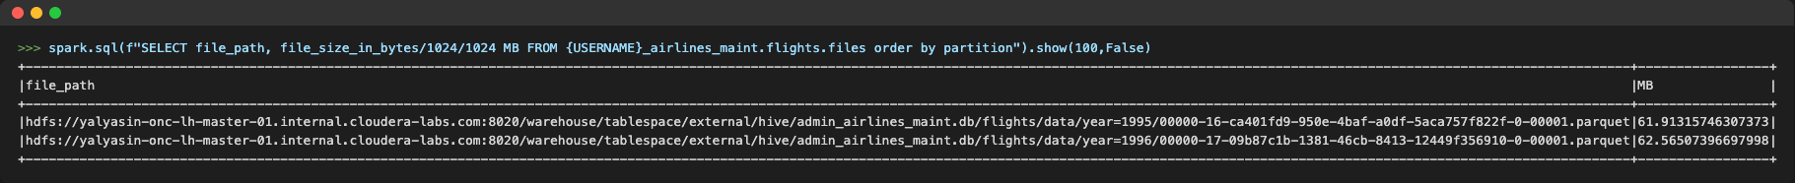
Partition evolution: add month to the partition spec, then rewrite only 1996 with the new spec:
spark.sql(f"ALTER TABLE {USERNAME}_airlines_maint.flights add PARTITION FIELD month").show(100,False)
spark.sql(f"CALL spark_catalog.system.rewrite_data_files( table => '{USERNAME}_airlines_maint.flights' , where => 'year=1996' , options => map('rewrite-all', 'true') )").show()
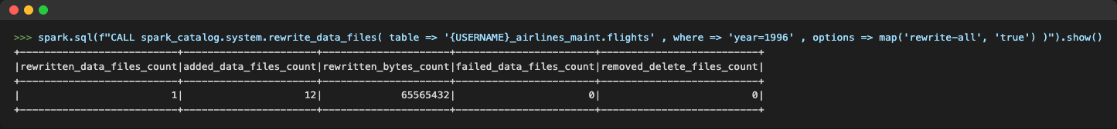
spark.sql(f"SELECT file_path, partition, file_format, record_count, round(file_size_in_bytes/1024/1024) MB FROM {USERNAME}_airlines_maint.flights.files order by partition").show(100)
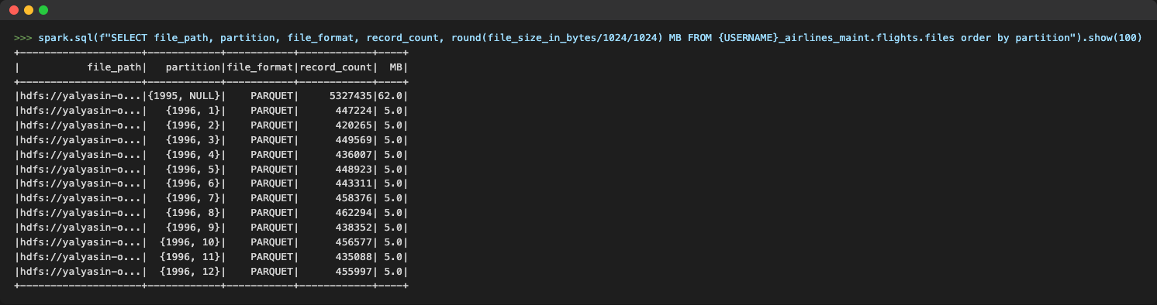
Note: v1.1 set USERNAME="user01" in this section: keep your own user id.
Rollback: list the snapshots of airlines_de and roll back to the first one (before the MERGE):
spark.sql(f"SELECT snapshot_id FROM {USERNAME}_airlines.airlines_de.snapshots").show()
first_snapshot = spark.sql(f"SELECT snapshot_id FROM spark_catalog.{USERNAME}_airlines.airlines_de.snapshots").first()[0]
spark.sql(f"CALL spark_catalog.system.rollback_to_snapshot('{USERNAME}_airlines.airlines_de', {first_snapshot})").show()
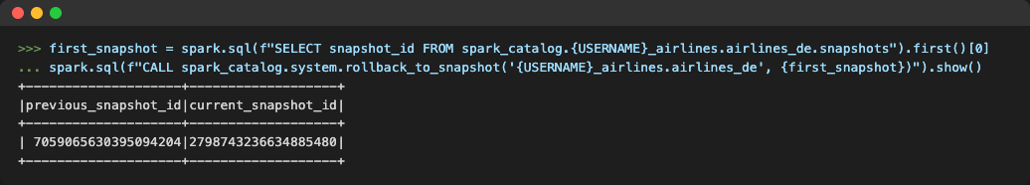
Expire snapshots older than three days, keeping at least one:
expireDate=spark.sql("select date_sub(current_timestamp(),3) as expireDate").first()["expireDate"]
minCatalogsRetain = 1
spark.sql(f"CALL spark_catalog.system.expire_snapshots(table => '{USERNAME}_airlines.airlines_de', older_than => TIMESTAMP '{expireDate}', retain_last => {minCatalogsRetain})").show()
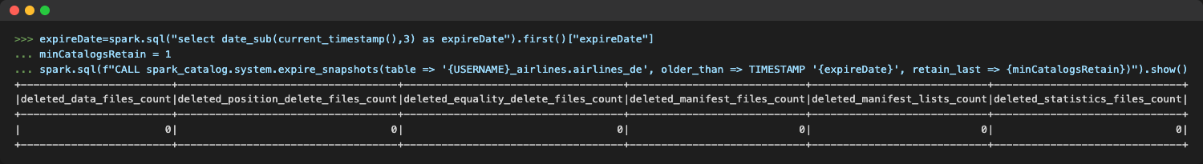

Hard deletes
With time travel, deletes are soft: older snapshots still reference the deleted rows. Regulations such as the "right to be forgotten" need hard deletes. There are two ways.
Copy-on-write (COW): data files are rewritten on every update or delete, so newer snapshots never reference deleted rows. Set it once per table (Spark only), then expire the older snapshots:
spark.sql(f"ALTER TABLE spark_catalog.{USERNAME}_airlines.airlines_de SET TBLPROPERTIES ('write.delete.mode'='copy-on-write', 'write.update.mode'='copy-on-write', 'write.merge.mode'='copy-on-write')").show()
spark.sql(f"CALL spark_catalog.system.expire_snapshots(table => '{USERNAME}_airlines.airlines_de', older_than => TIMESTAMP '2024-01-01 00:00:00.000', retain_last => 10)").show()
Merge-on-read (MOR), the default for all engines: compact to remove the delete files, then expire the prior snapshots:
spark.sql(f"CALL spark_catalog.system.rewrite_data_files(table => '{USERNAME}_airlines.airlines_de', strategy => 'sort', sort_order => 'zorder(code, description)')").show()
spark.sql(f"CALL spark_catalog.system.expire_snapshots(table => '{USERNAME}_airlines.airlines_de', older_than => TIMESTAMP '2025-01-01 00:00:00.000', retain_last => 1)").show()
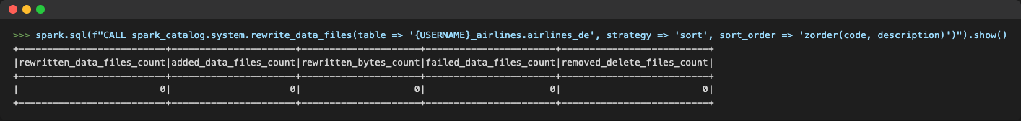
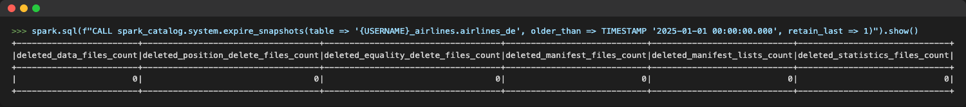

Lab 3 - Data Warehouse with Impala
Run these statements in the Hue Impala editor with your user id for ${user_id}. Select each statement (to the ;) and run it.

Migrate tables to Iceberg
Create Table As Select (CTAS) creates a new Iceberg table from an existing table:
drop table if exists ${user_id}_airlines.airports_dw;

CREATE TABLE ${user_id}_airlines.airports_dw
STORED AS ICEBERG AS
SELECT * FROM ${user_id}_airlines.airports_hive;

DESCRIBE FORMATTED ${user_id}_airlines.airports_dw;
In the output, check Location (data in HDFS), metadata_location (Iceberg metadata in the table directory), table_type ICEBERG and the HiveIcebergSerDe storage handler.
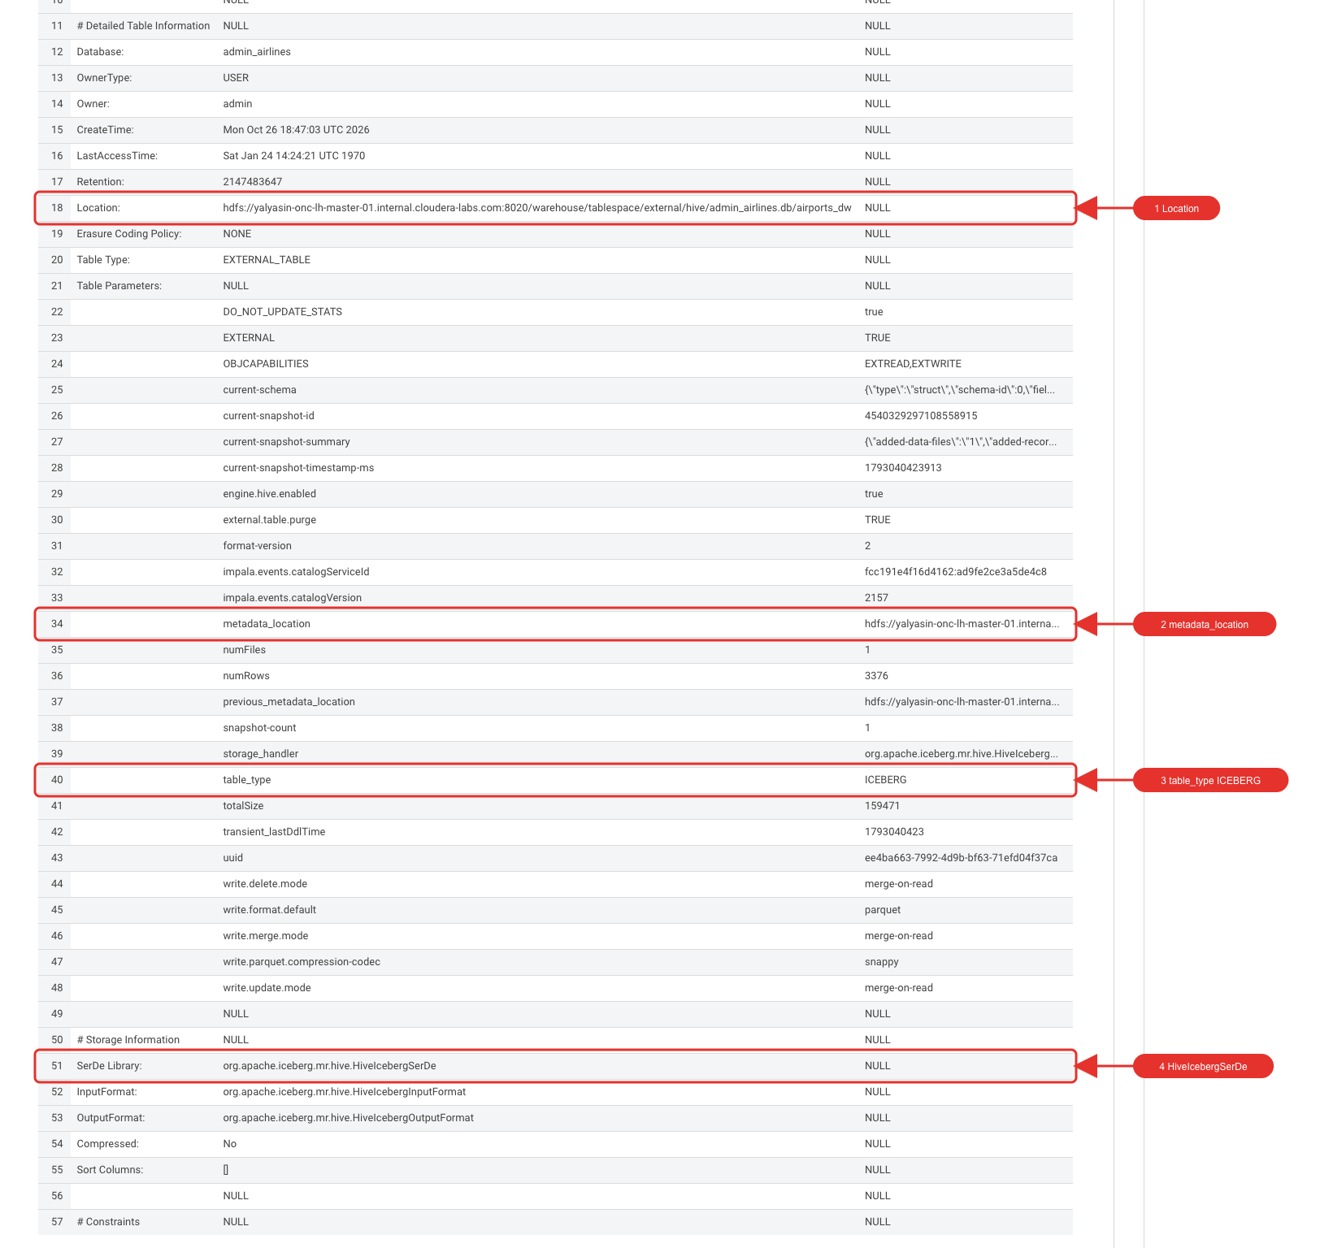
New in 7.3.2: in-place migration in Impala. v1.1 said this was not available in Base; Impala now converts an existing (non-transactional) table without rewriting the data:
CREATE EXTERNAL TABLE ${user_id}_airlines.planes_cv STORED AS PARQUET AS SELECT * FROM airlines_csv.planes_csv;

ALTER TABLE ${user_id}_airlines.planes_cv CONVERT TO ICEBERG;

DESCRIBE FORMATTED ${user_id}_airlines.planes_cv;
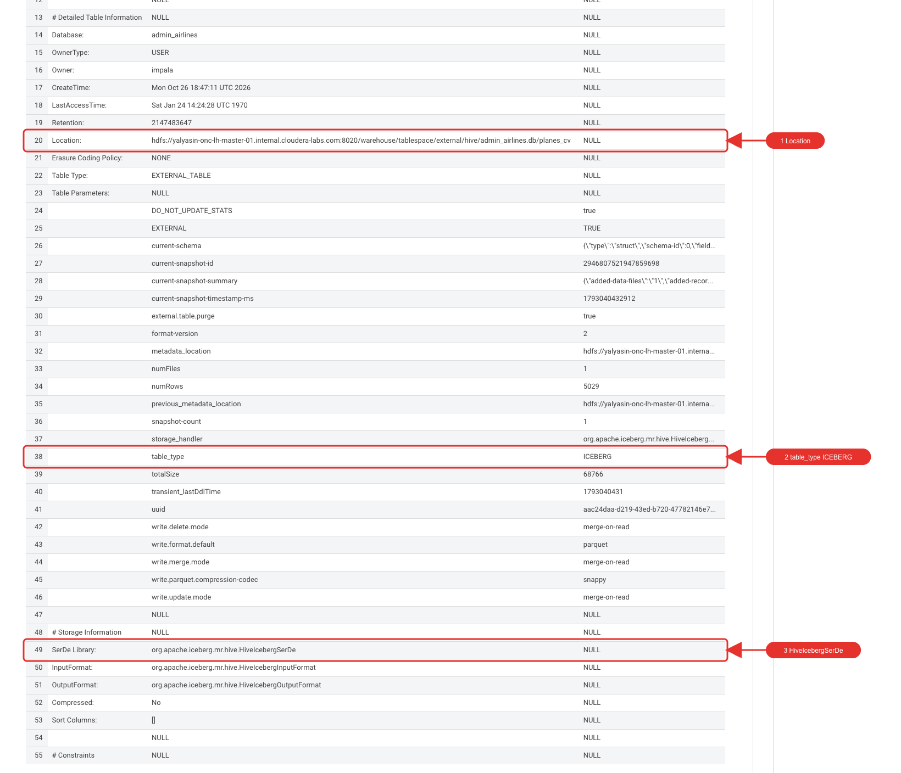

Create and load a partitioned Iceberg table
drop table if exists ${user_id}_airlines.flights_dw;

CREATE TABLE ${user_id}_airlines.flights_dw (
month int, dayofmonth int,
dayofweek int, deptime int, crsdeptime int, arrtime int,
crsarrtime int, uniquecarrier string, flightnum int, tailnum string,
actualelapsedtime int, crselapsedtime int, airtime int, arrdelay int,
depdelay int, origin string, dest string, distance int, taxiin int,
taxiout int, cancelled int, cancellationcode string, diverted string,
carrierdelay int, weatherdelay int, nasdelay int, securitydelay int,
lateaircraftdelay int
)
PARTITIONED BY (year int)
STORED AS ICEBERG;

DESCRIBE EXTENDED ${user_id}_airlines.flights_dw;
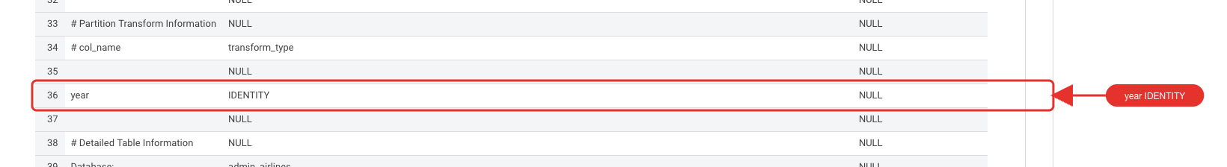
Load the years up to 2006 (about 6 minutes, the longest step of the labs):
INSERT INTO ${user_id}_airlines.flights_dw
SELECT * FROM airlines_csv.flights_csv
WHERE year <= 2006;

SELECT year, count(*)
FROM ${user_id}_airlines.flights_dw
GROUP BY year
ORDER BY year desc;
From 2004 to 2006 there are about 7.1 million rows per year. (The screenshot below was taken after the 2007 load in the next section.)
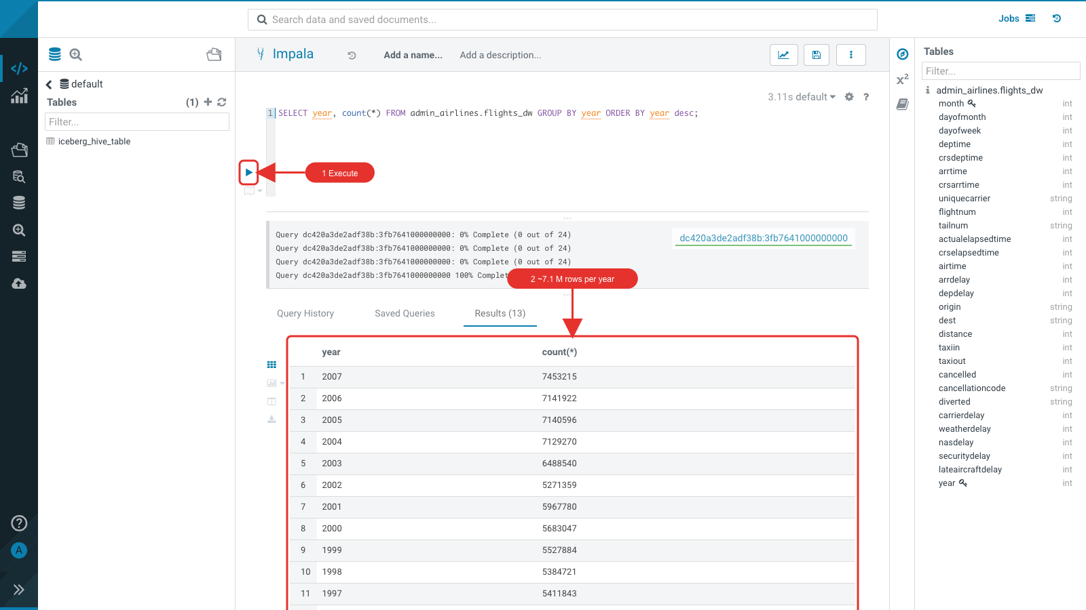

Partition evolution
Change the partition spec in place: no data is rewritten, existing data stays partitioned by year.
ALTER TABLE ${user_id}_airlines.flights_dw
SET PARTITION spec ( year, month );

SHOW CREATE TABLE ${user_id}_airlines.flights_dw;
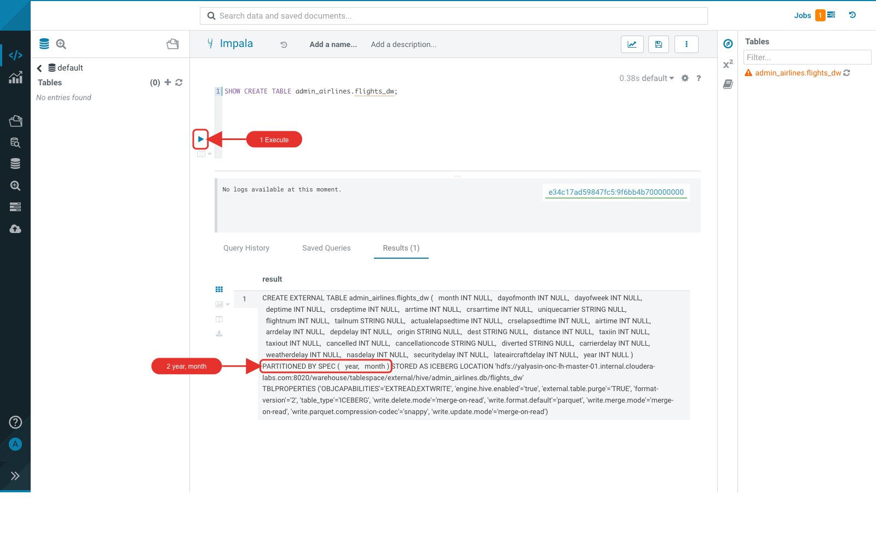
Load 2007, which uses the new year + month spec (about 40 seconds):
INSERT INTO ${user_id}_airlines.flights_dw
SELECT * FROM airlines_csv.flights_csv
WHERE year = 2007;
Compare the plans of the same query for December 2006 (year partition) and December 2007 (year + month partitions). Prefix each query with EXPLAIN, or select it and use the explain option:
EXPLAIN SELECT year, month, count(*)
FROM ${user_id}_airlines.flights_dw
WHERE year = 2006 AND month = 12
GROUP BY year, month
ORDER BY year desc, month asc;
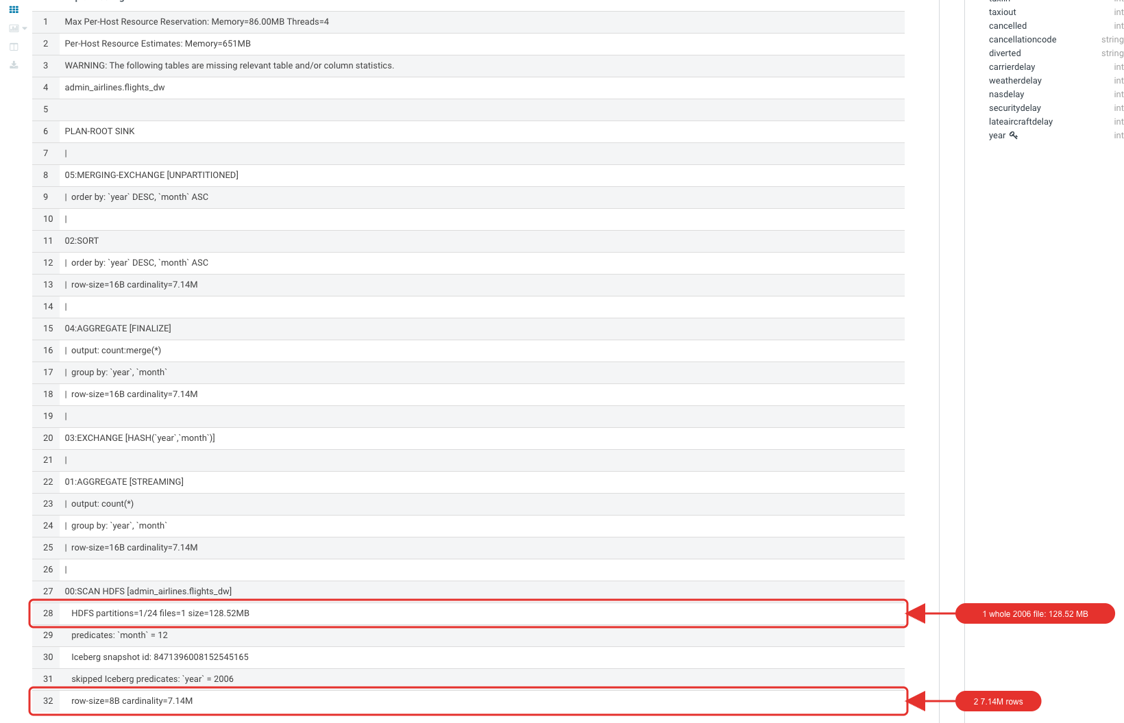
EXPLAIN SELECT year, month, count(*)
FROM ${user_id}_airlines.flights_dw
WHERE year = 2007 AND month = 12
GROUP BY year, month
ORDER BY year desc, month asc;
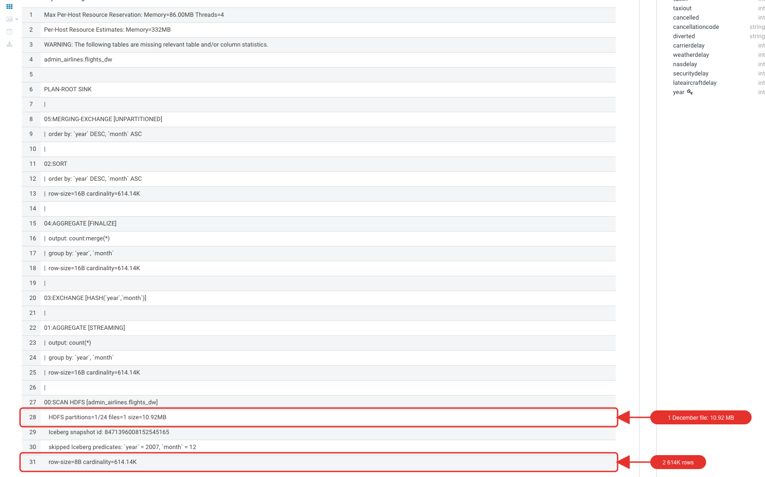
The 2006 query reads the whole year partition (about 7.14 million rows); the 2007 query reads only the December partition (about 614 thousand rows).

Time travel
Every load created a snapshot. List them:
DESCRIBE HISTORY ${user_id}_airlines.flights_dw;
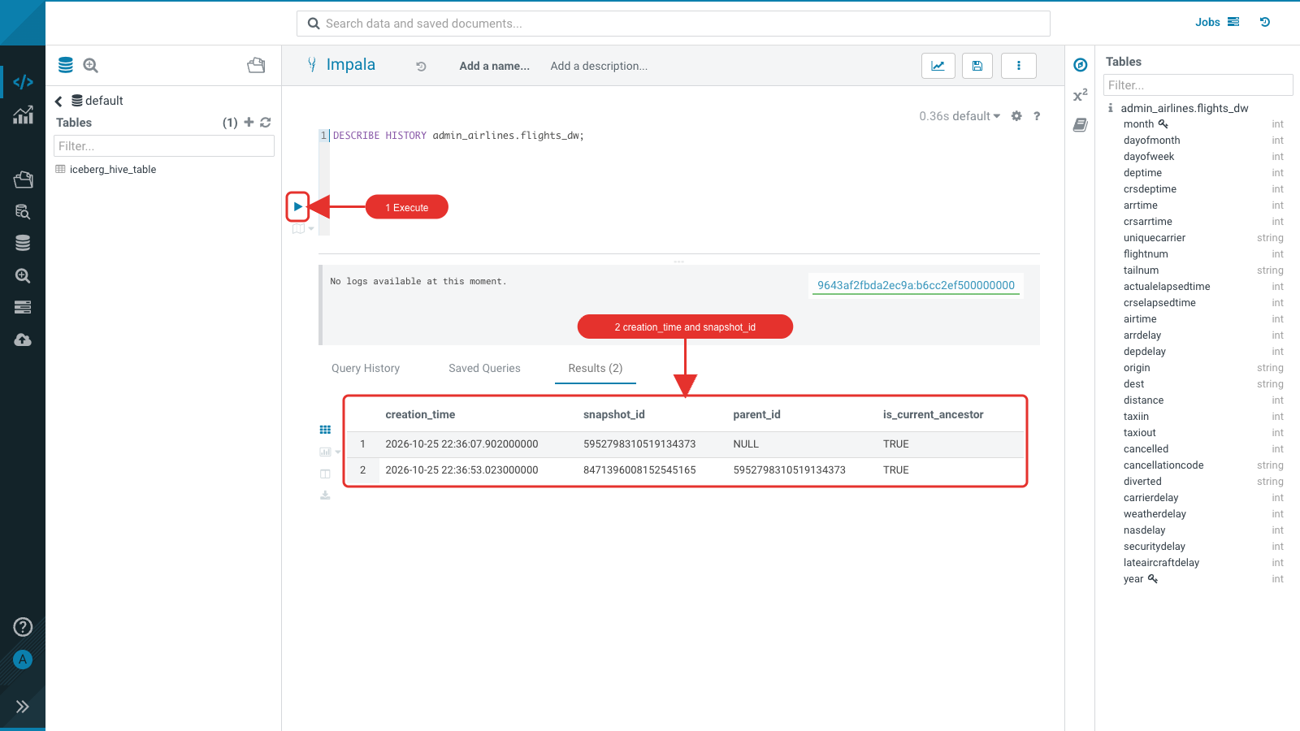
Enter a time between the two snapshots for ${create_ts} and the first snapshot id for ${snapshot_id}. Both queries return the data as it was before the 2007 load:
SELECT year, count(*)
FROM ${user_id}_airlines.flights_dw
FOR SYSTEM_TIME AS OF '${create_ts}'
GROUP BY year
ORDER BY year desc;
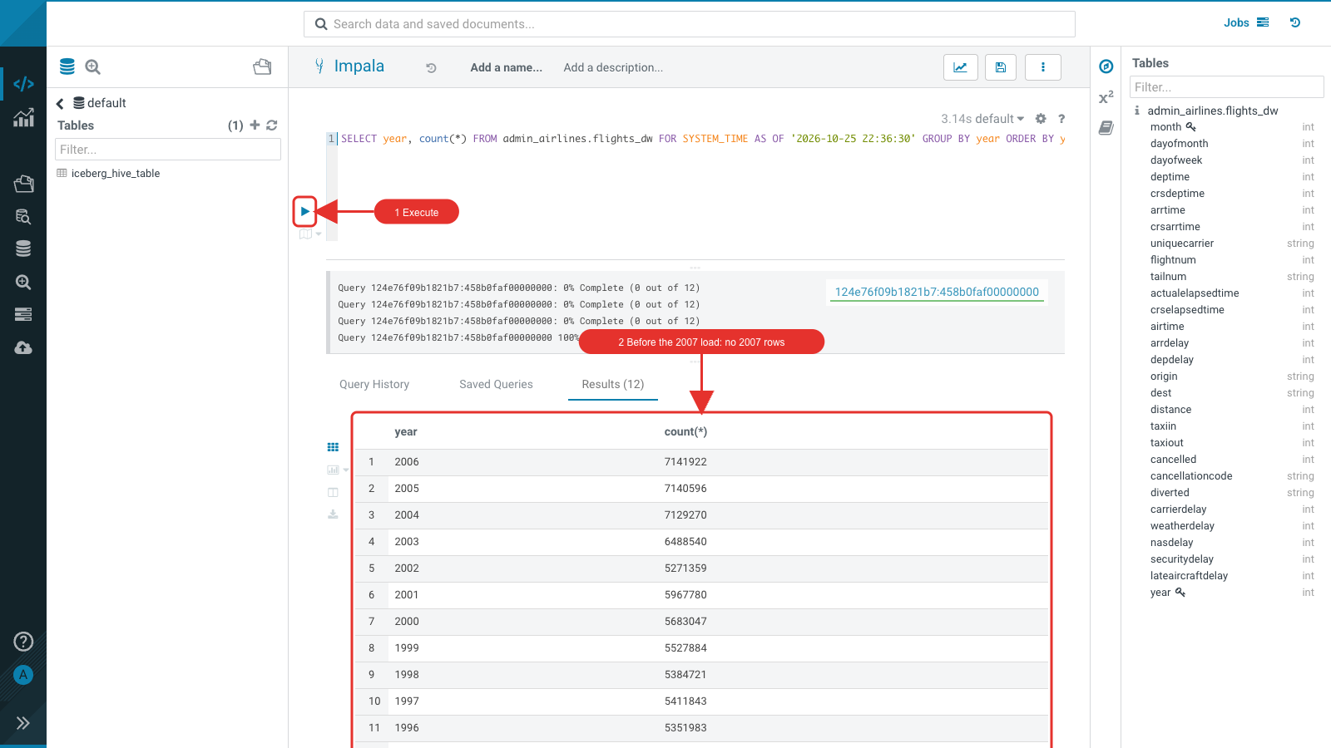
SELECT year, count(*)
FROM ${user_id}_airlines.flights_dw
FOR SYSTEM_VERSION AS OF ${snapshot_id}
GROUP BY year
ORDER BY year desc;
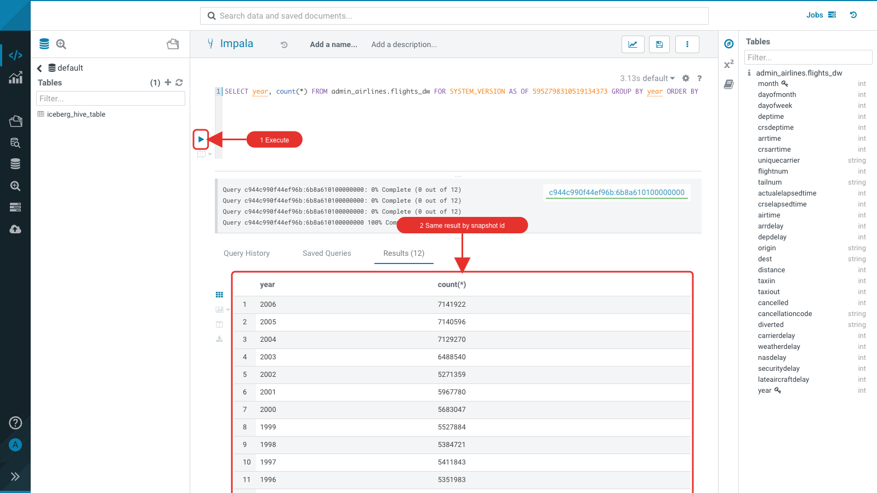

Hive and Iceberg tables in one query
You can migrate to Iceberg over time: one query can join a Hive-format table (unique_tickets) with an Iceberg table (flights_dw). The query takes about 10 seconds.
SELECT
t.leg1origin,
f.dest,
count(*) as num_passengers
FROM ${user_id}_airlines.unique_tickets t
LEFT OUTER JOIN ${user_id}_airlines.flights_dw f ON
t.leg1origin = f.origin
AND t.leg1dest = f.dest
AND t.leg1flightnum = f.flightnum
AND t.leg1month = f.month
AND t.leg1dayofmonth = f.dayofmonth
GROUP BY t.leg1origin, f.dest;
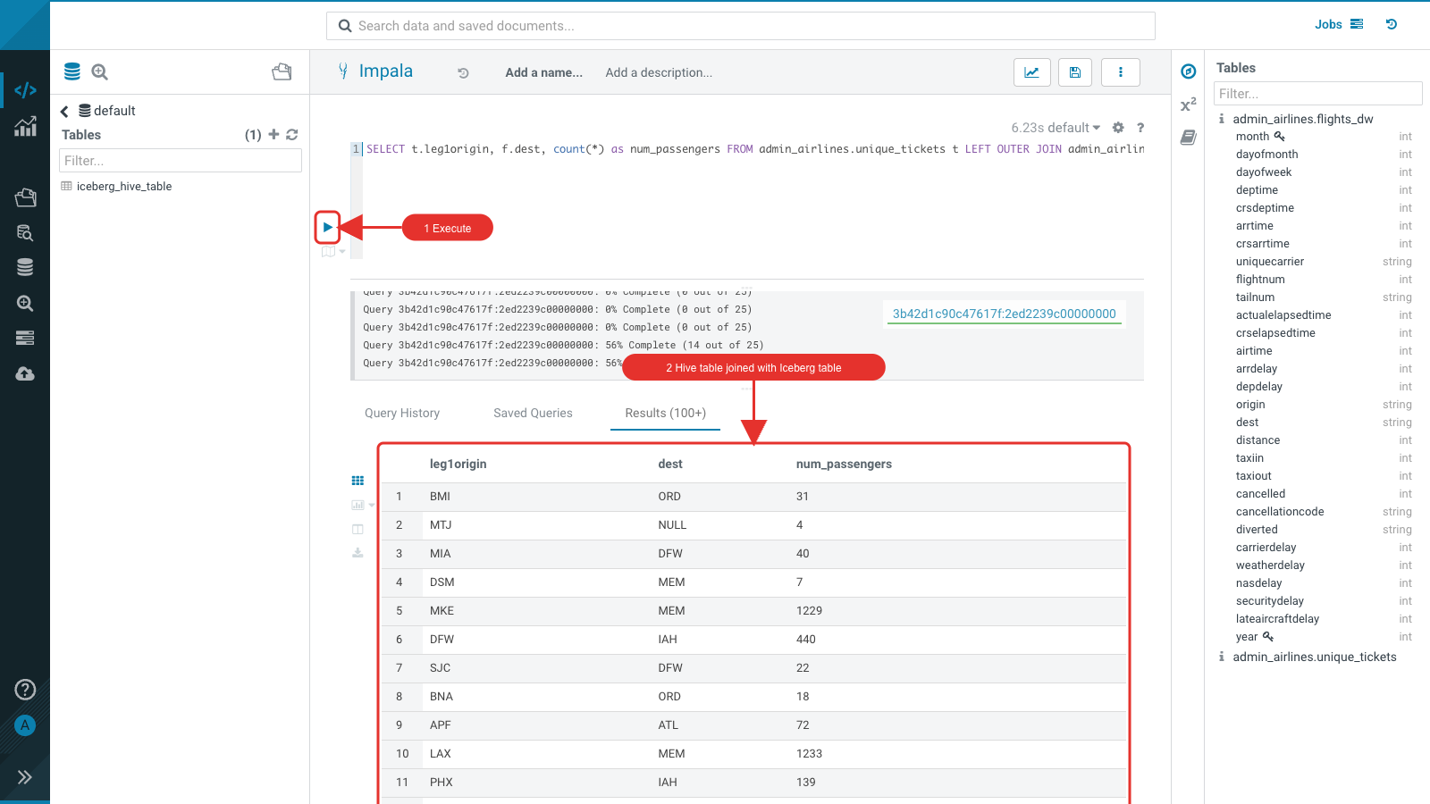

Lab 4 - SDX: Fine-grained Access Control and Lineage

Ranger: mask a column
Query the planes table: the tail number is plain text.
SELECT * FROM ${user_id}_airlines.planes_iceberg;
- Open Ranger from the Knox homepage → Hadoop SQL → Masking tab → Add New Policy.
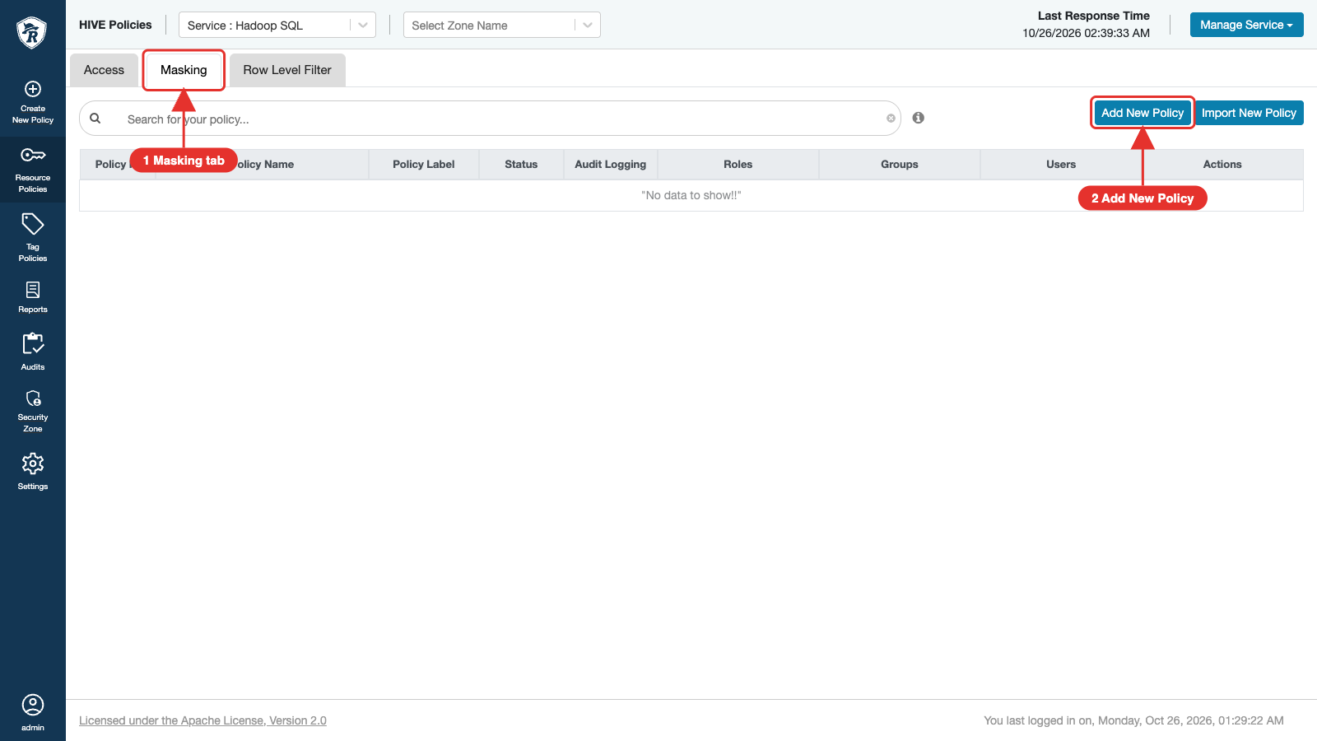
- Policy name <user_id>-iceberg-fgac; Hive Database <user_id>_airlines; Hive Table planes_iceberg; Hive Column tailnum. Under Mask Rules: Select User your user id, Add Permissions → select, Select Masking Option → Hash.
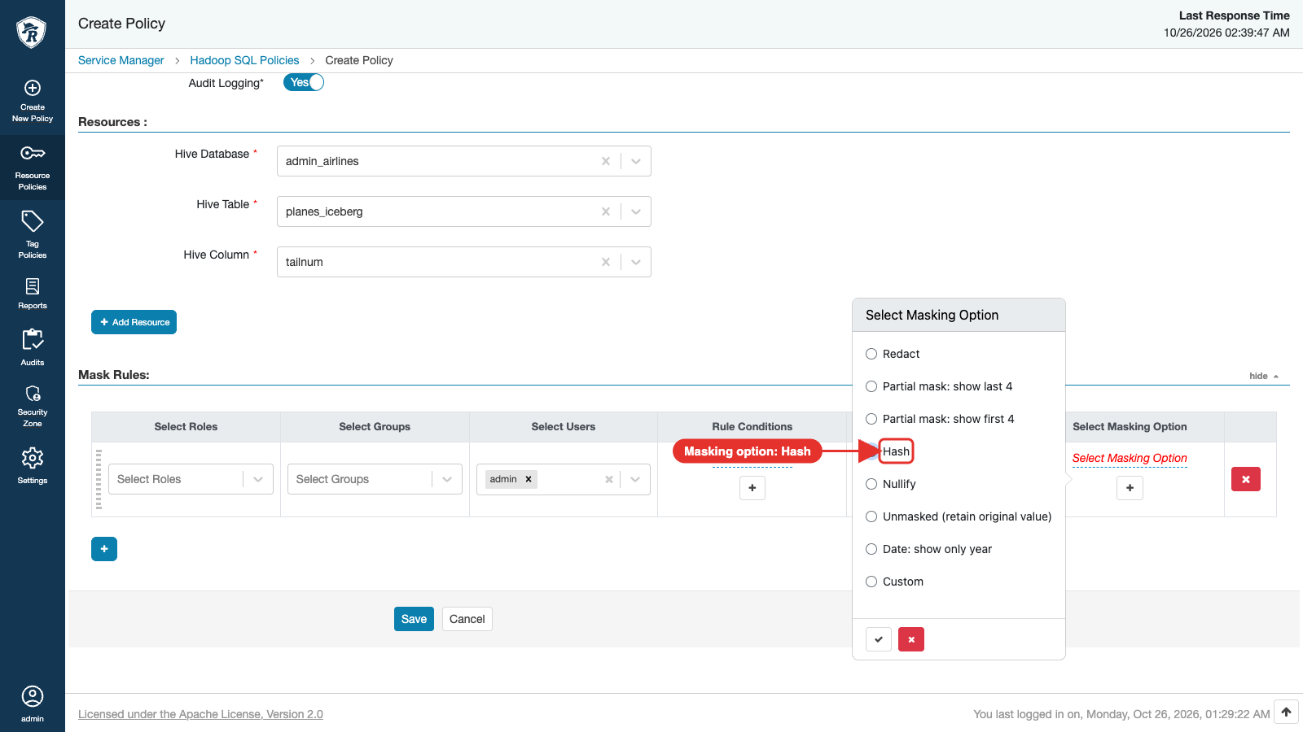
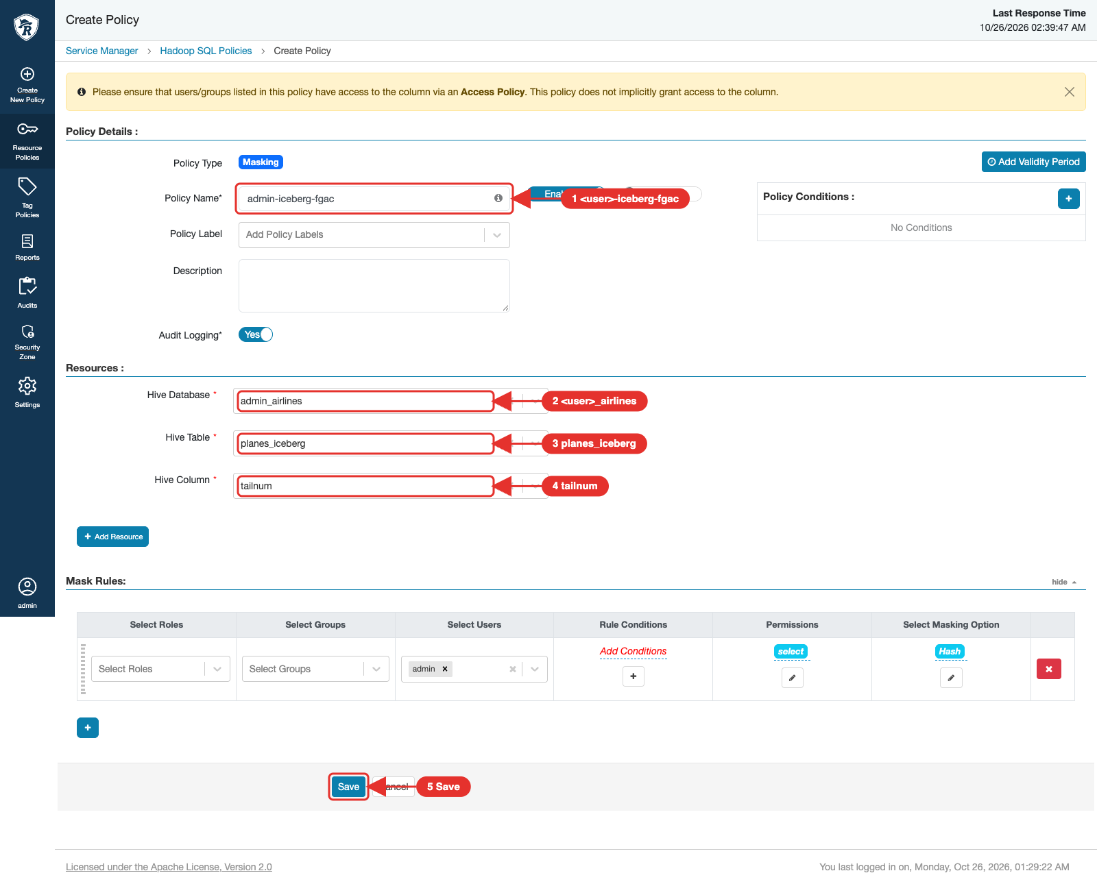
- Click Save.
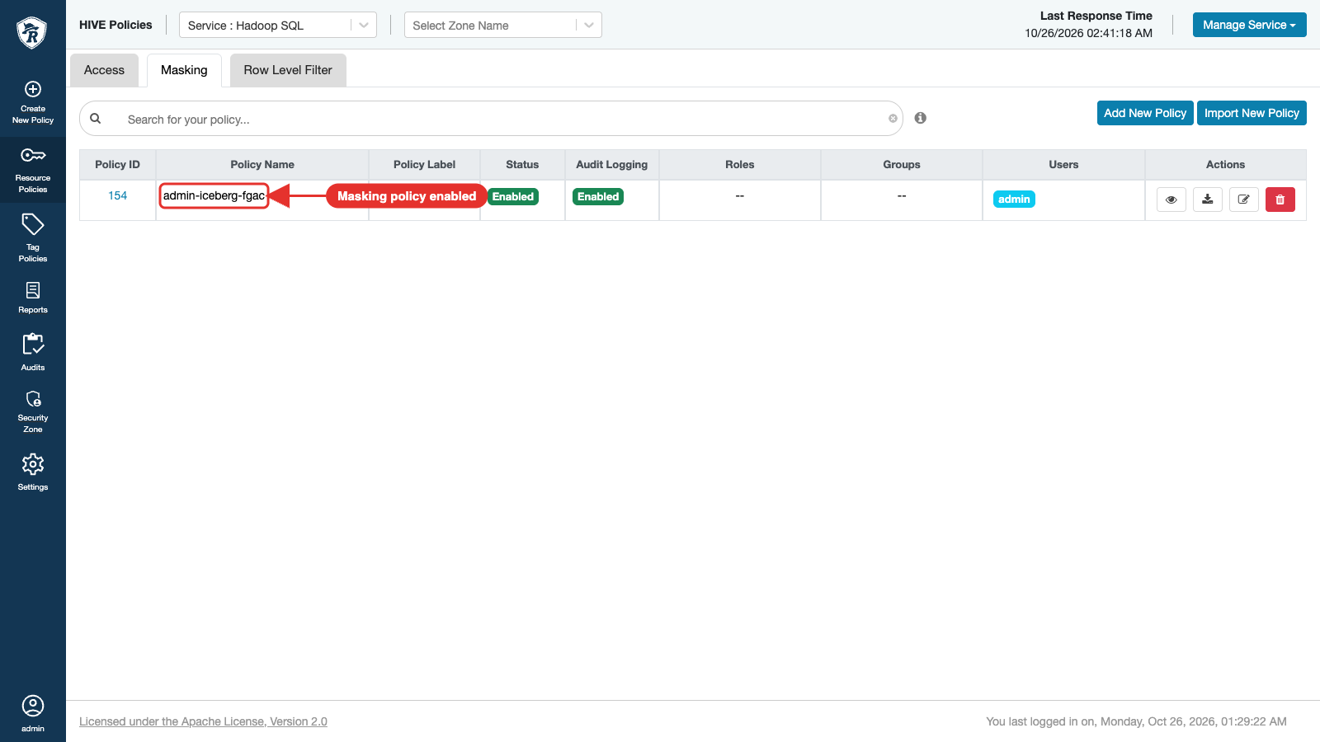
- Run the query again (Ranger plugins refresh their policies within 30 seconds): tailnum is now hashed.
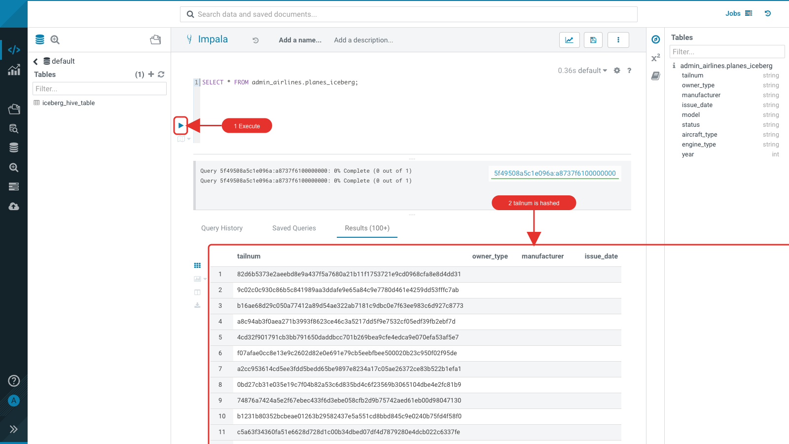

Atlas: metadata and lineage
- Open Atlas from the Knox homepage. Search By Type iceberg_table, Search By Text flights_dw, click Search, and open flights_dw.
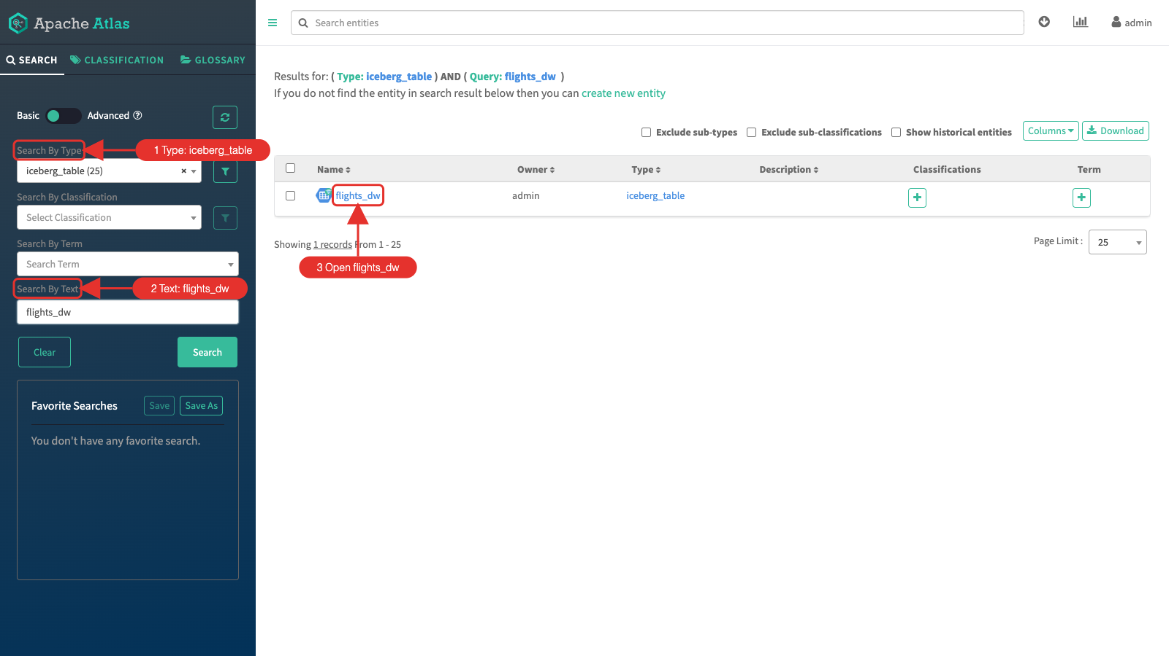
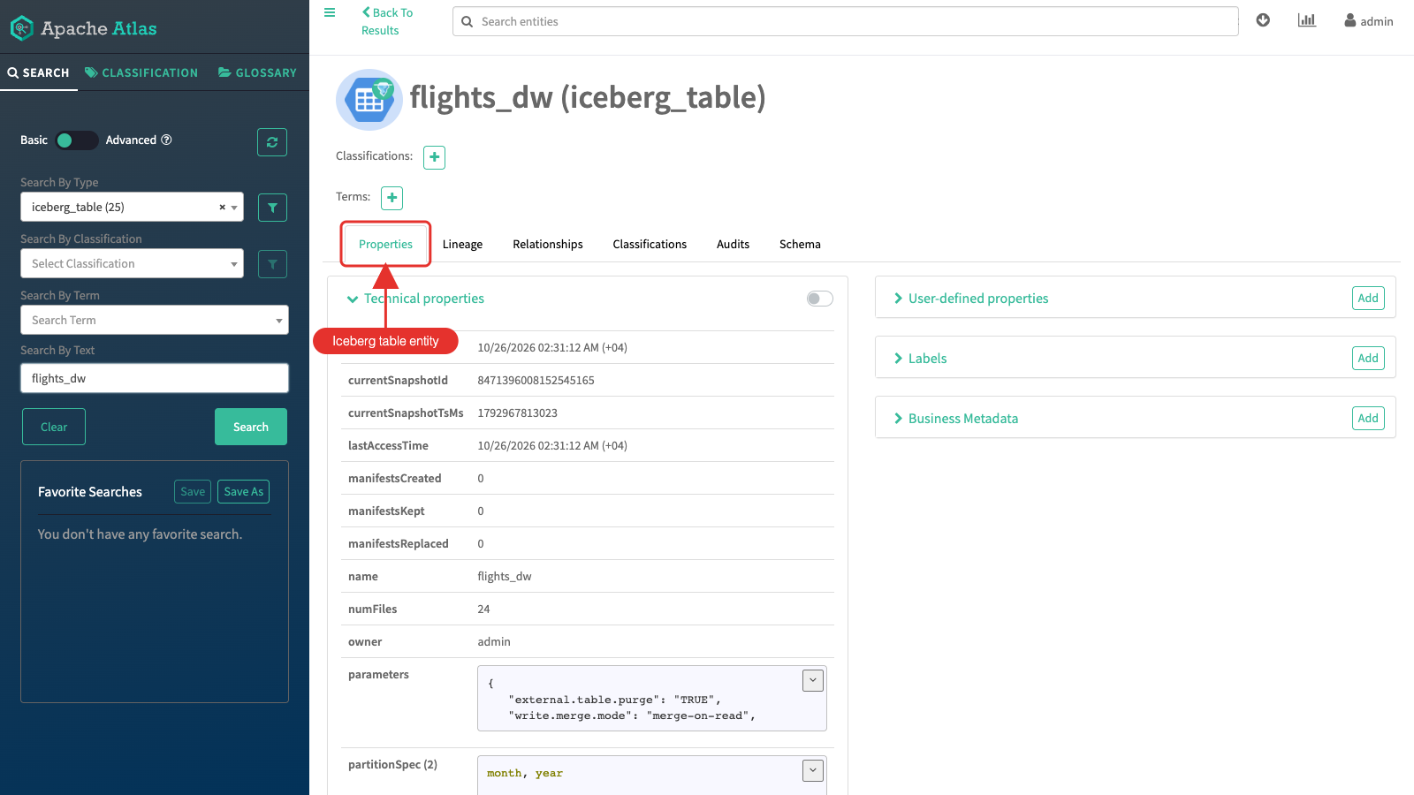
- The Schema tab lists the columns of the Iceberg table.
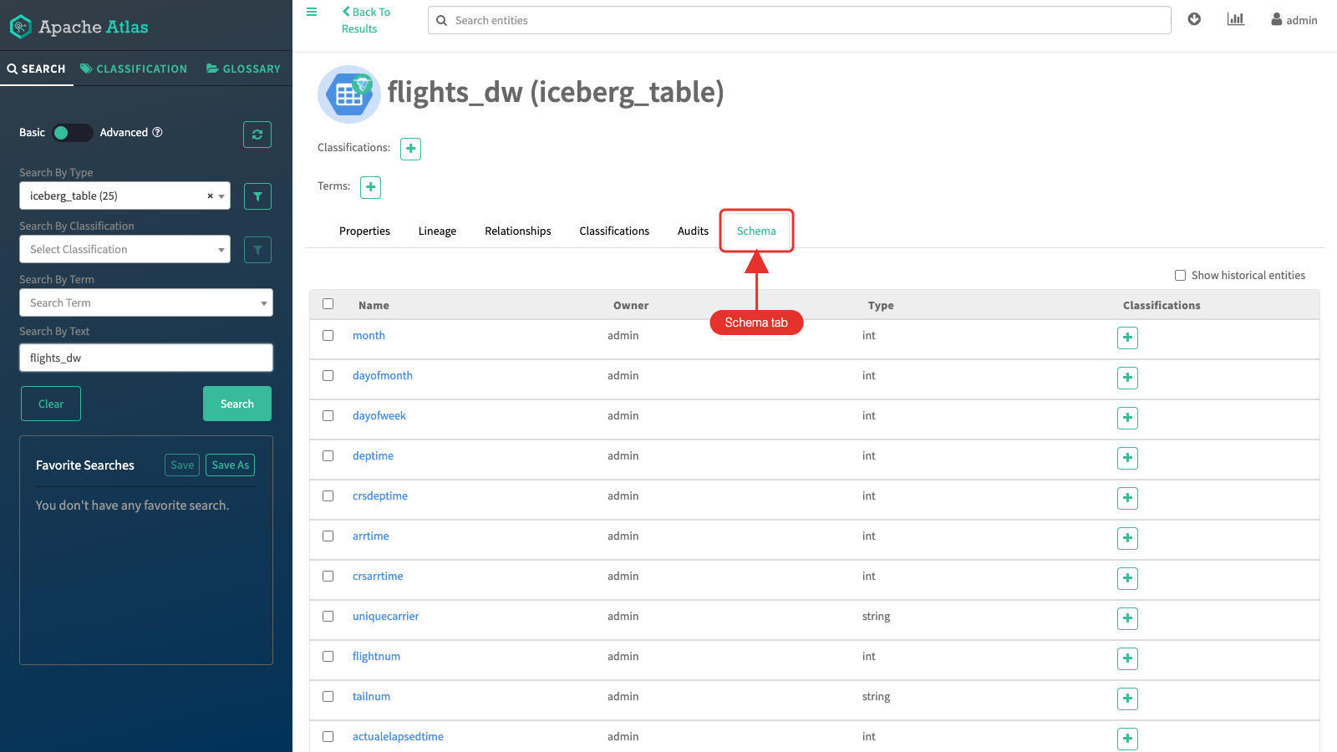
- The Lineage tab shows how the table was built: the CSV files in HDFS, the flights_csv table, and the Impala INSERT that loaded flights_dw.
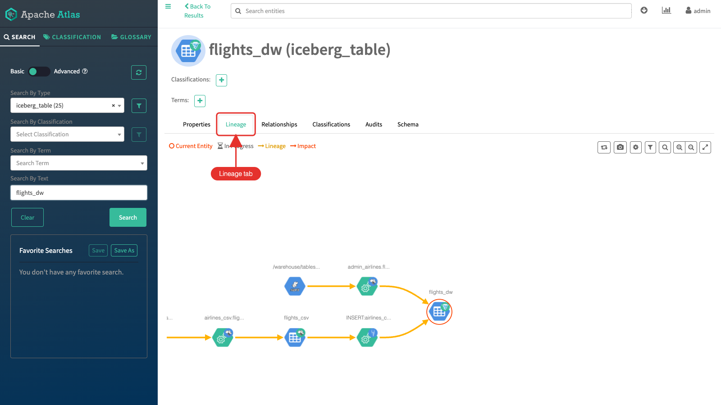

Lab 5 - Replication
Iceberg replication (Replication Manager) copies Iceberg tables between two clusters. It is not covered in v2.0 because the lab cluster is a single cluster. v1.1 describes the steps; the limits it lists still apply (HDFS to HDFS only, no Ozone tables, one source per target).

Lab 6 - Cloudera Lakehouse Optimizer
Streaming writers commit often. In Lab 1, NiFi PutIceberg committed every record on its own, so countries_nifi_iceberg holds one tiny data file and one snapshot per row. Every query has to open all those files and read all that metadata. Cloudera Lakehouse Optimizer (new in 7.3.2) maintains Iceberg tables for you: you attach a policy to the tables, and it runs the maintenance as Spark jobs (compaction, snapshot expiration, manifest rewrite, orphan file and position delete cleanup) when the table changes or on a schedule.
Policies are built from the ClouderaAdaptive template, which decides from the table statistics which actions a table needs. In this lab you create a policy for the Lab 1 streaming tables, preview it with a dry run, run it on one table and compare the table before and after.
Note: Use one policy per table: two policies on the same table can run at the same time and conflict. If several users share the cluster, each user creates the policy for their own ${user_id}_airlines tables.

Look at the problem
In the Hue Impala editor, count the data files, snapshots and rows of the NiFi table. The files and snapshots metadata tables are part of every Iceberg table:
SELECT 'data files' AS metric, count(*) AS value FROM ${user_id}_airlines.countries_nifi_iceberg.`files`
UNION ALL
SELECT 'snapshots', count(*) FROM ${user_id}_airlines.countries_nifi_iceberg.snapshots
UNION ALL
SELECT 'rows', count(*) FROM ${user_id}_airlines.countries_nifi_iceberg;
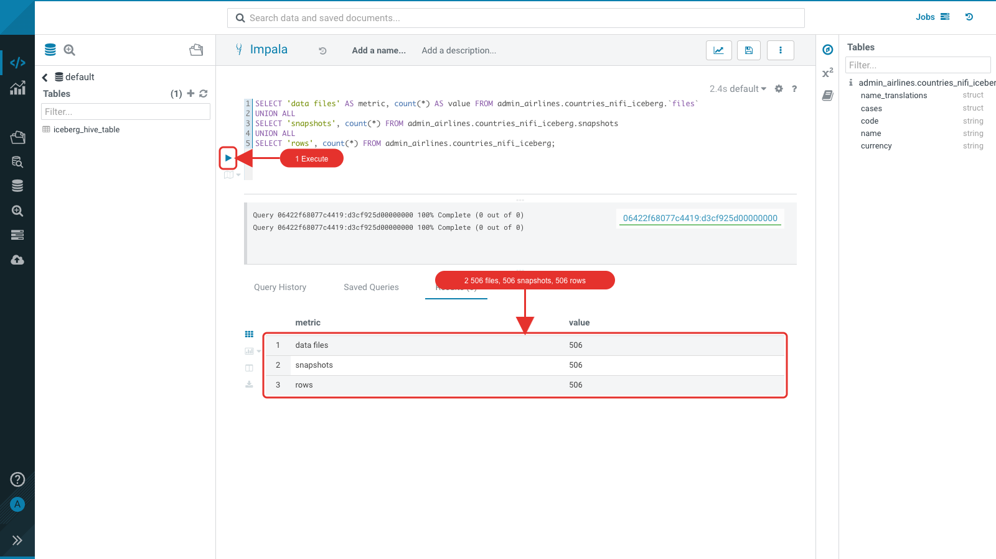
Each data file holds a single row of about 1.7 KB:
SELECT regexp_extract(file_path, '[^/]+$', 0) AS file_name,
file_size_in_bytes, record_count
FROM ${user_id}_airlines.countries_nifi_iceberg.`files`
LIMIT 10;
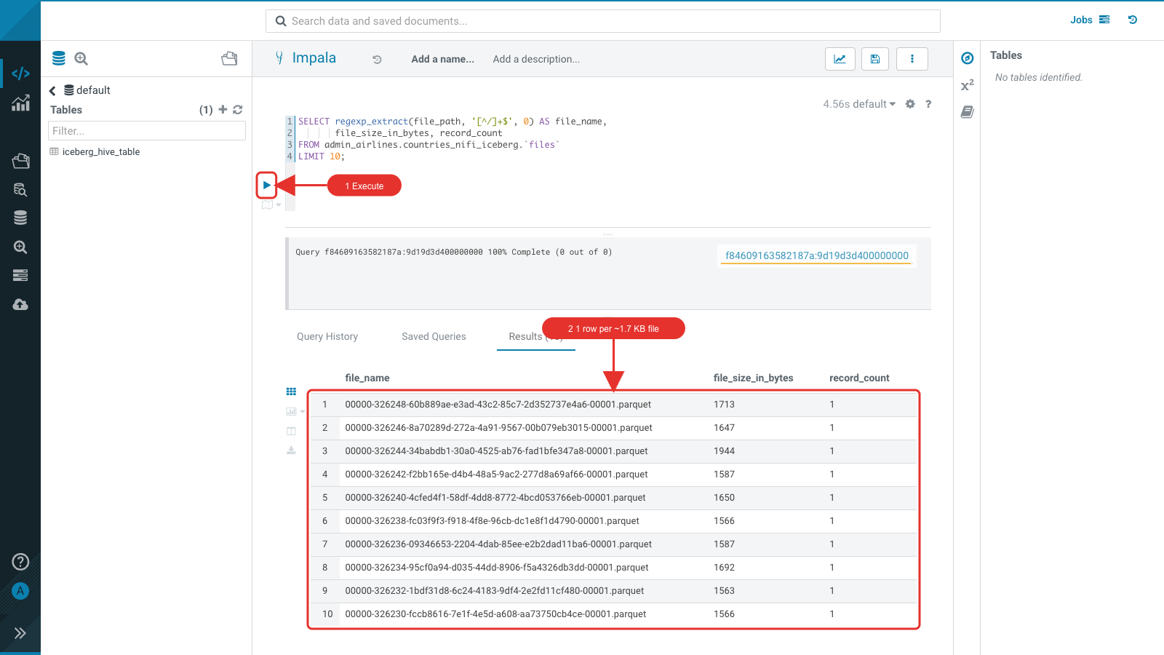

Open the Lakehouse Optimizer
Open the Lakehouse Optimizer UI through Knox: https://<knox-host>/gateway/cdp-proxy/lakehouse-ui/ (or Lakehouse Optimizer on the Knox home page). The Policies tab lists the policies; ClouderaAdaptive is the default template. Click Create Policy.
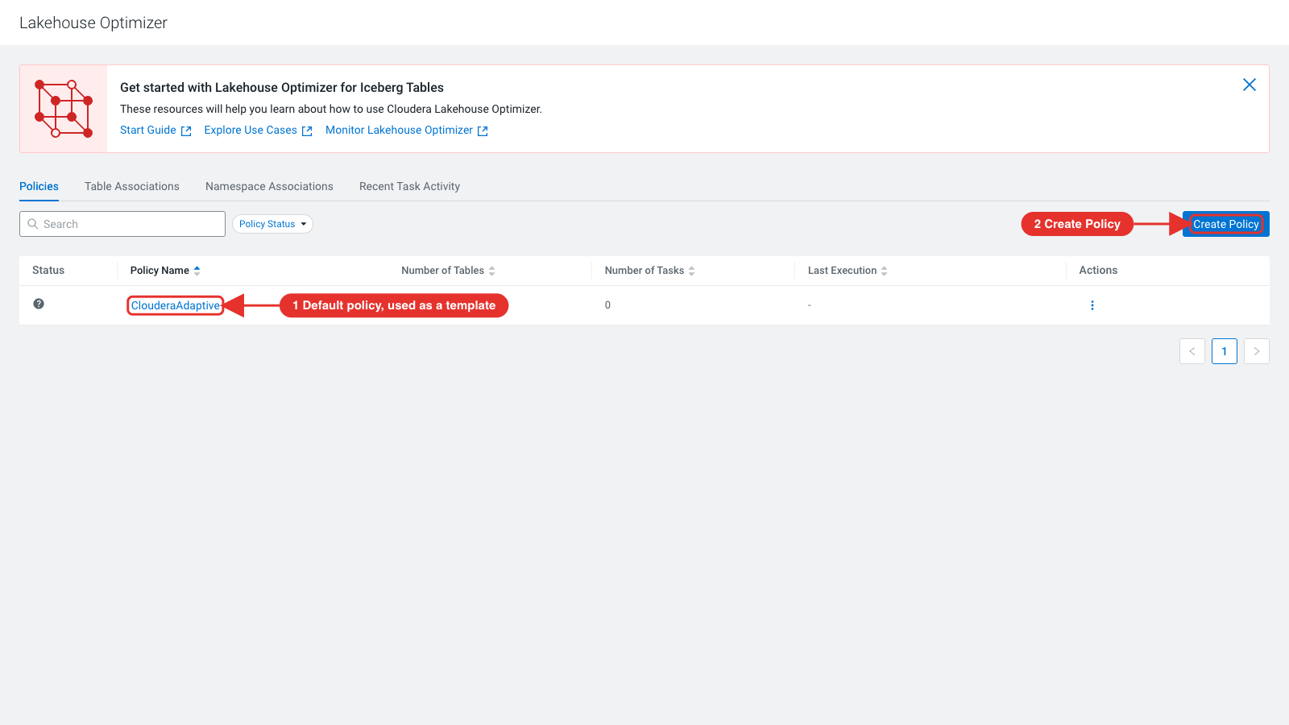

Create the policy
General Information: choose the Namespace scope (the policy applies to the tables you pick in a namespace; Catalog would apply it to every table of the chosen namespaces). Name the policy ${user_id}_airlines_small_files and add a description. Click Next.
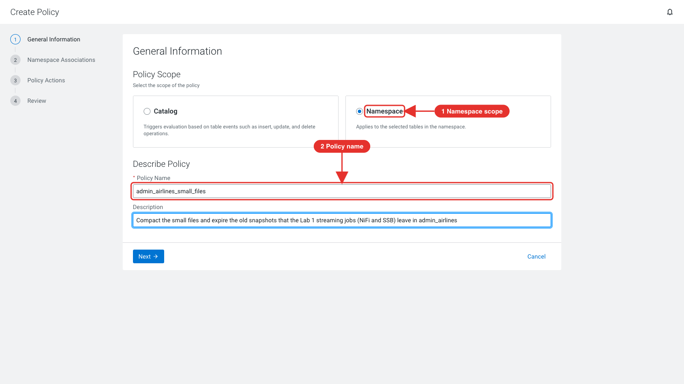
Namespace Associations: choose the namespace ${user_id}_airlines and select the four Lab 1 streaming tables: airports_kafka_iceberg, airports_nifi_iceberg, countries_kafka_iceberg and countries_nifi_iceberg. Leave the other tables out: expiring snapshots on flights_dw would remove the snapshots that the Lab 3 time travel step uses. Click Next.
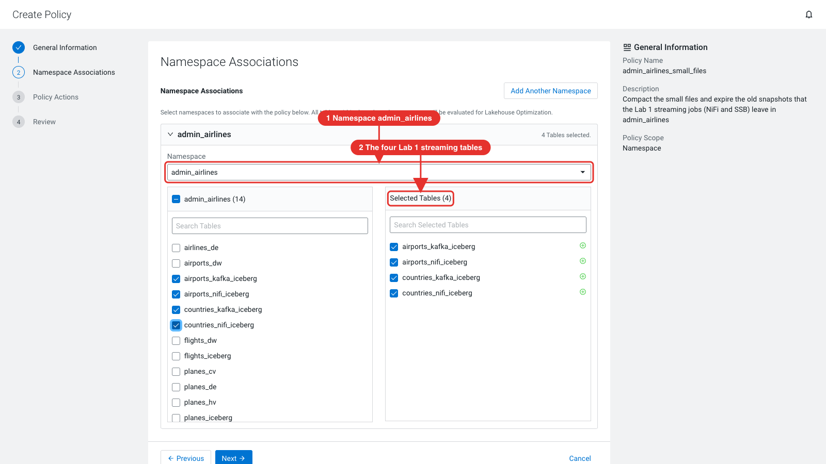
Policy Actions: keep the ClouderaAdaptive template, the Event Based schedule (the policy is evaluated when the table changes, which suits frequently written tables) and the Medium priority. Under Expire Snapshot, set Expire Older Than to 3600 (seconds, so 1 hour) and keep Retain Last at 5.
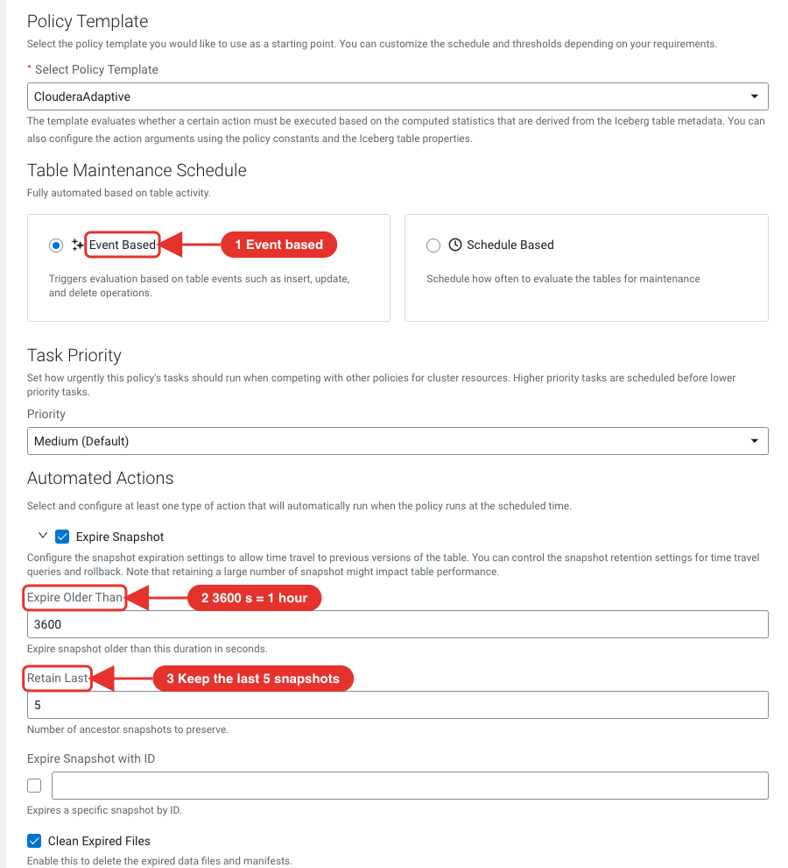
Select Compaction and turn on Partial Progress Enabled (commits the rewrite in parts, which avoids out-of-memory failures on large tables). Select Rewrite Manifest. Leave Delete Orphan Files and Rewrite Position Delete Files off: review those carefully before you use them, because they delete files. Click Next.
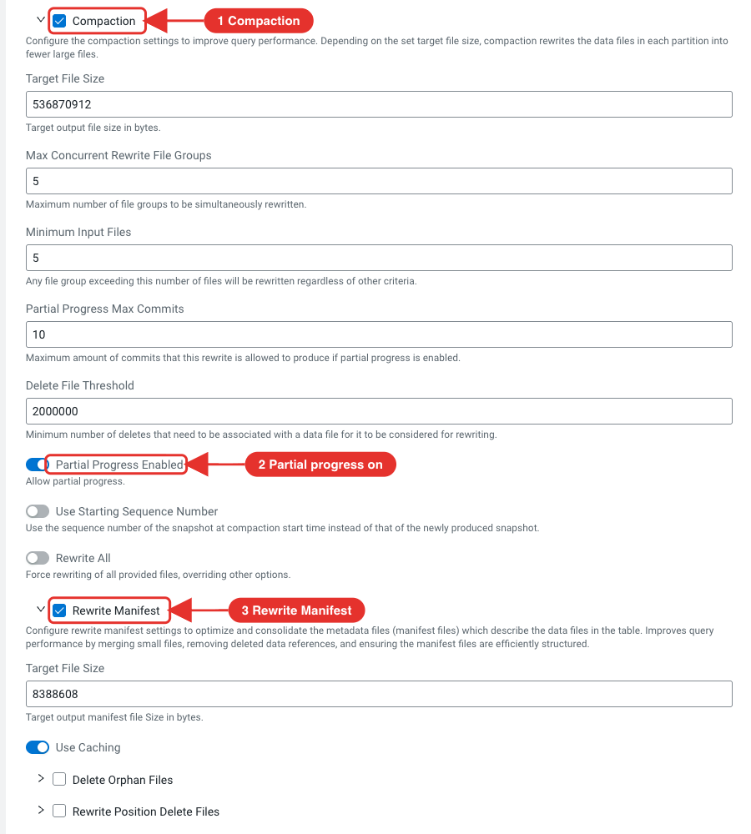
Review the settings and click Finish.
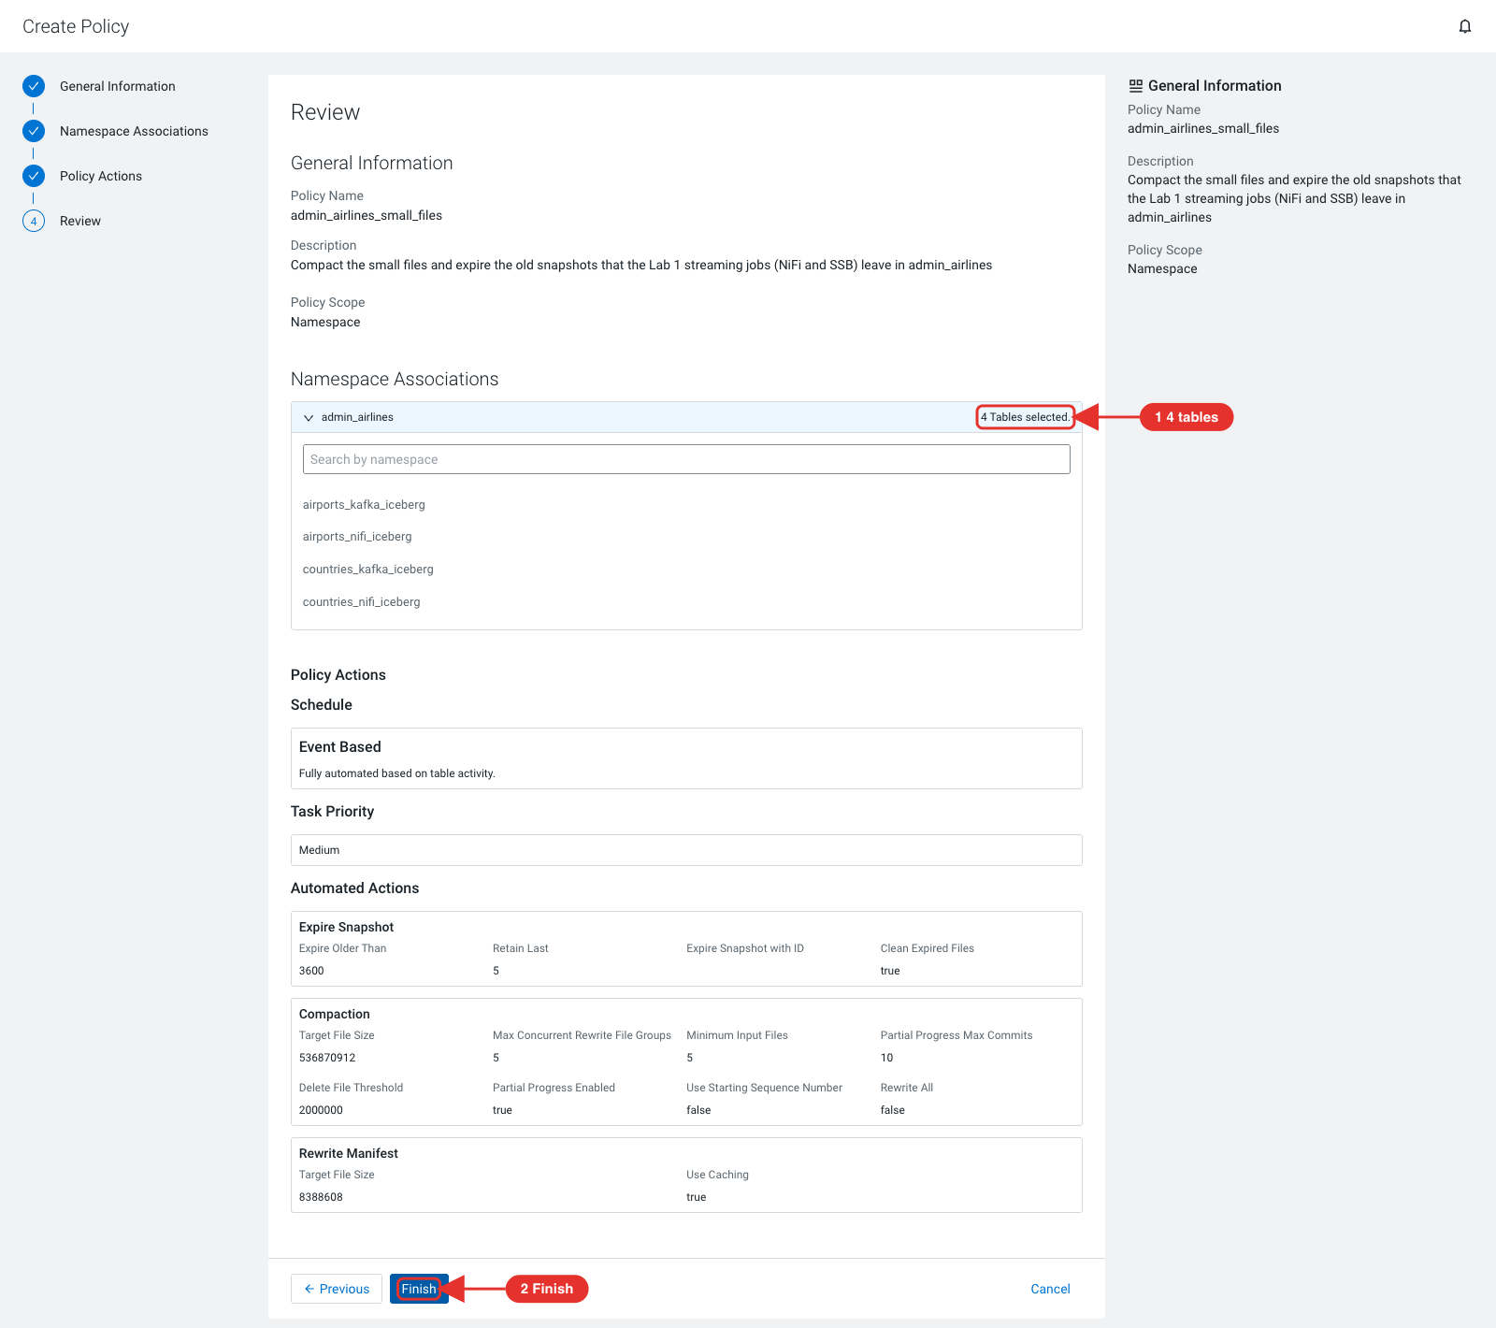
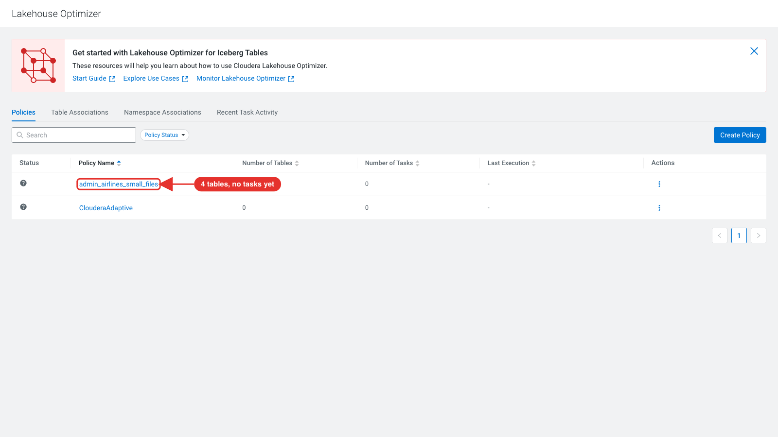
The Table Associations tab now lists your namespace and the four tables with the policy. Associating the policy declared the namespace to the Optimizer.
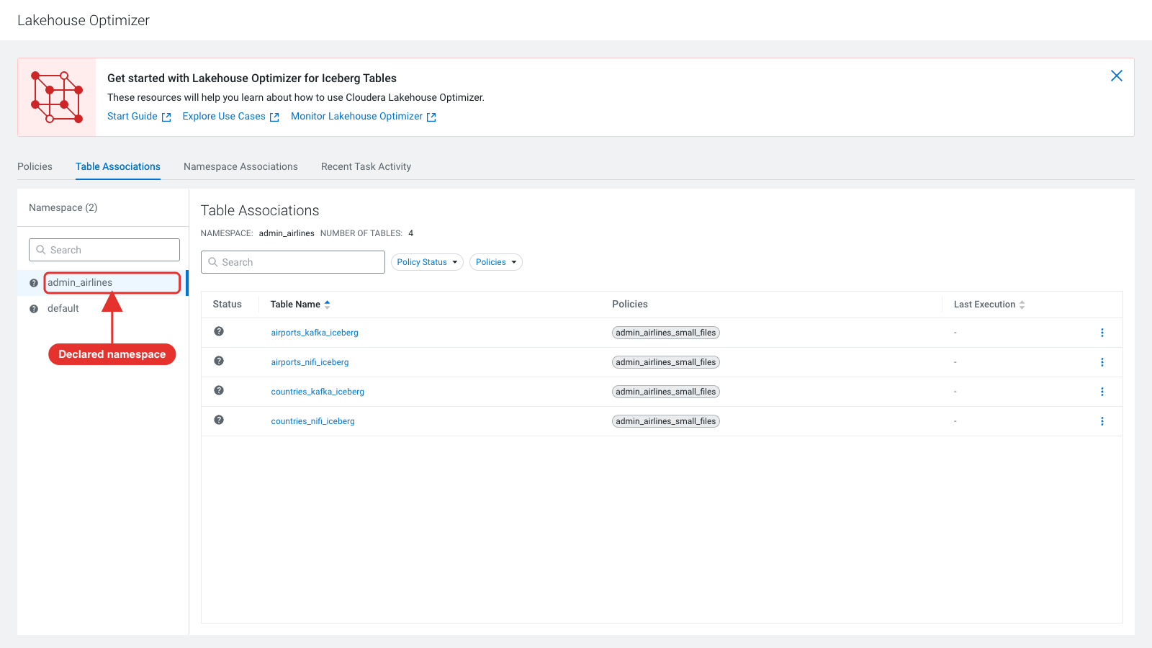
Click countries_nifi_iceberg and open Table Stats: the Optimizer reads the same numbers from the table metadata (506 data files, 506 snapshots).
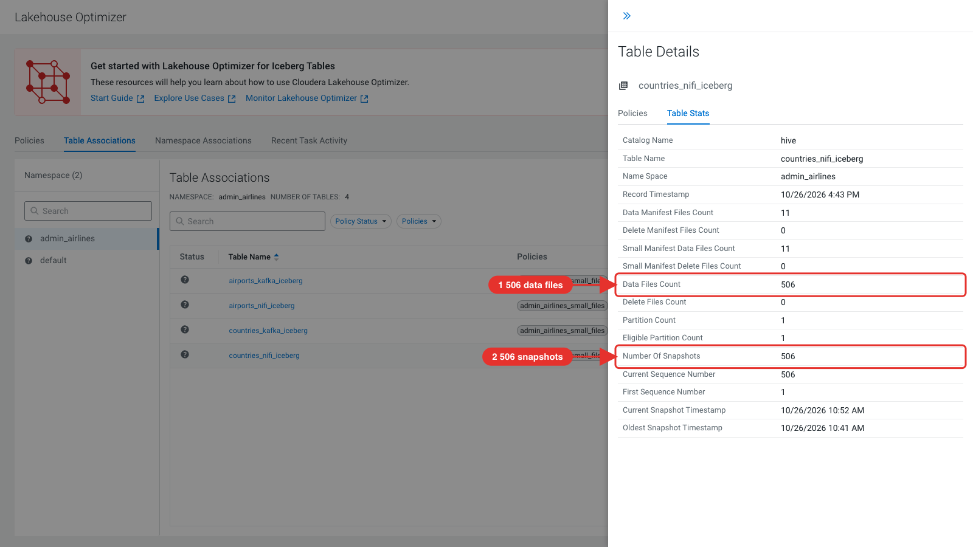

Dry run and run the policy
An event-based policy runs on the next write to the table. To run it now, use the Lakehouse Optimizer REST API through the Knox cdp-proxy-api topology. Always dry run first: the dry run evaluates the policy and only lists the actions it would take. On your laptop or the cluster host:
export USERNAME=admin
export CLO_API=https://<knox-host>/gateway/cdp-proxy-api/clo/api/v1

curl -sk -u $USERNAME -X PUT \
"$CLO_API/policies/${user_id}_airlines_small_files/tables/${user_id}_airlines.countries_nifi_iceberg/dryrun" | jq .
curl asks for your password. The output lists REWRITE_DATA_FILES (compaction) and EXPIRE_SNAPSHOTS with your settings. Rewrite Manifest is not listed: ClouderaAdaptive only generates the actions that the table statistics call for.
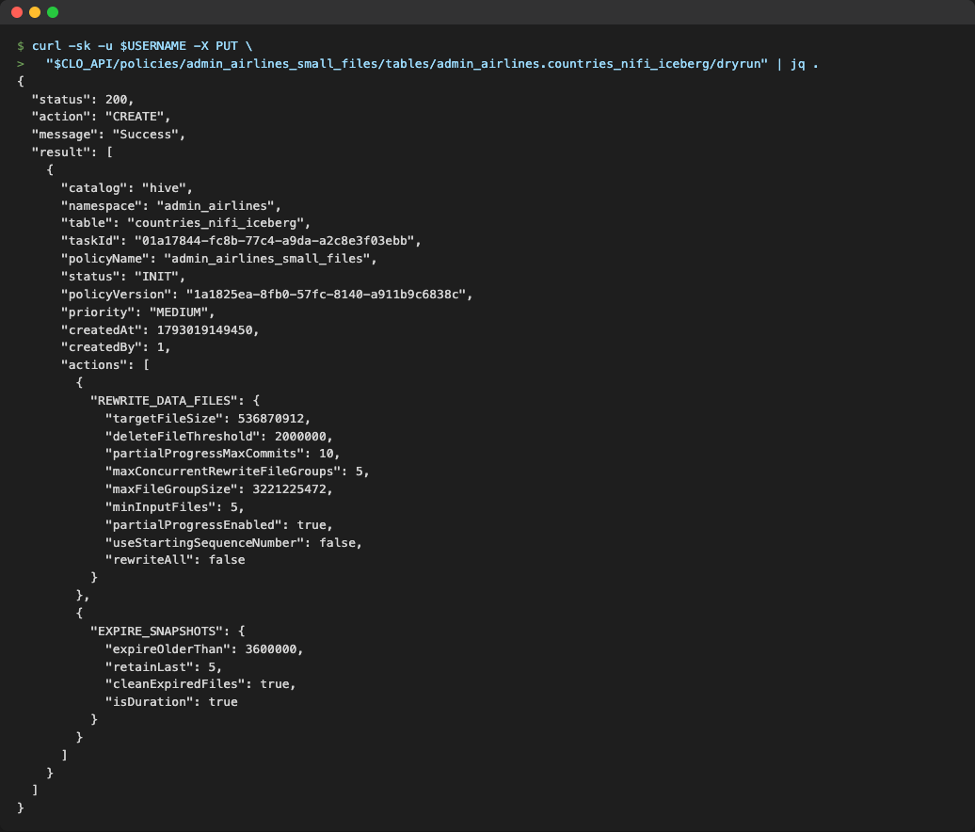
Note: The Dry Run Then Execute action in the UI (Table Associations > table > Policies > actions) works on Cloudera on cloud. On Cloudera Base 7.3.2 it does not start, so use the REST API as shown.
Run the policy on the table. The response contains the task ID:
curl -sk -u $USERNAME -X POST \
"$CLO_API/policies/${user_id}_airlines_small_files/tables/${user_id}_airlines.countries_nifi_iceberg/evaluation" | jq .

Monitor the task
The task runs as a Spark job through Livy and takes about two minutes. On the Recent Task Activity tab, choose your namespace and click Refresh; the green icon shows the completed task.
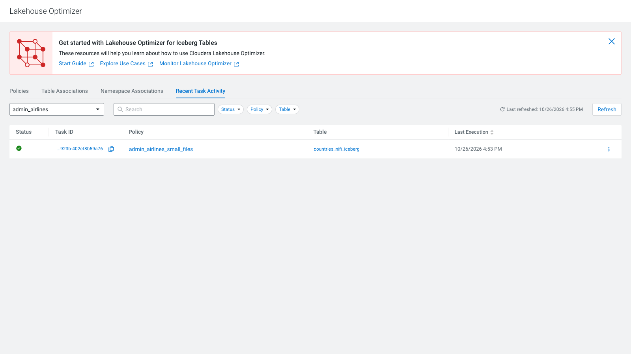
Open the task's actions menu and click Task Details. Compaction rewrote the 506 small files into one; snapshot expiration then removed the old snapshots and their manifests. You can also query the task with curl -sk -u $USERNAME "$CLO_API/tasks/id/<task-id>" | jq .
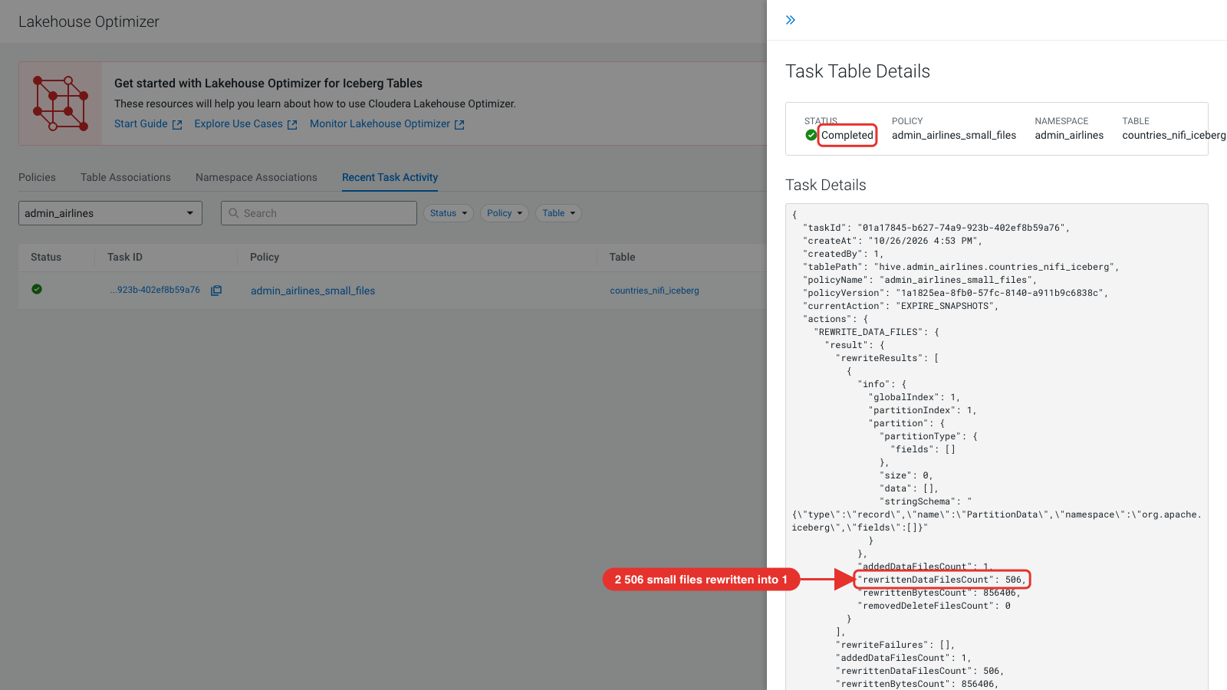
Run the counting query from the start of the lab again: one data file, five snapshots, and the same 506 rows.
SELECT 'data files' AS metric, count(*) AS value FROM ${user_id}_airlines.countries_nifi_iceberg.`files`
UNION ALL
SELECT 'snapshots', count(*) FROM ${user_id}_airlines.countries_nifi_iceberg.snapshots
UNION ALL
SELECT 'rows', count(*) FROM ${user_id}_airlines.countries_nifi_iceberg;
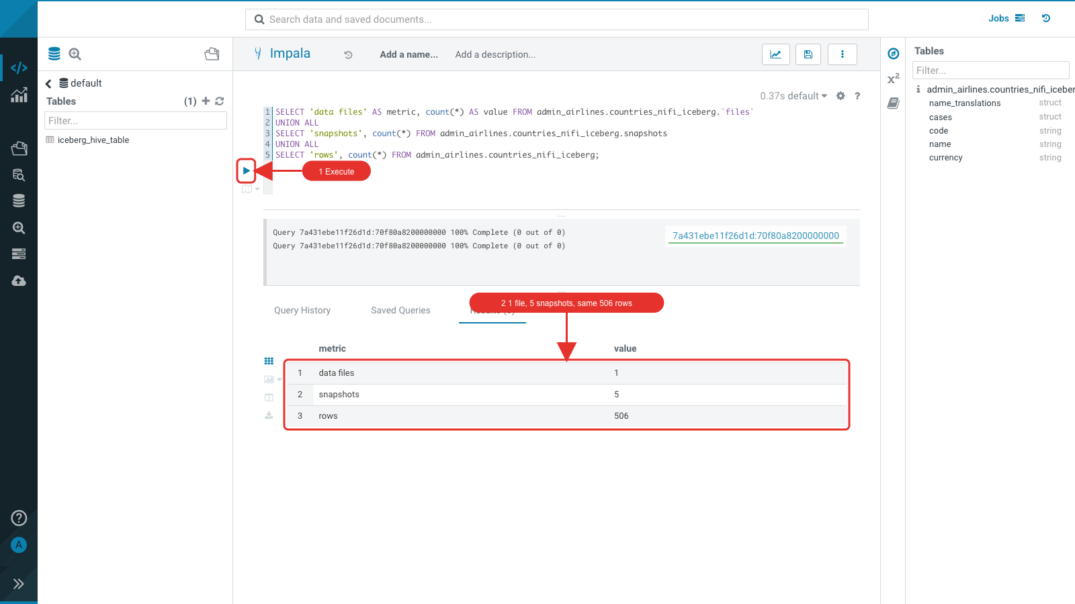
The View Policy page (click the policy on the Policies tab) shows the run status, the number of task runs and the last run for each table. The other three tables are maintained the next time NiFi or SSB writes to them.
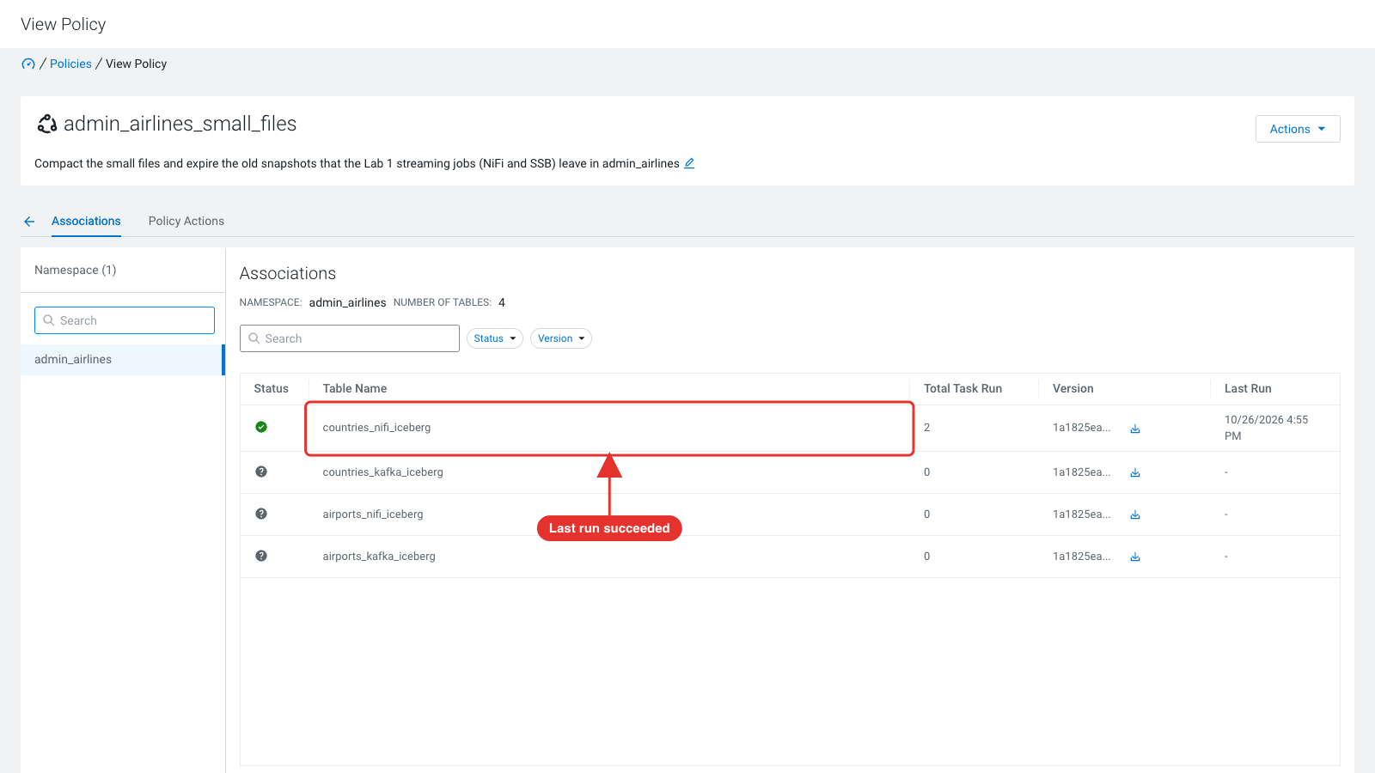
Note: Pause maintenance during bulk loads with Pause Table in the table's actions menu on Table Associations, and resume it with Unpause Table. The Optimizer also pauses a table by itself after repeated failures.

Cleanup
Delete your Lakehouse Optimizer policy (View Policy > Actions > Delete Policy). Stop your NiFi process group and your SSB jobs, then drop your databases in the Hue Impala editor:
drop database if exists ${user_id}_airlines cascade;
drop database if exists ${user_id}_airlines_maint cascade;

Appendix

Lab cluster settings
The labs need these settings on the cluster. lakehouse-cluster.yml applies all of them; they are listed here for clusters built another way.
Setting | Why
Hue trusted_origins = the external Knox URL | Otherwise Hue rejects every browser request through Knox ("Origin checking failed") and the editor stays blank
HDFS Enable Ranger Authorization, and a Ranger HDFS policy for the lab users and ssb on /warehouse/tablespace/*/hive | Impala creates the lab databases as impala:hive drwxrwx---; NiFi PutIceberg, Spark and SSB write to them directly
Ranger Hadoop SQL policy for ssb on *_airlines* | SSB registers its Iceberg tables in the Hive Metastore as the ssb user
Ranger NiFi and NiFi Registry policies for the lab users | The default policies only cover the nifi / nifiregistry service users
Flink Checkpointing Interval 30000 ms | The Iceberg sink only commits on checkpoints; without them SSB INSERT jobs show no rows
Single host: Kafka offsets.topic.replication.factor, transaction.state.log.replication.factor, transaction.state.log.min.isr = 1 | One broker cannot host the internal topics at replication 3; consumer groups and SSB samples hang
Single host: YARN NodeManager 24 GB / 12 vcores, HDFS replication 1 | Room for the SSB jobs and Spark; no under-replicated blocks
NiFi nifi.web.proxy.host includes the external Knox host | Otherwise NiFi answers 421 Invalid Proxy Host through Knox
Lakehouse Optimizer: Livy for Spark 3 and Metering V2 services, and the Lakehouse UI parcel | The Optimizer requires both services; Lakehouse UI is a separate parcel
Lakehouse Optimizer dlm_java_opts = -Djavax.net.ssl.trustStore=<Auto-TLS truststore> | Otherwise its Ranger plugin cannot reach Ranger over TLS and the Optimizer lists no namespaces
Lakehouse Optimizer dlm_security_role_admin includes the lab users' group | Otherwise the Optimizer API answers "No roles found for subject"
Lakehouse UI knox_host = the internal Knox gateway (https://<host>:8443) | The UI server calls the Optimizer API through Knox and cannot reach the external Knox address

Performance tuning with Iceberg metadata tables
Iceberg metadata tables: history, metadata_logs, snapshots, manifests, all_manifests, entries, all_entries, files, data_files, delete_files, all_files, all_data_files, all_delete_files. Useful queries (Spark SQL):
-- Files per partition
SELECT partition, file_count FROM db.table.partitions;

-- Size of each partition
SELECT partition, sum(file_size_in_bytes) AS partition_size FROM db.table.files GROUP BY partition;

-- Files added by a snapshot
SELECT data_file.file_path FROM db.table.entries WHERE snapshot_id = <id> AND status = 1;

-- Manifests: how many, and are they sorted?
SELECT count(*) FROM db.table.manifests;
SELECT path, partition_summaries FROM db.table.manifests;

-- Too many small files?
SELECT partition, count(*) AS file_count, sum(file_size_in_bytes)/count(*) AS avg_size FROM db.table.files GROUP BY partition;
Iceberg support by engine and form factor: Apache Iceberg in Cloudera.

Lab setup SQL
hol-setup.sh runs this in Hive (setup-admin.sql, with ${cdp_hdfs_dir} = data):
-- ADMIN RUN ON EACH CLUSTER TO SETUP DATA
CREATE DATABASE IF NOT EXISTS airlines_csv;

-- CREATE CSV TABLES
drop table if exists airlines_csv.flights_csv;

CREATE EXTERNAL TABLE airlines_csv.flights_csv (month int, dayofmonth int, dayofweek int, deptime int, crsdeptime int, arrtime int, crsarrtime int, uniquecarrier string, flightnum int, tailnum string, actualelapsedtime int, crselapsedtime int, airtime int, arrdelay int, depdelay int, origin string, dest string, distance int, taxiin int, taxiout int, cancelled int, cancellationcode string, diverted string, carrierdelay int, weatherdelay int, nasdelay int, securitydelay int, lateaircraftdelay int, year int)
ROW FORMAT DELIMITED FIELDS TERMINATED BY ',' LINES TERMINATED BY '\n'
STORED AS TEXTFILE LOCATION '/${cdp_hdfs_dir}/airlines-csv/flights' tblproperties("skip.header.line.count"="1");

drop table if exists airlines_csv.planes_csv;

CREATE EXTERNAL TABLE airlines_csv.planes_csv (tailnum string, owner_type string, manufacturer string, issue_date string, model string, status string, aircraft_type string, engine_type string, year int)
ROW FORMAT DELIMITED FIELDS TERMINATED BY ',' LINES TERMINATED BY '\n'
STORED AS TEXTFILE LOCATION '/${cdp_hdfs_dir}/airlines-csv/planes' tblproperties("skip.header.line.count"="1");

drop table if exists airlines_csv.airlines_csv;

CREATE EXTERNAL TABLE airlines_csv.airlines_csv (code string, description string)
ROW FORMAT DELIMITED FIELDS TERMINATED BY ',' LINES TERMINATED BY '\n'
STORED AS TEXTFILE LOCATION '/${cdp_hdfs_dir}/airlines-csv/airlines/' tblproperties("skip.header.line.count"="1");

drop table if exists airlines_csv.airports_csv;

CREATE EXTERNAL TABLE airlines_csv.airports_csv (iata string, airport string, city string, state DOUBLE, country string, lat DOUBLE, lon DOUBLE)
ROW FORMAT DELIMITED FIELDS TERMINATED BY ',' LINES TERMINATED BY '\n'
STORED AS TEXTFILE LOCATION '/${cdp_hdfs_dir}/airlines-csv/airports' tblproperties("skip.header.line.count"="1");

drop table if exists airlines_csv.unique_tickets_csv;

CREATE external TABLE airlines_csv.unique_tickets_csv (ticketnumber BIGINT, leg1flightnum BIGINT, leg1uniquecarrier STRING, leg1origin STRING, leg1dest STRING, leg1month BIGINT, leg1dayofmonth BIGINT,
leg1dayofweek BIGINT, leg1deptime BIGINT, leg1arrtime BIGINT,
leg2flightnum BIGINT, leg2uniquecarrier STRING, leg2origin STRING,
leg2dest STRING, leg2month BIGINT, leg2dayofmonth BIGINT, leg2dayofweek BIGINT, leg2deptime BIGINT, leg2arrtime BIGINT )
ROW FORMAT DELIMITED FIELDS TERMINATED BY ',' LINES TERMINATED BY '\n'
STORED AS TEXTFILE LOCATION '/${cdp_hdfs_dir}/airlines-csv/unique_tickets'
tblproperties("skip.header.line.count"="1");

Workshop repository
All lab files are in https://github.com/ylysn/lakehouse-workshop
File | Purpose
v2/hol-setup.sh | Lab administrator: data download, HDFS load, user home directories, airlines_csv tables
v2/setup-admin.sql | airlines_csv tables (Hive), run by hol-setup.sh
v2/setup-user-impala.sql | Per-user databases and tables (Hue Impala editor)
v2/setup-user-hive.sql | Per-user planes table (Hue Hive editor)
v2/SSBDemo-v2.json | NiFi 2 flow definition with generic parameters (parameter context lakehouse_hol_params), based on Steven Matison's SSBDemo.json
SSB-Iceberg-Demo/ | SQL Stream Builder project by Steven Matison (topic names set to the example user)
guide/ | This guide (.docx and .md with screenshots)

END OF DOCUMENT

